Real-Time PEME Monitoring and Result Access System for American Hospital Inc.: Solution for Pre-Employment Medical Examination Workflow Coordination

A Capstone Project Presented to the Faculty of the Department of Information Science and
Technology School of Sciences and Engineering,
University of Asia and the Pacific
Pearl Drive, Ortigas Center, Pasig City, Metro Manila



In Partial Fulfillment of the Requirements for the Degree of
Bachelor of Science in Information Technology

By:
Keith Alfred A. Avellaneda
Deejay Clark M. Datu
Alexander E. Velo

Date:
December 1, 2025

Real-Time PEME Monitoring and Result Access System for American Hospital Inc.: Solution for Pre-Employment Medical Examination Workflow Coordination

Presented to the
Faculty of the Department of Information Science and Technology,
School of Sciences and Engineering
University of Asia and the Pacific

In Partial Fulfillment of the Requirements for the Degree of
Bachelor of Science in Information Technology

By
Keith Alfred A. Avellaneda
Deejay Clark M. Datu
Alexander E. Velo

___________________
Giuseppe Ng
Faculty Adviser

___________________ ___________________
Panelist Panelist

TABLE OF CONTENTS
TITLE PAGE 1
TABLE OF CONTENTS 3
LIST OF TABLES 6
LIST OF FIGURES 7
ACKNOWLEDGEMENT 11
Chapter 1: THE PROBLEM AND ITS BACKGROUND 12
Introduction 12
Statement of the Problem 13
Objectives of the Study 16
Scope and Limitation of the Study 17
Significance of the Study 23
Chapter 2: REVIEW OF RELATED LITERATURE AND STUDIES 25
Introduction 25
Pre-Employment Medical Examination Workflows in Occupational Health 26
Healthcare Operations Management and Patient Flow Optimization 31
Queue Management Systems and Real-Time Patient Monitoring 35
Hybrid Health Information Environments, Regulatory Compliance, and Quality 41
Management
Web-Based Patient Portals and External Result Access 46
Digital Health Technologies and Healthcare Information System Architecture 49
System Usability and Evaluation Methodologies for Healthcare IT 53
Synthesis and Summary of Related Literature 62
Conceptual Model of the Study 63
Analysis of Alternatives 67
Chapter 3: RESEARCH METHODOLOGY AND TECHNICAL BACKGROUND 73
System Analysis 73
Context Diagram 73
Data Flow Diagram 76
Level 0 Diagram 78
Explosion Levels 80
Business Process Modeling and Notation (BPMN) 86
Program Design 103
External Design 104
Internal Design 105
Data Structure of the Program 106
Use Case Diagram 112
Class Diagram 121
Sequence Diagram 124
Activity Diagram 130
Statechart Diagram 133
Entity Relationship Diagram 136
Data Dictionary 137
Functional Requirements 151
Reception and Billing Staff 151
Nurse 153
Department Staff 153
Physician 155
Releasing Staff 156
Client Representative 158
Patient 159
System Administrator 160
Non-Functional Requirements 162
Usability 162
Reliability 163
Performance 164
Supportability 164
Security 165
Project Details 166
References 189
LIST OF TABLES

TABLE 2.1: TABLE OF COMPARISON | 60
TABLE 2.2: CRITERIA RATIONALE | 67
TABLE 2.3: ALTERNATIVES DECISION MATRIX | 69
TABLE 3.1: PATIENT | 138
TABLE 3.2 COMPANY | 139
TABLE 3.3 PACKAGE | 140
TABLE 3.4 DEPARTMENT | 141
TABLE 3.5 STATUS_CODE | 141
TABLE 3.6 PEME_CASE | 142
TABLE 3.7 DEPARTMENT_VISIT | 144
TABLE 3.8 RESULT_ITEM | 145
TABLE 3.9 PEME_DECISION | 147
TABLE 3.10 ROLE | 148
TABLE 3.11 USER_ACCOUNT | 148
TABLE 3.12 AUDIT_LOG | 150
TABLE 3.13 PROJECTED COST | 181
LIST OF FIGURES

FIGURE 3.1 PEME - Context Diagram | 74
FIGURE 3.2 PEME - Level 0 Diagram | 78
FIGURE 3.3 Process 1 - Patient Receiving Data Flow | 80
FIGURE 3.4 Process 2 - Billing and Payment Data Flow | 82
FIGURE 3.5 Process 3 - Medical Examinations Data Flow | 83
FIGURE 3.6 Process 4 - Compilation and Releasing of Results Data Flow | 85
FIGURE 3.7 Process 1 – Receive and Admit Patient | 86
FIGURE 3.8 Process 2 – Assess Fees and Process Payment (Billing & Cashier) | 88
FIGURE 3.9 Process 3 – Conduct Medical Examination | 90
FIGURE 3.10 Physical Examination Department | 91
FIGURE 3.11 Laboratory Department | 92
FIGURE 3.12 X-Ray Department | 92
FIGURE 3.13 Ultrasound Department | 93
FIGURE 3.14 ECG Department | 93
FIGURE 3.15 Pulmonary Function Test (PFT) Department | 94
FIGURE 3.16 Audiometry Department | 94
FIGURE 3.17 Dental Department | 95
FIGURE 3.18 Complete Chart & Release PEME | 97
FIGURE 3.19 With PEME System for Admit Patient | 99
FIGURE 3.20 With PEME System for Billing | 100
FIGURE 3.21 With PEME System for Conduct Medical Examinations | 101
FIGURE 3.22 With PEME System for Result Release | 102
FIGURE 3.23 AHI PEME Information System | 113
FIGURE 3.24 Reception and Billing Staff | 114
FIGURE 3.25 Triage Nurse | 115
FIGURE 3.26 Department Staff | 116
FIGURE 3.27 Physician | 117
FIGURE 3.28 Releasing Staff | 118
FIGURE 3.29 Client Representative | 119
FIGURE 3.30 Patient | 119
FIGURE 3.31 System Administrator | 120
FIGURE 3.32 Domain Model Classes | 122
FIGURE 3.33 Register PEME Case | 125
FIGURE 3.34 Manage Department Visit and Update Queue | 126
FIGURE 3.35 Approve Decision and Finalize PEME Case | 127
FIGURE 3.36 View PEME Result Summary | 129
FIGURE 3.37 Internal Patient Flow Monitoring | 131
FIGURE 3.38 External Result Access | 132
FIGURE 3.39 PEME Statechart Diagram | 133
FIGURE 3.40 Department Visit | 135
FIGURE 3.41 Entity Relationship Diagram | 136

ACKNOWLEDGMENT

The researchers gratefully acknowledge the guidance, encouragement, and constructive feedback of their Capstone Adviser, Sir Giuseppe Ng, whose expertise in information systems and research methodology greatly shaped the direction and rigor of this study. Appreciation is also extended to the College of Science and Engineering of the University of Asia and the Pacific for providing the academic framework, resources, and evaluation standards that guided the development of this project.

The researchers would like to express their sincere thanks to American Hospital Inc. (AHI), particularly COO Ms. Suzie Abesamis, for granting access to their pre-employment medical examination (PEME) workflow, operational data, and staff insights. The time and effort contributed by the reception, nursing, department, physician, and releasing staff during interviews, observations, and system validation activities were invaluable in ensuring that the proposed PEME Information System reflects the realities of clinical operations.

Finally, the researchers extend their heartfelt appreciation to their families, classmates, and friends for their patience, moral support, and understanding throughout the duration of this work. Their encouragement made it possible to complete both the research and system development components of this study.

Chapter 1
THE PROBLEM AND ITS BACKGROUND

1.1 Introduction
American Hospital Inc. is a private medical facility in Intramuros, Manila specializing in pre-employment medical examinations for workers requiring overseas deployment certification. The clinic operates with 45 employees across ten functional departments: reception, billing, cashier, laboratory, radiology, electrocardiography, psychology, dental, physical examination, and releasing. The facility processes approximately 1,000 pre-employment medical examinations monthly, with daily patient volume averaging 50 examinations ranging from 30 to 35 patients during low-demand periods to 60 to 70 patients during peak periods. The clinic maintains an active patient database containing 50,000 to 70,000 records.

The organization holds ISO 9001:2015 certification for quality management and maintains regulatory compliance with Department of Health standards and Data Privacy Act requirements under Republic Act No. 10173. The facility serves multiple international maritime authorities and recruitment agencies, processing approximately 900 regular pre-employment medical examinations monthly with 72-hour completion targets and 100 rush examinations monthly with 24-hour completion targets. Additionally, the clinic conducts 600 to 700 monthly re-medical examinations for workers requiring periodic health assessments.

The clinic operates a Computer Information System with modules supporting admission processing, billing management, laboratory results recording across multiple testing units, radiology and ultrasound reporting, electrocardiography recording, audiometry documentation, psychological test evaluation, triage assessment, and result releasing coordination. This partial computerization coexists with paper-based monitoring forms, charge slips, and manual logbooks used throughout the examination workflow.

1.2 Statement of the Problem
American Hospital Inc. manages pre-employment medical examinations through a paper-based and department-segmented system. Clinical staff in different units record findings and transmit information through forms, charge slips, and manual logbooks. The releasing unit consolidates results from all clinical departments to prepare final examination certificates. This process requires manual status verification across departments, repeated data handling, and staff initiative to determine when a case is complete and ready for final review.

Result collation encounters 224 documented incidents monthly. Staff must manually check all departments to confirm completion status, consuming 50 to 85 minutes of staff time daily. Laboratory results account for 85 monthly pending cases, radiology incomplete submissions total 64 monthly cases, psychology unscored examinations reach 43 monthly cases, ECG pending results represent 21 monthly cases, and dental or physical examination incomplete submissions total 11 monthly cases. Completed results remain idle for 1 to 3 hours after actual completion because releasing staff have no systematic notification when departments finish their work.

Encoding and transcription encounter 160 documented incidents monthly. Manual transcription incidents total 60 monthly cases. Historical retrieval for 600 to 700 monthly re-medical examinations requires 15 to 45 minutes per case because staff must search through physical files or navigate unintegrated digital archives. All patient information is entered twice: once when service departments record findings, and again when releasing staff compile final certificates.

These operational problems produce measurable performance gaps. Patient waiting time averages 2.6 hours across all departments, with laboratory wait times reaching 65 minutes during peak periods and radiology reaching 55 minutes. Regular pre-employment medical examinations fail to meet the 72-hour completion target in 8 percent of cases, totaling 72 monthly failures and 864 annual failures. Rush examinations fail to meet the 24-hour completion target in 10 to 11 percent of cases, totaling 11 monthly failures and 132 annual failures. Certificate errors occur at rates of 5 to 6 percent, producing 53 to 64 errors monthly and 636 to 768 errors annually. Encoding errors represent 26 monthly incidents, transcription errors represent 21 monthly incidents, and collation errors represent 11 monthly incidents.

Agencies submit 50 to 65 status inquiries weekly, averaging 8 to 10 daily requests that consume 55 to 85 minutes of staff time daily. Formal complaints occur 4 to 6 times monthly, and informal concerns arise 10 to 15 times monthly. Agency dissatisfaction affects 15 to 20 percent of clients. Patients have no direct visibility into their own examination progress and must ask staff or wait for verbal updates to determine which tests remain pending.

The operational problems translate into quantifiable financial losses. Direct measurable annual loss totals PHP 441,000 to 667,000 from operational inefficiency. Operational inefficiency costs break down into result collation checking consuming PHP 43,000 to 68,000 annually, status inquiry management consuming PHP 44,000 to 68,000 annually, error correction cycles consuming PHP 127,000 to 154,000 annually, and historical retrieval consuming PHP 77,000 annually. Client attrition reaches 0 to 1 agency annually representing PHP 150,000 to 300,000 loss per departed agency.

Timeline failures total 2,436 incidents annually, comprising 864 regular examination late completions, 132 rush examination late completions, and 1,440 releasing delays. These failures cause deployment delays affecting 17 to 26 patients monthly or 204 to 312 patients annually. Patient churn reaches 4 percent monthly, totaling 36 patients monthly or 432 patients annually who abandon the examination process after initial visit.

The cumulative impact compounds over time. Three-year projections show 7,308 late completions, 1,908 to 2,304 certificate errors, 612 to 936 patients affected by deployment delays, 1,296 patients lost to churn, and 0 to 3 agencies at risk, totaling PHP 1,323,000 to 2,001,000 in revenue loss. Five-year projections show 12,180 late completions, 3,180 to 3,840 certificate errors, 1,020 to 1,560 patients affected by deployment delays, 2,160 patients lost to churn, and 0 to 5 agencies at risk, totaling PHP 2,200,000 to 3,300,000 in revenue loss.

The structural problem is the absence of real-time visibility into patient progress and examination status. Staff cannot determine case status without manually checking each department. Agencies cannot access progress information without calling or emailing clinic staff. Patients cannot track their own examination progress or verify result availability. This creates coordination problems that extend patient waiting time, delay result availability, burden staff with repeated status confirmations, and produce errors through multiple manual data handling steps.

1.3 Objectives of the Study

1.3.1 General Objective
To develop a monitoring and result access solution that addresses operational problems in pre-employment medical examination tracking, patient flow visibility and examination status, and result release at American Hospital Inc.

1.3.2 Specific Objectives
- To design a centralized system workflow that actively tracks patient status across all relevant clinical departments, bridging the communication gaps between standalone units through real-time data encoding, digital queue tracking, and integrated result collation.
- To implement the project as a modern, responsive web-based application utilizing a cloud-native architecture, featuring secure user accounts, real-time staff dashboards, active clinical data encoding interfaces, and a mobile-responsive external portal for automated result access and email notifications.
- To test the system against FURPS+ requirements framework, verifying functional suitability through feature completeness testing, usability through System Usability Scale (SUS) administration (Hyzy et al., 2022) and task completion metrics, reliability through uptime monitoring and error rate measurement, performance through response time testing and load simulation, and supportability through code quality review and documentation assessment.
- To evaluate the system for compliance with ISO 9001:2015 quality management standards through structured audit procedures, Department of Health medical information system requirements through verification checklists, Data Privacy Act provisions through security and privacy controls assessment, and ISO/IEC 25010:2023 software quality characteristics through systematic quality attribute evaluation.

1.4 Scope and Limitation of the Study
The study addresses pre-employment medical examination workflows at American Hospital Inc. in Intramuros, Manila. The clinic processes 1,000 monthly cases across ten departments, employs 45 staff members, serves approximately 1,000 monthly external users including recruitment agencies and individual patients, and maintains 50,000 to 70,000 active patient records.

Data parameters include patient demographics, examination transaction identifiers, assigned package types, department status indicators, actively encoded clinical results from all service units, fitness-to-work conclusions, certificate generation, Data Privacy Act consent waivers, and audit records. The system functions as a specialized, parallel Electronic Medical Record (EMR) module dedicated strictly to PEME workflows. Rather than passively reading from legacy systems, clinical and departmental staff will encode PEME-specific examination findings directly into the new system to trigger real-time queue updates and automate result collation.

System deliverables include a web-based Single Page Application (SPA) deployed via modern cloud infrastructure, paired with a secure Backend-as-a-Service (BaaS). The staff dashboard provides real-time patient status monitoring and department queue visualization with WebSocket-driven live updates. The external portal provides secure authentication enabling recruitment agency representatives and patients to track examination progress and securely download finalized results through a mobile-first, responsive interface. Crucially, agency access to download full medical summaries is strictly contingent upon the system verifying that the patient signed a data release waiver during admission, ensuring full compliance with the Data Privacy Act.

Additional deliverables include database implementation supporting the full patient record dataset with normalized schema design, user account management with role-based permissions distinguishing staff users, individual patient users, and agency representative users, read-only integration connectors accessing data from existing Computer Information System modules for admission, billing, laboratory, radiology, ultrasound, ECG, audiometry, psychology, and triage, logic mapping completed examinations against package-defined requirements to determine progress status, and automated email notification system that alerts releasing staff when results are uploaded to the portal, notifies agency representatives when their workers' results become available, and notifies individual patients when their examination results are ready for access.

Testing procedures verify functional completeness through systematic test case execution covering all core workflows including staff case monitoring, patient progress tracking, agency result access, automated status aggregation from CIS modules, and email notification delivery. Usability assessment employs System Usability Scale administration (Hyzy et al., 2022) to three user groups comprising staff dashboard users, individual patient portal users, and agency representative portal users, with task-based completion metrics measuring time to locate case status, view examination progress, and access results. Performance testing measures page load times, concurrent user load simulation representing 20 to 30 staff users and 50 to 100 external users, database query performance across the full patient dataset, real-time status aggregation response times, and email notification delivery times. Reliability monitoring tracks system uptime and error frequency measurement.

Evaluation procedures assess compliance with multiple regulatory frameworks and quality standards. ISO 9001:2015 quality management standards compliance uses structured audit checklists that verify documentation control by confirming system documentation is version-controlled and accessible, assess record management by confirming the system supports the mandatory five-year retention period for medical records with secure storage and retrieval mechanisms, examine process control by verifying system workflows follow established procedures for data access and user management, and review corrective action procedures by confirming the system supports identification and tracking of issues through audit trails. Department of Health medical information system requirements under Administrative Orders 2012-0012 and 2013-0006 are verified through checklists that confirm data security measures protect patient information through encryption and access controls, verify patient privacy protections prevent unauthorized disclosure, assess interoperability by examining read-only integration with existing CIS modules, review certificate issuance procedures to ensure proper format and release protocols with required physician authentication, and confirm record retention capabilities maintain certificate copies per regulatory requirements.

Data Privacy Act compliance under Republic Act No. 10173 and National Privacy Commission Circular 16-03 employs security and privacy controls evaluation that verifies consent management procedures implement patient consent for data access, confirms access control enforcement through role-based permissions prevents unauthorized access by testing that staff view only permitted data while patients access only their own results and agencies access only assigned worker information, validates encryption protocols secure data at rest through database encryption and data in transit through HTTPS implementation, examines audit trail completeness to confirm documentation of all user login attempts and data access events with tamper-resistant logging, reviews breach notification procedures for incident response, and assesses data retention and disposal policies for alignment with legal requirements. ISO/IEC 25010:2023 software quality characteristics employ systematic quality attribute assessment that measures functional suitability by verifying all planned features work correctly with accurate data retrieval from CIS modules, evaluates performance efficiency through page load time measurements targeting 2-second thresholds and concurrent user load testing, confirms compatibility through verification of integration with existing CIS modules without conflicts, assesses usability through System Usability Scale scores targeting 68 or above (Hyzy et al., 2022), monitors reliability through uptime tracking targeting 99 percent availability, examines security through vulnerability scanning using OWASP ZAP and manual penetration testing, reviews maintainability through code quality assessment, and tests portability by verifying the system operates on different server hardware.

Time-and-motion study methodology adapts Karthikeyan et al. (2024) approach developed for tertiary care hospital outpatient departments, applying the workflow analysis techniques to the secondary clinic context by measuring patient flow through direct observation and recording timestamps at each department transition point to calculate cumulative waiting time and total cycle time. Pre-post quasi-experimental study design validated by Mansoor et al. (2024) assesses operational outcomes before and after system implementation by measuring changes in key performance indicators including completion rates, turnaround times, error frequencies, and staff coordination burden.

The project will not manage or execute financial or billing transactions. While the system may reference billing transaction numbers or payment statuses to verify that examination fees have been processed prior to medical testing, it strictly excludes financial data processing, focusing development resources entirely on operational workflow bottlenecks, clinical data encoding, and result releasing.

Furthermore, while the system requires staff to encode PEME findings directly into the application to facilitate automated collation, it does not alter the medical evaluation protocols or fitness-to-work determination standards established by the clinic. The application serves as a modern digital conduit for these existing clinical standards, ensuring that medical professionals retain complete diagnostic authority while benefiting from automated documentation consolidation.

The project will not include SMS text message alerts to patients and agencies, mobile application development for iOS or Android platforms, advanced analytics and business intelligence dashboards, integration with national health registries or government systems, or telemedicine capabilities. Furthermore, the system will not utilize automated patient routing algorithms or algorithmic priority queuing; queue management is intentionally scoped as a staff-driven digital tracking list to reflect physical clinic realities. These exclusions prioritize core functionality addressing documented operational problems within available development resources. Advanced features require specialized technical expertise, ongoing maintenance infrastructure, and integration with external communication platforms that exceed the scope of addressing immediate problems of manual status checking and repeated data entry. Email notification functionality is included as it addresses the documented problem of releasing staff having no systematic notification when departments finish their work and agencies having to call or email for status updates, using standard email protocols that can leverage existing clinic email infrastructure currently used for result distribution to agencies.

Testing and evaluation activities are constrained by operational requirements. The clinic cannot suspend patient care services for system testing, cannot allocate extended staff time away from patient care responsibilities, and cannot conduct testing during peak operational periods. Data collection sessions must be scheduled during low-volume periods and kept brief to minimize service impact. This limitation reflects ethical obligations to prioritize patient care over research activities and practical necessity of maintaining clinic revenue and contractual obligations to agency clients. The constraint affects sample sizes for user testing and limits the duration of observation periods but does not prevent collection of valid performance data through focused, carefully scheduled evaluation sessions employing time-and-motion methodology adapted from Karthikeyan et al. (2024) for secondary clinic operations and pre-post quasi-experimental design (Mansoor et al., 2024).

Security assessment will employ open-source vulnerability scanning tools and manual penetration testing following published security testing methodologies. The project will not include professional security audits by certified third-party firms or commercial penetration testing services. This limitation is justified by budget constraints of student capstone projects and represents acceptable risk for a locally-hosted system under existing physical security and network infrastructure controls. Security verification confirms absence of common vulnerabilities documented in established frameworks such as OWASP Top 10 while acknowledging that comprehensive protection against sophisticated attacks requires additional security hardening beyond student project capabilities.

Formal regulatory certification is outside project scope. The system demonstrates compliance readiness through documented controls, implemented security measures, and audit trail capabilities addressing ISO 9001:2015, Department of Health, and Data Privacy Act requirements. However, official certification audits by accredited bodies including ISO certification auditors, Department of Health accreditation teams, or National Privacy Commission assessors require clinic management initiation and involve assessment of broader organizational policies, physical security measures, staff training programs, and administrative procedures beyond information system implementation. The project provides evidence of regulatory compliance through structured verification procedures but does not replace formal certification processes.

1.5 Significance of the Study
For American Hospital Inc., the project addresses documented problems in how the organization monitors ongoing examinations and compiles final results. A functional monitoring and result access system reduces repeated manual checking by aggregating completion status from existing Computer Information System modules, clarifies case status for staff through unified dashboard visualization, shortens the interval between clinical completion and releasing by eliminating idle time when completed results await manual discovery, and automates notification to staff, agencies, and patients when results become available.

For recruitment agencies, the proposed system provides direct access to examination status and results for their workers with automated email notification when results are ready. Agency representatives can verify progress and retrieve completed results without telephone or email coordination.

For individual patients, the proposed system provides visibility into personal examination progress showing which tests have been completed, which remain pending, and what results are available, with email notification when examination results are ready for access. This addresses the current situation where patients must ask staff for updates and have no independent way to track their own status through the multi-department examination process.

For the academic program, the proposed project demonstrates how information systems address specific, documented operational problems in a healthcare setting with real regulatory and operational constraints. The study shows how read-only integration with existing systems can create operational value without disrupting established workflows or requiring additional data entry from clinic staff.

Chapter 2

REVIEW OF RELATED LITERATURE AND STUDIES

2.1 Introduction
American Hospital Inc. conducts pre-employment medical examinations to determine whether applicants are fit for deployment, yet its PEME operations suffer from fragmented tracking, prolonged waiting times, and delayed result consolidation. To understand how information systems can address these problems, this review synthesizes literature from several domains: healthcare operations management and patient flow optimization, occupational health and PEME service delivery models, queue management and queueing theory in clinical settings, digital health technologies and infrastructure, web-based architectures for operational and patient-facing services, real-time monitoring systems, and data privacy and regulatory compliance in healthcare.
The discussion is organized around three analytic dimensions. The first dimension establishes operational foundations that explain how patient flow, resource allocation, and queue discipline affect waiting times and throughput in outpatient and occupational health settings. The second dimension examines enabling technologies such as hybrid health information environments, web-based portals, dashboards, and local hosting architectures that support real-time visibility and multi-stakeholder access. The third dimension focuses on evaluation methods and quality frameworks, including ISO-aligned quality characteristics, the FURPS plus requirements framework, System Usability Scale benchmarks, time-and-motion analysis, and satisfaction measurements. Together, these strands inform the design of an on-premises, web-based PEME monitoring and result access system that fits the regulatory and operational realities of American Hospital Inc.

2.2 Pre-Employment Medical Examination Workflows in Occupational Health
Pre-employment medical examinations in Philippine occupational health clinics follow standardized protocols set by the Department of Health. These protocols prescribe core tests such as blood work, urinalysis, chest radiography, electrocardiography, and neuro-psychiatric assessment to determine medical fitness for work (DOH Administrative Order No. 2013-0006, n.d.). Clinics must also adapt to client-specific packages that vary by employer, destination country, and position, which adds complexity to scheduling, coordination, and results consolidation. For overseas Filipino workers, the regulatory framework restricts PEME provision to DOH-accredited or DOH-operated clinics while still allowing workers to choose among accredited providers (DOH Administrative Order No. 1, s. 2003, n.d.). Any information system designed for PEME must therefore accommodate standardized protocols and variable employer requirements inside a regulated environment.
The PEME workflow in American Hospital Inc. resembles typical occupational health models, where patients move through multiple departments such as reception, laboratory, radiology, specialty clinics, and releasing. Each department contributes partial results that must be collated into an integrated medical report and fitness-to-work decision. Without real-time tracking, staff rely on repeated manual status checks, phone calls, and physical chart chasing to know where a case is in the process. The literature indicates that in such multi-department workflows, lack of visibility creates idle time, misplaced charts, and failures to meet promised turnaround times (Lima et al., 2024; Samadbeik et al., 2024). A PEME-specific information system must therefore treat each case as a single episode that moves across units, while preserving compliance with DOH accreditation and employer-specific documentation requirements.

2.2.1 PEME Services and Clinical Workflows in the Philippines
PEME services in the Philippines are specialized examinations that certify applicants as fit, unfit, or fit with restrictions for work, with particular emphasis on overseas employment where medical clearance is a formal prerequisite (DOH Administrative Order No. 1, s. 2003, n.d.). The regulatory framework involves DOH issuances, overseas employment agencies, and international maritime standards for seafarers endorsed by the International Labour Organization (Guidelines on the medical examinations of seafarers, 2011). DOH Administrative Order 2013-0006 classifies PEME facilities into Regular clinics for land-based and domestic seafarers, Special Seafarer clinics for international seafarers, and other specialized types, each with minimum service and equipment standards (DOH Administrative Order No. 2013-0006, n.d.).
Workflows in Philippine PEME clinics include standardized steps such as registration, verification of employer package, physical examination, diagnostic tests, and final medical evaluation, but actual paths can vary based on package composition and clinical findings (DOH Administrative Order No. 2013-0006, n.d.). Studies on healthcare service delivery highlight how multi-stage clinical paths and multi-stakeholder reporting requirements increase coordination demand and heighten the risk of lost time when results are delayed or incomplete (Ezeanyim et al., 2025; Samadbeik et al., 2024). Electronic health record implementations in occupational health contexts have shown potential for improving documentation quality and reducing processing times when integrated into existing clinical workflows (Kowalski-Mcgraw et al., 2023). An information system for American Hospital Inc. must therefore support package-driven routing, multi-stage clearance, and structured result consolidation while remaining consistent with national regulatory frameworks.

2.2.2 Multi-Department Coordination in PEME Operations
Multi-department PEME operations require coordination across reception, billing, diagnostic units, specialty clinics, and medical directors. Each unit controls a segment of the process but no single actor has a complete real-time view of case status under purely manual systems. DOH regulations define documentation, consent, and record-keeping standards but do not prescribe how information should flow operationally across departments (DOH Administrative Order No. 2013-0006, n.d.). Contemporary operations research emphasizes that lack of a single source of truth for patient status leads to duplicated work, repeated status inquiries, and delays in downstream steps such as physician evaluation or report printing (Lima et al., 2024; Samadbeik et al., 2024; Chen et al., 2024).
Studies of multi-department hospital workflows show that unified tracking mechanisms reduce handoff failures and shorten end-to-end cycle times when they provide each actor with filtered, role-appropriate views of cases in progress (Harbi et al., 2024; Lima et al., 2024). Bottleneck factors in clinical workflows often stem from communication gaps and lack of standardized handoff procedures between departments (Al Moteri et al., 2024). Queue-aware scheduling and inter-department coordination depend on accurate, timely updates for each step completed, rather than retrospective reconciliation of paper forms (Zamani et al., 2024). Health information systems that centralize patient tracking across multiple service points have demonstrated improvements in care coordination and reductions in patient waiting times (Chen et al., 2024). For American Hospital Inc., this implies that a PEME monitoring system must centralize status updates for all departments, allow controlled editing only at appropriate stages, and expose real-time views of queues and backlogs to staff managing daily operations.

2.2.3 Overseas Filipino Worker Medical Assessment Requirements
PEME for overseas Filipino workers is tied to deployment decisions and international compliance. DOH guidelines specify mandatory examination elements for seafarers and land-based workers, and align with maritime and labor conventions that require standardized documentation formats and validity periods (DOH Administrative Order No. 2013-0006, n.d.; Guidelines on the medical examinations of seafarers, 2011). Clinics must produce certificates acceptable to foreign principals and flag states, and are subject to audits that verify adherence to DOH standards and international guidelines. Failure to maintain complete, accurate, and timely records can lead to sanctions and loss of accreditation (Licensing/Accreditation of Health Facilities and Services, n.d.).
Because OFW examinations are often linked to fixed departure dates, delays in any part of the workflow can lead to missed vessels or flight schedules. The literature emphasizes that for healthcare services with time-sensitive outcomes, alignment between clinical processes, documentation, and external timetables is critical (Zamani et al., 2025; Youn et al., 2022). Visibility into examination progress and result status is important for employment agencies that coordinate placements (Kowalski-Mcgraw et al., 2023). A web-based monitoring and results access system that allows agencies to see PEME status and summary fitness decisions in a controlled way can reduce repeated inquiries and help agencies schedule applicants more efficiently, provided that access is limited to necessary information and is consistent with data privacy requirements (Republic Act 10173, n.d.).

2.2.4 Rush Processing and Priority Queue Management in Time-Critical Medical Services
Rush or expedited PEME cases introduce additional operational pressure because examinations and result consolidation must be completed within compressed timeframes. Research on time-critical clinical services shows that unstructured handling of urgent cases can disrupt routine workflows, prolong average waiting times, and create inequities in access when no priority rules guide resource allocation (Harbi et al., 2024; Alipour-Vaezi et al., 2022). Studies of emergency and urgent care units demonstrate that explicit priority disciplines and differentiated queues for urgent and routine cases can reduce service time variability and improve completion of high-priority cases without fully displacing routine clients (Wang et al., 2025; Liao et al., 2022).
Priority-based queue discipline separates patients into service classes so that time-critical cases are prioritized while routine cases still meet agreed performance thresholds. Multi-tier queueing models allocate more capacity to rush cases while preserving minimum capacity for regular cases and are often guided by service level agreements that specify acceptable completion percentages within defined time limits (Adhicandra et al., 2024; Liu et al., 2024). Research on queue management systems indicates that when priority rules and capacity allocations are implemented and monitored through digital systems, urgent completion metrics improve and routine throughput remains acceptable (AlQudah et al., 2024; Hassan et al., 2022). Empirical work on appointment and scheduling systems shows that priority-aware resource allocation can balance competing demands without creating excessive delays for lower-priority patients (Manarte, 2024). For American Hospital Inc., the literature supports explicit representation of rush versus regular PEME queues in the monitoring system, including dedicated indicators and configurable service targets for each class.

2.3 Healthcare Operations Management and Patient Flow Optimization
Healthcare operations management coordinates processes, resources, and workflows to achieve efficiency, quality, and patient satisfaction (Harbi et al., 2024). It includes patient throughput optimization, capacity planning, resource allocation, and continuous quality improvement strategies that can be applied to outpatient and occupational health settings (Harrison et al., 2025; Zhao et al., 2025). For PEME clinics, these principles provide a framework for redesigning multi-department workflows so that scarce resources such as diagnostic equipment, physicians, and administrative staff are used more effectively and end-to-end examination times are reduced.
Operations management literature emphasizes that patient flow is a system-level phenomenon shaped not only by individual tasks but also by bottlenecks, variability in arrivals, and coordination across departments. Studies of outpatient clinics show that unbalanced workload distribution, unclear routing rules, and limited shared visibility into queues often lead to prolonged waiting times and incomplete visits (Harbi et al., 2024; Harrison et al., 2025). For American Hospital Inc., the same concepts apply to PEME cycles that involve serial and parallel processes. To improve performance, the system must not only automate documentation but also expose how cases move through the process so that managers can identify delays and adjust resource deployment in line with operations management best practices.

2.3.1 Fundamentals of Healthcare Operations Management
Fundamental models of healthcare operations management conceptualize care delivery as a network of interdependent processes that transform inputs such as patients and resources into outputs such as completed consultations, diagnostic reports, and clinical decisions (Harbi et al., 2024; Javaid et al., 2024). Key levers include scheduling, capacity allocation, process standardization, and performance measurement. Research indicates that clinics that systematically monitor throughput and apply structured improvement methods achieve better service times and higher patient satisfaction than clinics that rely on ad hoc adjustments (Zamani et al., 2025; Ferreira et al., 2023).

More recent work extends these principles to occupational health and pre-employment settings, where the output is often a fitness-to-work certificate under time constraints set by employers or deployment schedules. These studies highlight the need to integrate information about patient arrivals, resource availability, and examination requirements to coordinate tasks efficiently (Harbi et al., 2024; Machireddy, 2023). Resource planning strategies in healthcare emphasize that operational efficiency depends on matching capacity with demand patterns, which requires accurate data collection and real-time monitoring capabilities (Fattahi et al., 2023). In American Hospital Inc., adopting this view means treating PEME not as isolated departmental tasks but as a coordinated operations system that can be monitored and controlled through a dedicated information system.

2.3.2 Patient Flow and Throughput Metrics in Outpatient Settings
Patient flow literature defines flow as the progression of patients through a series of stages, from registration and triage to diagnostics and discharge, and uses throughput metrics such as waiting time, length of stay, and completion rates to quantify performance (Samadbeik et al., 2024; Samadbeik et al., 2025). Studies show that small delays at early stages can cascade into large end-to-end delays, especially in systems with multiple serial dependencies (Zamani et al., 2025). Patient flow analysis with real-time tracking has demonstrated effectiveness in optimizing consultation visits and reducing unnecessary waiting periods (Mesko et al., 2022).
Research in outpatient clinics and diagnostic centers indicates that measuring and visualizing throughput metrics is a prerequisite for improvement. Any intervention aimed at reducing waiting times or improving completion rates must be evaluated against baseline measures and monitored through feedback loops (Samadbeik et al., 2024; Samadbeik et al., 2025; Zamani et al., 2025). Studies on patient satisfaction consistently show that waiting time is among the strongest predictors of overall satisfaction with healthcare services (Bhatt et al., 2024; Leow & Liew, 2022). Optimization of outpatient waiting times has been linked to improvements in national quality indicators, demonstrating the strategic importance of flow management (Prayudi et al., 2024). For American Hospital Inc., the PEME monitoring system will need to capture timestamps at key steps, such as registration, departmental arrival and completion, and result release, so that patient flow can be quantified and adjusted according to these established metrics.

2.3.3 Queue Theory and Waiting Time Reduction Models
Queueing theory provides mathematical models to analyze waiting line systems and to study how arrival rates, service times, and capacity decisions influence waiting times and system congestion. Work in healthcare queueing shows that balancing arrival patterns and service capacity through appropriate scheduling and resource pooling can significantly reduce average waiting times without necessarily increasing resources (Alipour-Vaezi et al., 2022; Aminah et al., 2025). Queueing theory is consistently described as a core framework for understanding and addressing waiting time problems in healthcare settings, with recent reviews and applications highlighting its role in modelling hospital queues and optimizing service performance (Suleiman et al., 2022; Sachidhanandham & Srinivasan, 2025; Okemmiri et al., 2024)
Simulation models and analytical formulations have been used to evaluate alternative appointment rules, triage schemes, and routing policies in outpatient settings (Aminah et al., 2025; Okemmiri et al., 2024). Mathematical programming approaches have been applied to analyze and improve robust queue management in healthcare systems, demonstrating the potential for quantitative methods to guide operational decisions (Ahmed, 2025). Single-server and multi-server exponential queueing models have been applied in hospital contexts to optimize resource utilization and reduce patient waiting times (Suleiman et al., 2022). Recent studies also explore how digital tools can support the implementation of queueing-theory-informed policies. These studies show that systems that dynamically display current load and waiting times support better decision-making for staff and reduce perceived waiting times among patients (Liang & He, 2023; AlQudah et al., 2024). Although American Hospital Inc. will not implement advanced optimization algorithms in the initial capstone phase, the literature supports using queueing concepts to inform the design of status indicators, departmental load dashboards, and simple priority rules inside the PEME monitoring system.

2.3.4 Process Bottleneck Identification and Flow Analysis
Bottleneck analysis locates stages in a process where capacity constraints or variability cause queues and delays. In healthcare, studies show that bottlenecks often arise at diagnostic units, physician consultations, or administrative release steps, and that system-wide improvements require rebalancing these constraints rather than optimizing individual steps in isolation (Al Moteri et al., 2024; Lima et al., 2024). Bottleneck factors impacting clinical workflows include communication gaps, documentation requirements, and resource limitations that create cumulative delays across service points (Al Moteri et al., 2024).
For pre-employment clinics, flow analysis methods such as process mapping, time-and-motion measurements, and throughput tracking have been used to identify where patients spend most of their time and which handoffs are prone to error. These methods inform targeted interventions such as real-time alerting when cases linger in a stage beyond a tolerated threshold or when queues in a department reach a predefined limit (Lima et al., 2024; Benjamin, 2024). Hospital operations management research emphasizes the importance of characterizing patient process flows to identify inefficiencies and guide improvement efforts (Lima et al., 2024). Studies of emergency nursing workflows have shown that patient flow management requires continuous situational awareness and proactive intervention to prevent queue buildup (Benjamin, 2024). The PEME monitoring system for American Hospital Inc. is designed in line with these findings, with process diagrams and monitoring views that make bottlenecks visible so that staff can intervene early.

2.4 Queue Management Systems and Real-Time Patient Monitoring
Queue management systems support patient registration, ticketing, routing, and calling across service points. In healthcare settings, these systems range from simple manual approaches such as physical numbering and verbal calling to advanced digital platforms with integrated kiosks, displays, and electronic queues (Adhicandra et al., 2024; Hassan et al., 2022). Real-time patient monitoring extends basic queuing by providing continuous visibility into where each patient is in the workflow and by offering dashboards that show departmental load and potential bottlenecks (Sekarini et al., 2025; Liang & He, 2023; Munbodh et al., 2022).
In environments like American Hospital Inc., which already maintains clinical information systems and paper records, the challenge is not only to modernize queues but also to respect regulatory constraints and the existing hybrid processes. The literature indicates that incremental introduction of digital queue and monitoring systems, anchored on real-time displays and status updates, can improve patient flow and staff coordination even when full electronic health record adoption is not feasible (Adhicandra et al., 2024; AlQudah et al., 2024). Studies on queue management system acceptance in healthcare emphasize that perceived usefulness, ease of use, and compatibility with existing workflows are critical factors for successful implementation (AlQudah et al., 2024).

2.4.1 Types and Evolution of Queue Management Systems in Healthcare
Queue management systems have evolved from manual queues to semi-automated systems with LED counters and kiosks, and more recently to fully integrated platforms linked to electronic records. Studies from outpatient clinics and diagnostic centers show that shifting from manual to digital queues reduces confusion about service order, lowers perceived unfairness, and improves waiting room organization (Hassan et al., 2022; Baballe, 2022). Research on hospital queue management systems indicates that digital implementations have positive effects on patient satisfaction and operational efficiency when properly designed and implemented (Baballe, 2022).
In many low- and middle-income settings, however, clinics still rely on paper logbooks and verbal calling, which are prone to errors when patient volumes grow. Evidence shows that even basic digital ticketing combined with structured calling can reduce miscalls and lost charts (Hassan et al., 2022; Nabila & Ayuningtyas, 2024). Web-based reservation systems have demonstrated effectiveness in reducing outpatient waiting times by allowing patients to schedule appointments and receive queue numbers remotely (Nabila & Ayuningtyas, 2024). For American Hospital Inc., the proposed PEME system does not aim to replicate all features of advanced commercial products but draws from this evolution to implement role-appropriate digital queues and views that work with existing reception and departmental processes.

2.4.2 Real-Time Patient Flow Visibility and Routing Dashboards
Real-time visibility tools and routing dashboards display current queues, service status, and key performance indicators in a way that supports operational decision-making. Studies demonstrate that such dashboards help staff identify congestion before it leads to severe delays and support rerouting or rescheduling when capacity constraints arise (Liang & He, 2023; Sekarini et al., 2025; Munbodh et al., 2022). Research on real-time operational dashboards has shown that continuous displays of patient flow metrics enable proactive management and improve overall department performance by driving agile decision-making across health systems (Liang & He, 2023; Mesko et al., 2022).
Research also shows that providing staff with a shared overview of patient queues increases accountability and reduces the tendency to attend only to local queues without regard to global performance (Liang & He, 2023; Sekarini et al., 2025). Dashboard applications for monitoring patient data in hospitals have been shown to improve coordination by presenting consolidated views of patient status across multiple service points (Sekarini et al., 2025). Real-time analysis and display of quantitative measures has demonstrated effectiveness in tracking and improving clinical workflow performance (Munbodh et al., 2022). When combined with simple rules such as maximum tolerated waiting time per stage, dashboards can trigger early interventions and cross-department coordination (Harbi et al., 2024). For American Hospital Inc., the PEME dashboard is designed to give reception, nursing, and departmental heads a consolidated view of cases in progress and waiting counts per unit so that they can prioritize, communicate, and adjust assignments in line with best practices in real-time patient flow monitoring.

2.4.3 Department Load Monitoring and Bottleneck Prevention
Department load monitoring focuses on the distribution of work across units and on the identification of overloaded services that may become bottlenecks. Studies show that when dashboards show both current load and historical patterns, managers can adjust staffing, redistribute tasks, or redirect patients to alternative units to prevent sustained congestion (Al Moteri et al., 2024; Shoaib et al., 2023). Multi-tier healthcare facility network simulations have demonstrated that capacity planning informed by real-time load data can improve resource utilization and reduce patient waiting times (Shoaib et al., 2023).
In environments where resources are fixed, early detection of overload through monitoring helps prevent queue growth and protects downstream departments from cascading delays. Research on bottleneck factors in nursing workflows shows that systematic identification and prioritization of improvement efforts can reduce workflow disruptions and improve patient care delivery (Al Moteri et al., 2024). Patient-centered outpatient process optimization systems based on intelligent guidance have demonstrated improvements in patient flow by directing patients to less congested service points (Wang et al., 2025). For American Hospital Inc., PEME cases pass through diagnostic and clinical departments whose capacity is shared with other patient types. Literature on load monitoring suggests that visual indicators such as color-coded thresholds for queue length or waiting time help staff recognize when a unit is approaching problematic levels (Sekarini et al., 2025; Liang & He, 2023; Munbodh et al., 2022). Incorporating these indicators into the PEME dashboard allows staff to adjust schedules or coordinate with departments before bottlenecks crystallize into missed service commitments.

2.4.4 Priority-Based Queue Discipline in Healthcare Settings
Priority-based queue discipline assigns different levels of urgency to patient groups and allocates capacity accordingly. Research on outpatient and diagnostic services shows that priority rules, when clearly defined and implemented, can improve completion times for urgent cases while still maintaining acceptable service for routine patients (Adhicandra et al., 2024; Alipour-Vaezi et al., 2022). Optimization of hospital queue management using priority queue algorithms has demonstrated effectiveness in emergency service prioritization without severely impacting routine patient flow (Adhicandra et al., 2024).
Allowing urgent cases to pre-empt routine appointments and reassigning routine slots when necessary can reduce blocking probabilities and forced cancellations. Studies on strategic queueing behavior of different patient groups in healthcare systems show that explicit priority rules help manage competing demands and reduce overall system congestion (Liu et al., 2024). Markov decision optimization models for medical service resources have demonstrated that two-class patient queue systems can effectively balance urgent and routine cases through appropriate capacity allocation (Wang et al., 2025). Research on data-driven decision-making methodologies for emergency department queueing has shown that prioritization frameworks improve resource utilization and patient outcomes (Alipour-Vaezi et al., 2022).
In PEME settings, rush clients who have imminent deployment deadlines represent a natural high-priority class. The literature supports the design of distinct priority classes with explicit service level targets and transparent visibility in the queue system. For American Hospital Inc., this means that the PEME monitoring system must distinguish rush and regular cases in its views and reports, provide predictable handling rules, and allow managers to verify that rush service commitments are met without unintentionally delaying regular clients beyond acceptable limits.

2.4.5 Automated Notification Systems in Healthcare Workflow Coordination
Automated notification systems in healthcare enable timely communication of status changes, task completions, and alerts to relevant stakeholders without requiring manual intervention. Research on clinical information systems shows that automated alerts and notifications can reduce communication delays, improve care coordination, and decrease the administrative burden on staff who would otherwise need to make phone calls or send manual updates (Kang et al., 2024; Chen et al., 2024). Early warning systems with automated notification capabilities have demonstrated effectiveness in acute care settings by alerting staff to critical status changes that require immediate attention (Kang et al., 2024).
Studies on digital information ecosystems in healthcare emphasize that automated notifications support care coordination by ensuring that relevant parties receive timely updates about patient progress and task completions (Chen et al., 2024). In outpatient and diagnostic settings, automated notifications can inform patients when results are ready, alert staff when cases require attention, and notify external stakeholders when processing milestones are reached (Steitz et al., 2023; Hulter et al., 2023; Petrovskaya et al., 2023). Research on patient perspectives regarding immediate access to test results through online portals shows that automated notification of result availability improves patient satisfaction and engagement (Steitz et al., 2023; Bruno et al., 2022).
Email-based notification systems offer advantages in healthcare workflow coordination because they can leverage existing infrastructure, provide documentation of communications, and reach recipients across different locations and devices (Stoumpos et al., 2023). Studies on digital transformation in healthcare indicate that email notifications integrated with information systems can reduce the volume of status inquiry calls and improve coordination between healthcare facilities and external stakeholders (Stoumpos et al., 2023; Javaid et al., 2024). For American Hospital Inc., the PEME monitoring system includes automated email notification functionality that alerts releasing staff when all department results are complete, notifies agency representatives when their workers examination results become available, and informs individual patients when their results are ready for access. This design addresses the documented problem of releasing staff having no systematic notification when departments finish their work and agencies having to call or email repeatedly for status updates.

2.5 Hybrid Health Information Environments, Regulatory Compliance, and Quality Management
Hybrid information systems seek to combine digital efficiency with regulatory requirements for paper documentation by designing workflows that support multimodal data capture and processing while preserving consistency and auditability (Cronin et al., 2025). These systems face challenges such as manual data entry inefficiencies, risk of data inaccuracy or loss, and increased staff workload when paper records must still be retained for regulatory compliance (Cronin et al., 2025). Nevertheless, electronic medical record implementations have shown substantial benefits including reductions in documentation time and improvements in documentation quality when supported by appropriate infrastructure, training, and compliance measures (Torab-Miandoab et al., 2025).
For occupational health PEME clinics, understanding hybrid system design is therefore critical to maintaining mandated paper records while realizing digital operational improvements and ensuring that electronic tools complement rather than replace medico-legal paper documentation, as required in settings such as American Hospital Inc. The Philippine healthcare context presents particular challenges and opportunities for hybrid systems given the persistence of paper-based processes alongside partial computerization in many facilities (Amor C. Tinam-isan & F. Naga, 2024; Bettina D. Evio et al., 2024).

2.5.1 Hybrid Paper-Digital Health Information Systems
Many healthcare facilities operate in hybrid environments where electronic systems coexist with paper records. Studies describe hybrid setups as pragmatic responses to regulatory and medico-legal requirements, infrastructure constraints, and change management challenges (Cronin et al., 2025; Hospodkowski & Caithamlov, 2025). While hybrid systems can preserve existing documentation practices, they often create duplication, reconciliation tasks, and risks of data inconsistency when electronic and paper records diverge.
Hospital and clinic case studies show that hybrid documentation frequently requires staff to transcribe data from paper to digital systems or vice versa, which increases workload and error risk (Cronin et al., 2025; Torab-Miandoab et al., 2025). However, when electronic layers are designed as operational tracking tools on top of legally mandated paper records, they can still improve visibility and coordination without replacing medico-legal charts. A qualitative study of hybrid health management information systems in a Tanzanian healthcare context documented staff experiences with the challenges and opportunities of balancing digital and paper processes (Cronin et al., 2025). Research on hybrid management in healthcare from Czech hospitals revealed lessons learned about coordinating paper and digital information flows to maintain regulatory compliance while improving operational efficiency (Hospodkowski & Caithamlov, 2025).
This perspective is directly relevant to American Hospital Inc., where the existing clinical information system and paper records remain the official medical record, while the proposed PEME system provides an operational status layer that centralizes tracking, queue information, and summary results. The PEME monitoring system reads data from the existing CIS without modifying clinical records, thereby preserving the paper records as the medico-legal source of truth while enabling real-time operational visibility.

2.5.2 Health Data Privacy and Security in the Philippine Context
The Data Privacy Act of 2012 and its implementing rules treat health information as sensitive personal data and impose strict requirements on collection, processing, storage, and disclosure (Republic Act 10173, n.d.). Clinics must implement reasonable organizational, physical, and technical measures, enforce purpose limitation and data minimization, and respect data subject rights. Studies on privacy governance in healthcare show that systems that centralize monitoring and result access must incorporate access control, audit logs, and limited data views to protect confidentiality (Ibrahim et al., 2024; Fareed & Yassin, 2022).
Role-based access control is a critical security mechanism for healthcare information systems that store sensitive patient data. Research demonstrates that RBAC schemes with trust mechanisms can effectively prevent unauthorized access while enabling authorized users to access only the information necessary for their roles (Fareed & Yassin, 2022; Butt et al., 2023). Security risk assessments of patient portals in hospital systems have identified common vulnerabilities and recommended controls including strong authentication, role-based permissions, and audit logging (Yeh et al., 2024).
DOH and licensing bodies also enforce record retention rules. Administrative issuances require that paper records be kept for a minimum of five years in designated storage areas, even when electronic systems are in place (Bush, n.d.). Research on compliance in hybrid setups highlights that digital systems must be designed to complement rather than replace mandated paper records, and that digital views for external stakeholders should expose only the minimum necessary information for their role (Petrovskaya et al., 2023; Ibrahim et al., 2024). Multi-factor authentication in healthcare information systems has been shown to enhance security while maintaining usability when appropriately designed (Suleski et al., 2023; Fareed & Yassin, 2022).
For American Hospital Inc., this implies that the PEME system must limit external portal views to status and summary fitness information, maintain paper records as medico-legal documents, and support retention and access controls consistent with national data privacy and health regulations. Implementation of role-based access control ensures that staff view only permitted data while patients access only their own results and agencies access only assigned worker information.

2.5.3 Department of Health Medical Information System Requirements
The Department of Health establishes requirements for medical information systems serving occupational health and PEME clinics through Administrative Orders including DOH AO 2012-0012 and DOH AO 2013-0006 (DOH Administrative Order No. 2013-0006, n.d.). These orders specify that PEME facilities must maintain proper documentation of medical findings, ensure secure storage of patient records, and follow prescribed procedures for certificate issuance and record retention. The orders establish regulatory standards for data security, patient privacy protections, interoperability requirements, and certificate authentication procedures.
Electronic health records and occupational data systems must support interoperability with diverse data sources while maintaining data integrity and auditability (Kowalski-Mcgraw et al., 2023). Occupational health information systems designed for compliance with regulatory requirements must incorporate mechanisms for documenting system access, recording data modifications, and maintaining audit trails that demonstrate compliance with DOH standards (Jedwab et al., 2022). Implementation of quality management systems according to ISO 9001:2015 standards in healthcare contexts has included provisions for proper documentation control and record management that align with DOH requirements (Avruscio et al., 2022; Mercader Alarcon et al., 2023).
For American Hospital Inc., compliance with DOH requirements means that the PEME monitoring system must support proper documentation practices, provide secure storage and retrieval mechanisms for medical records, enable verification of physician authentication on fitness-to-work determinations, and maintain certificates and supporting documentation per regulatory requirements. The system design incorporates audit trails that document all user access and data modifications to demonstrate compliance readiness.

2.5.4 ISO 9001:2015 Quality Management in Healthcare Information Systems
ISO 9001:2015 defines quality management system principles around customer focus, leadership, process orientation, evidence-based decision-making, and continuous improvement. Healthcare organizations that adopt ISO 9001 often operationalize these principles through defined procedures, documented processes, and systematic monitoring of performance indicators such as timeliness, error rates, and service reliability (Bugdol, 2024; Petryk et al., 2023). Implementation of ISO 9001:2015 in healthcare settings has produced documented improvements in process control, error reduction, and operational consistency (Avruscio et al., 2022; Mercader Alarcon et al., 2023).
Research shows that information systems can support ISO 9001 implementation by standardizing workflows, generating audit trails, and providing data for corrective and preventive actions (Bugdol, 2024; Hartika et al., n.d.). Quality management strategies in healthcare organizations emphasize the importance of systematic process monitoring and continuous improvement based on objective performance data (Petryk et al., 2023). Analysis of ISO 9001:2015 implementation in hospitals has revealed that effective quality management systems require documented procedures, staff training, and regular review of performance metrics (Hartika et al., n.d.).
For PEME operations at American Hospital Inc., an on-premises web-based system that captures process steps, timestamps, and error incidents can become a key component of the quality management system. It can provide objective data to evaluate whether patient flow and turnaround commitments are met and supply evidence for internal and external audits. The monitoring system supports ISO 9001 compliance by maintaining version-controlled documentation, recording all examination process steps with timestamps, tracking error incidents through audit trails, and enabling corrective action procedures that address identified quality issues. These capabilities align with ISO 9001:2015 principles and provide evidence of systematic quality management that benefits both the organization and its stakeholders.

2.6 Web-Based Patient Portals and External Result Access
Web-based portals extend clinical information systems to patients and external stakeholders by providing online access to selected health information, appointment details, and educational resources. Studies show that portals can enhance transparency, patient engagement, and satisfaction when designed with appropriate usability and privacy safeguards (Alomar et al., 2024; Lear et al., 2022). At the same time, literature warns that poorly controlled portals risk exposing sensitive data and increasing administrative burdens if patients rely on staff to troubleshoot portal access issues.
In the context of PEME, portals for patients and client companies are primarily used for status checking and access to fitness certificates rather than full clinical histories. The literature supports a role-based view where staff have detailed access to operational and clinical data, while external users see limited information tailored to their decisions, such as whether a case is complete and whether the applicant is fit for deployment (Alomar et al., 2024; Jawad et al., 2024). This distinction underpins the design of the American Hospital Inc. PEME portal, which should expose examination status and summary decisions without revealing more information than necessary.

2.6.1 Patient Portal Design and Security Considerations
Research on patient portals highlights several design principles: clear navigation, simple language, accessible layout, and strong authentication and authorization controls. Security studies emphasize the need for role-based access control, encryption, and audit logging, together with practices that protect login credentials and limit access from shared devices (Islam et al., 2025; Mathieu et al., 2025; Suleski et al., 2023).
Patient-facing systems must also address digital literacy and device access. Studies report that non-intuitive designs, complex passwords, and lack of clear feedback discourage portal use even when features are available (Islam et al., 2025; Suleski et al., 2023). For American Hospital Inc., the PEME patient portal should use straightforward flows for credential creation, login, and case lookup, and should protect accounts through reasonable security without making access overly burdensome. Authentication and authorization must be designed so that only the patient, or a duly authorized representative, can see PEME status and summary results.

2.6.2 Result Delivery and Patient Engagement through Portals
Studies in hospitals and clinics show that portals can accelerate delivery of laboratory results and reports, improve patients’ understanding of their health, and reduce the need for phone calls and in-person visits for simple inquiries (Mathieu et al., 2025; Swart & Michell, 2025; van der Mee et al., 2024). When patients can see completion status and result availability online, they report higher satisfaction and a greater sense of control over their care trajectory.
At the same time, some research notes that unmediated release of complex clinical results can cause anxiety or confusion, especially when technical terms are not explained (Mathieu et al., 2025; Swart & Michell, 2025). For PEME, where the main concern is fitness for work rather than chronic disease management, literature supports sharing clear summary statuses such as fit, fit with restrictions, or unfit, combined with simple indications of whether all required tests are complete. This level of detail can reduce repeated status calls and encourage patients to plan their next steps, while clinical details remain available to staff for consultations when needed.

2.6.3 External Stakeholder Access: Client Companies and Manning Agencies
Client companies and manning agencies are central stakeholders in PEME, since they schedule applicants, coordinate documentation, and make deployment decisions. Research on occupational health portals notes that employers benefit from timely visibility into examination completion and fitness outcomes for their applicants, but that access must be limited to information needed for employment decisions and must respect workers’ privacy rights (Mathieu et al., 2025).
For American Hospital Inc., the literature suggests providing agency and employer users with controlled portal accounts where they can view lists of applicants linked to their organization, see status indicators such as scheduled, in progress, pending review, or completed, and access summary fitness decisions once results are finalized. Access to detailed clinical data remains restricted. This approach aligns with data minimization and supports agencies in planning deployment while reducing the volume of phone calls and emails requesting status updates.

2.7 Digital Health Technologies and Healthcare Information System Architecture
Digital health technologies support clinical and administrative processes by integrating data, automating workflows, and enabling new forms of communication and monitoring. In many facilities, these technologies are implemented as modular systems that combine core clinical applications with supporting tools such as dashboards, portals, and specialized registries. The choice of architecture influences scalability, reliability, regulatory compliance, and total cost of ownership. For American Hospital Inc., the literature supports an on-premises web-based approach where a three-tier architecture separates the presentation layer, application logic, and database. This structure allows the PEME monitoring and portal system to integrate with existing clinical information systems through controlled interfaces while keeping data under local control and satisfying national data privacy and licensing requirements.

2.7.1 Web-Based Healthcare Information Systems: Architecture and Deployment Models
Web-based healthcare information systems typically adopt client-server or three-tier architectures in which browsers access application servers that mediate requests to a database. Studies report that such architectures simplify deployment and updates, because functionality is centralized on the server and accessed through standard web technologies (Perdana & Mokhtar, 2023; Lindsay & Lytle, 2022). In contrast, thick-client and distributed desktop systems require installation and maintenance on many endpoints.
The literature compares on-premises, cloud-based, and hybrid hosting models. Cloud systems offer scalability and reduced infrastructure management but raise concerns about data sovereignty, compliance with local regulations, and reliance on external vendors, especially for sensitive health data (Chung et al., 2025; Raunaq et al., 2025). On-premises systems provide full data control and may align better with strict local regulations, though they demand internal capacity for maintenance and backup (Stoumpos et al., 2023). Research on health informatics has documented diverse architectural approaches and their implications for different healthcare contexts (Javaid et al., 2024). Studies on leveraging digital technologies for healthcare transformation indicate that architecture decisions must balance functionality, compliance, scalability, and cost considerations (Perdana & Mokhtar, 2023).
For American Hospital Inc., an on-premises web-based architecture is consistent with privacy and licensing requirements and supports integration with existing local clinical systems. This approach allows the facility to maintain control over sensitive patient data, implement local security policies, and ensure compliance with Philippine data privacy regulations without dependency on external cloud providers.

2.7.2 Read-Only Integration and Data Aggregation from Legacy Systems
A critical design consideration for the PEME monitoring system is read-only integration with the existing clinical information system. This approach allows the new system to access data from existing CIS modules without modifying, deleting, or writing to the original clinical records. Read-only integration protects the integrity of existing clinical data, avoids disruption to established workflows, and eliminates risks of corrupting data that staff depend on for patient care.
Electronic health record interoperability and occupational data integration present technical and organizational challenges that read-only integration strategies can help address (Kowalski-Mcgraw et al., 2023). Data aggregation from multiple clinical sources requires careful design to ensure consistency and accuracy of aggregated information. Real-time data aggregation can create performance challenges if the existing CIS is heavily loaded or if query performance is poor. Literature on health information ecosystem design emphasizes that data integration must be planned carefully to avoid disrupting existing systems while enabling new capabilities (Chen et al., 2024).
For American Hospital Inc., read-only access means that the PEME monitoring system retrieves admission data, package information, laboratory results, radiology findings, ECG recordings, psychology evaluations, and other clinical data from the existing CIS but does not write back or modify that data. The system aggregates this information to determine case status, identify which examinations are complete, and track which remain pending. This design preserves the existing CIS as the system of record for clinical data while enabling the new monitoring system to provide operational visibility without introducing data consistency risks.

2.7.3 Local Hosting and Security in Philippine Healthcare Settings
Studies on health information systems in low- and middle-income countries highlight that local hosting is often chosen to comply with national data privacy regulations and to maintain operational continuity in the face of variable internet connectivity (Amor C. Tinam-isan & F. Naga, 2024; Chung et al., 2025). Local servers allow facilities to implement physical and network controls in their own premises, such as restricted server rooms, firewalls, and local backup procedures. The Data Privacy Act of 2012 places obligations on data controllers to implement reasonable security measures, which local hosting supports by keeping sensitive health information within the facility.
Security literature emphasizes that even on-premises systems must implement defense-in-depth measures. These include authentication and authorization mechanisms, encryption in transit on internal networks, secure database configuration, and regular monitoring of access logs and system events (Benaich et al., 2024; Suleski et al., 2023). Implementation of secure multi-factor authentication protocols in healthcare cloud and SDN environments demonstrates that security controls can be adapted across different hosting models (M Abd El-Aziz et al., 2022). Research on security risk assessment for patient portals identifies common vulnerabilities and recommends controls including strong authentication, encryption, audit logging, and regular security testing (Yeh et al., 2024).
For American Hospital Inc., where the PEME monitoring system will co-exist with other local systems, design decisions must ensure that the new system respects existing security policies and that integration does not introduce new vulnerabilities. Local hosting allows the facility to maintain physical control over servers, implement local network security measures, and ensure that patient data remains within the facility premises in compliance with Philippine data privacy principles.

2.7.4 User Interface Design for Healthcare Dashboards and Real-Time Monitoring
User interface design strongly influences whether healthcare workers can effectively use dashboards and monitoring systems. Studies show that dashboards that display too much information or that rely on cluttered layouts reduce usability and hinder decision-making, while clear layouts with grouped information, suitable font sizes, and simple visual encodings are associated with better task performance (Almasi et al., 2023; Khanbhai et al., 2022). Usability evaluation of dashboards through systematic literature review has identified design principles and tools that support effective dashboard implementation in healthcare settings (Almasi et al., 2023).
Real-time monitoring interfaces should support quick visual scanning to assess status, rather than require users to read long tables or navigate multiple screens. Research recommends using simple visual indicators such as traffic-light colors, icons, and concise labels to signal status and threshold breaches, together with consistent interaction patterns for filtering and drill-down (Khanbhai et al., 2022; Almasi et al., 2023; Sekarini et al., 2025). Enriching patient experience feedback through web-based dashboard development using co-design and heuristic evaluation has demonstrated that user-centered design approaches improve dashboard effectiveness and adoption (Khanbhai et al., 2022). Usability and evaluation research on health information systems in emergency departments shows that mixed-methods approaches combining usability testing with qualitative feedback improve system design (Østervang et al., 2024).
For the American Hospital Inc. PEME dashboard, these principles imply consolidated views that show current queue lengths, departmental loads, and status categories per case in a single page, with options to filter by package, department, or priority. Detailed information is available on secondary screens so that the main dashboard remains focused on situational awareness and quick decision support. Visual indicators using color coding, clear labels, and simple icons should help staff quickly recognize normal operations versus situations requiring attention or intervention.

2.8 System Usability and Evaluation Methodologies for Healthcare IT
Evaluation of healthcare information systems must address both technical quality and user experience. Literature emphasizes that systems that perform well technically but are difficult to use or that do not fit existing workflows are unlikely to be adopted or to deliver expected benefits (Hyzy et al., 2022; Dehghani Mahmoodabadi et al., 2025). As a result, many studies combine usability evaluation, operational performance measurement, and user satisfaction assessment when assessing digital interventions in clinical settings (Nadav et al., 2024).
For American Hospital Inc., the evaluation of the PEME monitoring and result access system is grounded in several complementary frameworks and methods. Requirements are organized using the FURPS plus structure, which groups functional, usability, reliability, performance, and supportability requirements, and technical quality is viewed through the lens of ISO-aligned characteristics such as functional suitability, performance efficiency, usability, reliability, and security. Usability is assessed through standardized instruments, while operational impact is evaluated using time-based metrics and before-and-after comparisons that follow accepted quasi-experimental designs (Hyzy et al., 2022; Dehghani Mahmoodabadi et al., 2025; Mansoor et al., 2024).

2.8.1 System Usability Scale and Healthcare IT Benchmarks
The System Usability Scale is a ten-item questionnaire that produces a single usability score from zero to one hundred. It has been widely used across healthcare information systems, including electronic health records, clinical decision support tools, patient portals, and mobile health applications (Hyzy et al., 2022). Meta-analytic work suggests that an average SUS score of about sixty-eight represents acceptable usability, with scores in the seventies and above indicating good usability and higher likelihood of user acceptance (Hyzy et al., 2022).
Healthcare IT benchmarking using the System Usability Scale has established that digital health applications typically achieve mean SUS scores ranging from fifty to eighty depending on design quality and user familiarity with digital tools (Hyzy et al., 2022). Comparison of usability evaluation methods for health information systems has shown that SUS provides a quick, validated measurement that complements other usability assessment approaches (Farzandipour et al., 2022). Administration of the SUS to diverse user groups including clinical staff, patients, and administrative users provides insights into whether the system meets usability needs across stakeholder populations. For American Hospital Inc., SUS assessment will be administered to three user groups comprising staff dashboard users, individual patient portal users, and agency representative portal users, targeting a mean score of sixty-eight or above to indicate acceptable usability across all groups.

2.8.2 ISO/IEC 25010:2023 Software Quality Characteristics
ISO/IEC 25010:2023 defines software quality characteristics that enable systematic evaluation of healthcare information systems across multiple dimensions (ISO/IEC 25010:2023, n.d.). The standard identifies eight quality characteristics: functional suitability, performance efficiency, compatibility, usability, reliability, security, maintainability, and portability. Quality assessment models based on ISO/IEC 25010 have been applied to evaluate e-learning platforms and healthcare applications, providing structured approaches for comprehensive quality evaluation (Marroquin & Rodriguez, 2023).
Functional suitability measures whether all planned features work correctly and whether data retrieval from CIS modules is accurate. Performance efficiency is evaluated through page load time measurements targeting two-second thresholds and concurrent user load testing representing twenty to thirty staff users and fifty to one hundred external users. Compatibility is verified through integration testing with existing CIS modules to confirm absence of conflicts. Usability is assessed through System Usability Scale scores and task completion metrics. Reliability is monitored through uptime tracking targeting ninety-nine percent availability and error rate measurement. Security is examined through vulnerability scanning using open-source tools and manual penetration testing to identify common vulnerabilities. Maintainability is assessed through code quality review and documentation completeness. Portability is tested by verifying system operation on different server hardware within the local infrastructure.

2.8.3 FURPS+ Requirements Framework for System Testing
The FURPS plus framework organizes system requirements into five categories: Functional, Usability, Reliability, Performance, and Supportability, plus additional considerations (Marroquin & Rodriguez, 2023). Functional requirements specify what the system must do, including staff dashboard monitoring, patient progress tracking, agency result access, automated status aggregation from CIS modules, and email notification delivery. Usability requirements address user experience including interface clarity, navigation consistency, response feedback, and accessibility. Reliability requirements specify uptime targets, error recovery procedures, and data integrity preservation. Performance requirements define response time thresholds, concurrent user capacity, and throughput targets. Supportability requirements address documentation, code maintainability, system configuration, and administrative functions.
FURPS plus testing methodology ensures comprehensive coverage of both functional and non-functional requirements through systematic test case development and execution. Each requirement is mapped to specific test cases that verify both happy-path scenarios and error conditions. For American Hospital Inc., FURPS plus organization ensures that testing addresses all dimensions of system quality and that evaluation results provide evidence of readiness across functional, usability, reliability, performance, and supportability dimensions.

2.8.4 Time-and-Motion Studies in Healthcare Operations
Time-and-motion studies provide quantitative data about how long specific tasks consume and how workflow patterns change before and after system implementation. Studies on time-motion analysis methodology in healthcare show that direct observation and timestamp recording at key workflow transitions yield objective performance data (Al-Moteri et al., 2023; Kalne & Mehendale, 2022). Systematic review of time-motion study purposes in healthcare identifies applications including workflow analysis, resource allocation optimization, and implementation evaluation (Kalne & Mehendale, 2022).
Time-motion studies adapted for secondary clinic contexts such as occupational health PEME facilities can measure patient flow through direct observation by recording timestamps at each department transition point to calculate cumulative waiting time and total cycle time (Karthikeyan et al., 2024). Measurement focuses on critical time points including patient registration, laboratory visit, radiology visit, other specialty examinations, physician review, and result release. Pre-implementation baseline measurement establishes current performance, while post-implementation measurement captures improvements and identifies remaining bottlenecks. Time-motion study methodology has demonstrated effectiveness in identifying operational improvements in outpatient and tertiary care contexts (Karthikeyan et al., 2024; Gelisanga et al., 2024). For American Hospital Inc., time-and-motion analysis will measure patient flow cycles before and after PEME system implementation to quantify improvements in waiting times, completion rates, and staff coordination efficiency.

2.8.5 Pre-Post Quasi-Experimental Design in Healthcare IT Evaluation
Pre-post quasi-experimental design assesses operational outcomes before and after system implementation by measuring changes in key performance indicators including completion rates, turnaround times, error frequencies, and staff coordination burden. This design methodology allows comparison of performance across the same facility and population under different conditions without requiring a control group, making it practical for single-site healthcare implementations (Mansoor et al., 2024).
Quasi-experimental studies in healthcare IT have documented improvements in process outcomes, staff satisfaction, and patient outcomes following system implementation (Mansoor et al., 2024). Evaluation methodology emphasizes the importance of pre-implementation baseline measurement, post-implementation measurement at defined intervals, and statistical analysis to determine whether observed changes are clinically or operationally significant. For American Hospital Inc., pre-post measurement will compare PEME performance indicators before and after monitoring system implementation, measuring documented changes in result collation incidents, status inquiry calls, certificate error rates, patient waiting times, and completion rate achievements for rush and regular examination classes.

2.8.6 Patient and Staff Satisfaction Measurement in Healthcare IT Implementation
Patient and staff satisfaction measurement captures user perspectives on system effectiveness, ease of use, and impact on their work or experience. Research on patient satisfaction with healthcare services emphasizes that satisfaction is a key outcome metric reflecting whether systems meet user needs (Ferreira et al., 2023; Bhatt et al., 2024). Studies show that waiting time, communication clarity, and perceived attention to individual concerns are among the strongest predictors of overall satisfaction (Bhatt et al., 2024). For healthcare IT specifically, user satisfaction with information systems correlates with adoption rates, system utilization, and perceived organizational success (Walle et al., 2023; Nadav et al., 2024).
Measurement approaches for satisfaction include structured questionnaires, focus groups, and individual interviews capturing user perceptions about system functionality, usability, impact on efficiency, and overall satisfaction. Research on information system success models emphasizes that satisfaction reflects system quality, information quality, and perceived usefulness from the user perspective (Walle et al., 2023). For American Hospital Inc., satisfaction assessment will use validated questionnaires administered to staff dashboard users, patient portal users, and agency portal users, measuring perceptions of system usefulness, ease of use, impact on their work or patient experience, and overall satisfaction with the monitoring and result access system. Qualitative feedback through interviews will capture contextual insights about system strengths, areas for improvement, and unintended consequences that quantitative measures may not capture.

Table 2.1 Table of Comparison
Feature Category | Liang & He (2023) | Samonte et al. (2024) | Sekarini et al. (2025) | Harbi et al. (2024) | Adhicandra et al. (2024) | Proposed System
System Type | Operational Dashboard | RBAC Web App | Monitoring Dashboard | Case Management | Priority Queue | PEME Monitoring & Portal
Setting | Multi-Site Health System | Diagnostic Center | General Hospital | General Hospital | Emergency Dept | Occupational Health
Real-Time Monitoring | ✓ | ○ | ✓ | ○ | ○ | ✓
Multi-Dept Tracking | ✓ | ○ | ✓ | ✓ | ○ | ✓
Priority Queue | ○ | ○ | ○ | ✓ | ✓ | ✓
Role-Based Access | ○ | ✓ | ○ | ○ | ○ | ✓
CIS Integration | ✓ | ✓ | ✓ | ✓ | ○ | ✓
Staff Dashboard | ✓ | ✓ | ✓ | ✓ | ○ | ✓
Patient Portal | ✗ | ○ | ✗ | ✗ | ✗ | ✓
Agency Portal | ✗ | ✗ | ✗ | ✗ | ✗ | ✓
Email Notifications | ○ | ○ | ○ | ○ | ○ | ✓
Hybrid Paper-Digital | ○ | ○ | ○ | ○ | ○ | ✓
Philippine DOH Compliant | ✗ | ✓ | ✗ | ✗ | ✗ | ✓
RA 10173 Compliant | ✗ | ✓ | ✗ | ✗ | ✗ | ✓
PEME-Specific | ✗ | ○ | ✗ | ✗ | ✗ | ✓
OFW/Seafarer Support | ✗ | ✗ | ✗ | ✗ | ✗ | ✓
Legend: ✓ = Fully Supported | ○ = Partial/Not Specified | ✗ = Not Supported
Table 2.1 represents the recent healthcare workflow literature (2022–2025) presents five complementary operational approaches: Liang & He (2023) demonstrates real-time dashboards for multisite health systems, Samonte et al. (2024) implements role-based access control in Philippine diagnostic centers, Sekarini et al. (2025) consolidates patient monitoring across service points, Harbi et al. (2024) validates case management for patient flow optimization, and Adhicandra et al. (2024) applies priority queue algorithms for emergency departments. However, no existing system comprehensively addresses occupational health PEME operations, none offer PEME-specific workflow monitoring, dedicated patient and agency portals, automated result notifications, or integration of priority queue management with multi-role portal access. While Samonte et al. addresses Philippine regulatory context, no system fully combines DOH PEME requirements with Data Privacy Act compliance and hybrid paper-digital design. The proposed PEME Monitoring and Result Access System synthesizes these research-backed practices by combining real-time staff dashboards, secure role-based access control, priority queue classification (rush vs. regular), clinical information system integration, patient portals, agency/employer portals, automated email notifications, and full Philippine DOH PEME regulatory compliance, creating a specialized solution that no general healthcare system currently provides..

2.9 Synthesis and Summary of Related Literature
This section synthesizes research across queue management, real-time dashboards, patient portals, role-based access control, regulatory compliance, system architecture, user interface design, and evaluation methods. Evidence establishes that real-time operational dashboards effectively support agile decision-making, RBAC can be securely implemented in Philippine healthcare contexts, priority queue algorithms improve patient flow, email notifications enhance patient engagement, and hybrid paper-digital systems preserve medico-legal compliance while enabling digital coordination. However, no existing general-purpose healthcare system comprehensively addresses the unique combination of needs required for occupational health PEME operations: real-time multi-department workflow visibility, rush vs. standard priority handling, multi-role portal access, automated completion notifications, and full alignment with Philippine DOH PEME requirements (AO 2013-0006) and Data Privacy Act compliance. The proposed PEME monitoring and result access system synthesizes these research-validated best practices into a specialized, context-appropriate solution tailored to American Hospital Inc.'s occupational health examination workflows and Philippine regulatory environment.

2.10 Conceptual Model of the Study
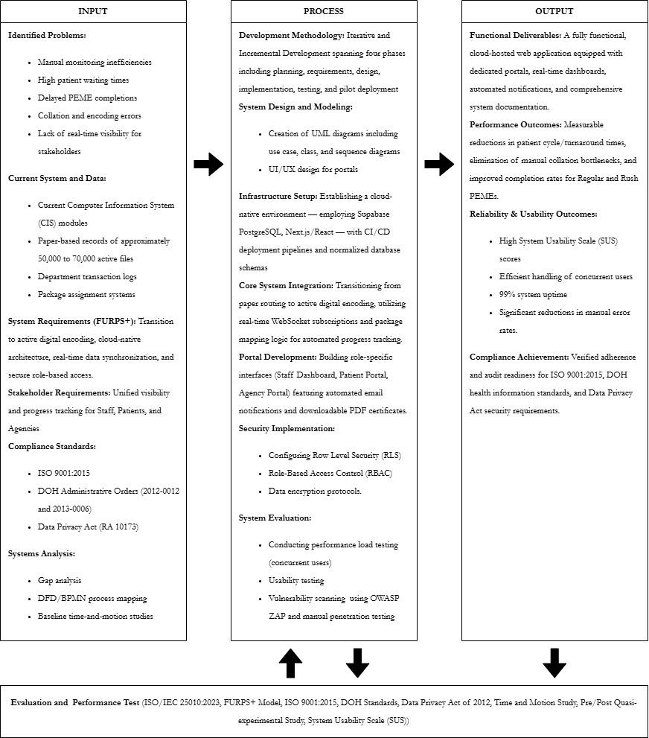
The Input block establishes the baseline conditions, core requirements, and constraints that drive the development of the proposed system. It begins with the identified problems, highlighting the operational inefficiencies of the current setup, such as high patient waiting times, delayed PEME completions, and manual collation errors. To address these, the study assesses the Current System and Data, which consists of existing Computer Information System (CIS) modules, extensive paper-based records, and department transaction logs. From this baseline, the system requirements (FURPS+) and stakeholder requirements are formulated, emphasizing the need to transition to active digital encoding, establish a cloud-native architecture, and provide unified, real-time progress visibility for staff, patients, and agencies. Furthermore, the inputs are guided by strict compliance standards, including ISO 9001:2015, Department of Health (DOH) Administrative Orders (2012-0012 and 2013-0006), and the Data Privacy Act of 2012 (RA 10173). Finally, systems analysis tools such as gap analysis, process mapping (DFD/BPMN), and baseline time-and-motion studies serve as the empirical foundation for designing the new system.

The Process block details the technical methodology, architectural design, and development phases required to transform the inputs into the desired outputs. The project utilizes an Iterative and Incremental Development Methodology spanning four distinct iterations, with each iteration completing planning, requirements analysis, design, implementation, testing, and pilot deployment. The phase initiates with system design and modeling, utilizing UML diagrams and UI/UX prototyping to structure the application. This is followed by infrastructure setup, which establishes a robust cloud-native environment using Supabase PostgreSQL and Next.js/React, supported by CI/CD deployment pipelines. A critical component of the process is the core system integration, which transitions the clinic from legacy paper routing to active digital encoding by utilizing WebSocket subscriptions and package mapping logic for real-time tracking. Portal Development involves building role-specific interfaces for staff, patients, and agencies, integrated with automated notifications and PDF certificate generation. Concurrently, strict security implementations—Row Level Security, RBAC, and encryption—and rigorous system evaluations—load testing, usability testing, and OWASP ZAP vulnerability scanning—are conducted to ensure system integrity and security throughout the development lifecycle.

The Output block represents the final deliverables and the measurable impacts of the newly developed system. The primary functional deliverable is a fully functional, cloud-hosted web application equipped with dedicated portals, real-time dashboards, automated notifications, and comprehensive technical documentation. The deployment of this system is expected to yield significant performance outcomes, specifically measurable reductions in patient cycle and turnaround times, the elimination of manual collation bottlenecks, and improved completion rates for both regular and rush PEMEs. In terms of reliability and usability, the system targets high System Usability Scale (SUS) scores, the efficient handling of concurrent users, a 99% system uptime, and a drastic reduction in manual error rates. Ultimately, the system serves as a compliance achievement, ensuring verified adherence and audit readiness for ISO 9001:2015, DOH health information standards, and data privacy regulations.

The Evaluation and Performance Test component is anchored in ISO/IEC 25010:2023 software quality characteristics and the FURPS+ model, employing validated methodologies from recent healthcare information technology research to ensure rigorous, evidence-based assessment of system effectiveness. Time-and-motion study methodology, following the approach established by Vignesh et al. (2024) in their tertiary outpatient department study, will measure patient flow efficiency, cycle times, waiting durations per department, and staff coordination activities through direct observation and timestamp recording at each patient transition point, enabling precise quantification of process improvements through comparison of pre-implementation baseline measurements against post-deployment performance. Pre/post quasi-experimental study design, validated by Mansoor et al. (2024) in their evaluation of healthcare educational interventions, will assess operational outcomes before and after system implementation by measuring changes in key performance indicators including PEME completion rates, rush case turnaround times, error frequencies, and staff-reported coordination burden, using statistical analysis to demonstrate measurable improvements and establish causal linkages between system deployment and performance gains. System usability will be quantitatively assessed using the standardized 10-item System Usability Scale questionnaire administered to staff users of the dashboard and external users of the patient portal, following the benchmarking framework established by Hyzy et al. (2022) in their meta-analysis of digital health applications, with target scores of 68 or above indicating above-average usability and scores in the 70 to 80 range representing good to excellent user acceptance. Compliance and security audit will conduct systematic verification of regulatory adherence through structured checklist evaluation against ISO 9001:2015 quality management requirements, Department of Health medical information system standards, and Data Privacy Act provisions governing patient data protection, consent management, access controls, and audit trail integrity, ensuring the system meets all mandatory legal and operational requirements for deployment in a Philippine healthcare setting. These evaluation results create a feedback loop, informing iterative refinements to the system design and implementation processes and ensuring continuous alignment with research objectives and stakeholder needs.

2.11 Analysis of Alternatives

2.11.1 Criteria Rationale
Six criteria guide the evaluation of alternatives for the PEME monitoring and result access system. Each criterion has a weight reflecting its importance to project success.

Table 2.2 Criteria Rationale
CRITERION | WEIGHT | RATIONALE
Compliance | 5 | Solutions must support or enforce all requirements stipulated under ISO 9001:2015, Department of Health minimum standards for medical information systems, and the Data Privacy Act of the Philippines. Loss of compliance can result in loss of operating licenses and patient safety incidents.
Security and Data Control | 5 | The security of patient data, internal auditability, and on-premise control is critical in medical information management. Systems must robustly prevent unauthorized access, loss, and leakage, while remaining subject to internal oversight.
Total Cost | 4 | This reflects both initial investment and operational expenditure over the expected system lifetime, including all hidden costs such as licensing, updates, training, and support.
Integration | 4 | New solutions must interact effectively with existing administrative and clinical systems, supporting business continuity and safeguarding historical data.
Scalability | 3 | The chosen system must remain effective and cost-efficient as patient loads increase, and reporting as well as legal requirements evolve over several years.
Support | 2 | Ongoing access to troubleshooting, updates, and maintenance is vital to minimize system downtime and maximize business resilience, but is of lesser weight compared to other critical criteria.

Compliance and security receive equal weight (5) because AHI operates under strict regulatory oversight. Loss of either creates legal and operational risk. Total cost (4) and integration (4) also receive high weight; the clinic cannot afford overruns, and new systems must coexist with existing workflows without disruption. Scalability (3) matters less immediately but becomes critical as the clinic's patient volume grows. Support (2) has the lowest weight because a well-designed system with solid documentation reduces ongoing dependency on external vendors.

2.11.2 Alternatives Considered
- Status Quo
The present system: paper monitoring forms, logbooks, in-person record management, Messenger/email for results, and established manual audit/compliance routines. This approach is fully compliant with ISO 9001, DOH, and DPA through documentary controls and strict staff procedure, and has repeatedly passed regulatory audits.
- Bespoke Solution
A bespoke, on-premise web solution developed for AHI, designed to fit exact PEME operational requirements, integrating real-time dashboards and secure portals for internal and external users. It is engineered to be fully aligned with existing partial-electronic, partial-paper processes and regulatory controls.
- Commercial HIS + PEME Module
A generalized, large-scale hospital information system provided by established vendors (e.g., Bizbox, Medsys). Includes various modules but is primarily targeted at general and specialty hospitals, requiring significant configuration or custom development to fit specialized PEME routines.
- Cloud-based Patient Management SaaS
A third-party subscription software platform (e.g., cloud EMRs, queue management SaaS). Allows fast online rollout and some workflow automation but hosts all sensitive data on external servers and offers only the configurability and compliance built into its shared-tenant model.
- Enhanced Manual Process + Spreadsheet Tracking
Current operations, but upgraded with staff-managed, shared spreadsheet solutions (Excel or Google Sheets) with macros for some real-time tracking and visual status, plus more rigorous manual data entry rules. This minimizes new cost while incrementally improving staff coordination, but still depends heavily on the discipline and skill of administrative staff.

2.11.3 Alternatives Decision Matrix
Five alternatives address the clinic's need to improve patient flow visibility and result access while maintaining compliance and security. The decision matrix evaluates each alternative against the six criteria using weighted scoring to identify the optimal solution.

Table 2.3 Alternatives Decision Matrix
 | Compliance (5) | Security & Data Control (5) | Total Cost (4) | Integration (4) | Scalability (3) | Support (2) | Total
Status Quo | 5 | 4 | 5 | 5 | 2 | 2 | 95
Bespoke Solution | 5 | 5 | 4 | 5 | 4 | 3 | 104
Commercial HIS + PEME Module | 4 | 4 | 2 | 3 | 5 | 5 | 85
Cloud-based Patient Management SaaS | 3 | 3 | 4 | 2 | 5 | 4 | 77
Enhanced Manual Process + Spreadsheet Tracking | 4 | 3 | 5 | 5 | 2 | 1 | 83

Status Quo (Score: 95):
The existing AHI process is proven compliant and sustainable under current volume and legal scrutiny. Manual processes, secured via key-controlled records rooms, signed logs, and paper dispute trails, are reliable in the short term. Integration is complete by default, and costs are contained within administrative budgets. Scalability is challenging; as volume, scrutiny, or data mining demands increase, the ability to rapidly retrieve, search, or re-audit records declines, and error or loss risk rises. Support is fundamentally limited to staff retraining and procedural adjustment.

Bespoke Solution (Score: 104):
This alternative scores highest overall. It enables exact mapping to every regulatory procedure and reporting demand, ensuring robust compliance. By retaining all data internally, it offers multidisciplinary access controls, role-based security, granular audit logging, and rapid incident response – all critical under the Data Privacy Act. While development costs are higher than off-the-shelf solutions, the absence of ongoing license or rental fees balances these over the system's useful life. This approach minimizes integration risks, as the system is built using current AHI procedures as the blueprint, ensuring a smooth deployment and minimal staff disruption. The custom system’s scalability is directly tied to hardware and modular code, and can be expanded or enhanced incrementally. Although ongoing support responsibility lies with AHI or its designated IT partner, this burden can be managed with robust documentation and a phased skills transfer.

Commercial HIS + PEME Module (Score: 85):
This alternative supports compliance and generally employs international standards, though it is not guaranteed to fit every unique PEME scenario without expensive customization or consulting. Security is typically strong, but access and incident management may be fixed to software vendor paradigms and may be harder to audit fully. Total cost is comparatively high due to enterprise licensing, mandatory upgrades, and potential consulting fees. Integration is moderate at best, as large HIS often expects to replace legacy systems rather than meaningfully interoperate with them. Scalability is excellent, as these systems are designed for hospital networks, but this is often beyond the true requirements of AHI. Vendor support is excellent, though it can generate additional cost with service contracts and is not always responsive to highly tailored workflows.

Cloud-based Patient Management SaaS Solution (Score: 77):
Cloud-based solutions expedite deployment and offer built-in scaling advantages, but strongly underperform on compliance and local regulatory auditability. Storing sensitive patient information on global, third-party infrastructure complicates legal defensibility and creates latent risk for patient data governance. While monthly costs are accessible, expense rises with system usage and as modules/features are added. True, lossless integration with existing, sometimes paper-based, workflow is rarely possible. Although support is usually reliable and remote, it may not include expertise targeting the Philippines' unique regulatory constraints.

Enhanced Manual Process + Spreadsheet Tracking (Score: 83):
This alternative is immediately actionable, offers improvement in transactional traceability, and can be utilized with minimal or no new cost. Excel or Google Sheets offer process mapping and low-complexity dashboard functions. However, compliance and security depend entirely on staff discipline, experience, and adherence to evolving templates or checklists. As volume increases, coordination failures, inconsistent data entry, and recovery difficulties from data loss or corruption are real threats. Integration is seamless since all staff are already trained for manual administration, but support limitations and eventual performance bottlenecks make this a transitional, not permanent, solution.

2.11.4 Matrix Discussion
The results demonstrate that a custom-developed web application, hosted and controlled locally by AHI, provides optimal alignment with compliance demands, security, cost management, integration sensitivity, and the clinic’s future expansion direction. The existing manual process, while compliant and cost-efficient, fundamentally lacks the transparency, efficiency, and forward-compatibility now expected by client companies, agencies, and future regulators. Improved manual tracking is suitable as a temporary bridge but should not be considered a long-term solution. Commercial hospital information systems and cloud-hosted offerings provide some short-term wins but introduce either budgetary or regulatory exposures that outweigh their benefits for an ISO 9001-certified, compliance-focused outpatient clinic. The decision is thus substantiated by both operational evidence and best-practices decision analysis.

Chapter 3

PROJECT METHODOLOGY AND TECHNICAL BACKGROUND

3.1 System Analysis
This section translates the problems, objectives, and scope identified in the earlier chapters into a structured description of the proposed AHI PEME Information System. It defines the system boundary, the external entities that interact with the system, and the flow of information between them. The analysis focuses on how PEME cases, examination statuses, and result releases are recorded, monitored, and accessed by the different user roles. This provides the logical foundation for the detailed design, database structure, and functional and non-functional requirements presented in the succeeding sections.

3.1.2 Context Data Flow Diagram
The context diagram illustrates the Pre-Employment Medical Examination (PEME) system as a single, high-level process and identifies the numerous external entities that interact with it. The process encompasses all activities in conducting and releasing PEME results for clients and their employees.
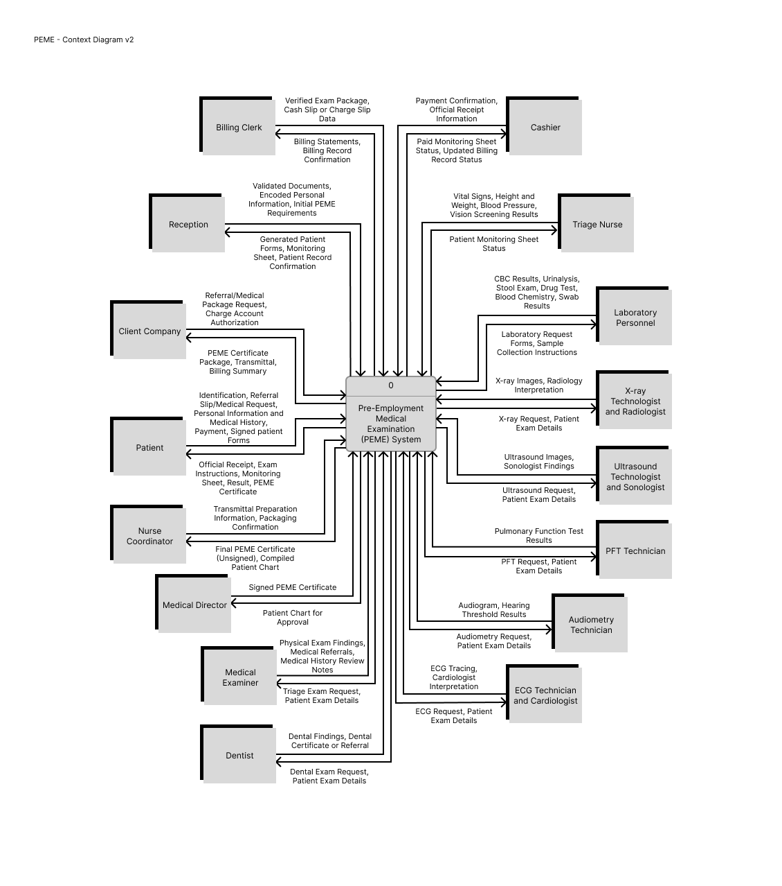
Figure 3.1 PEME - Context Diagram
The patient entity is the individual applicant whose capability to work is being determined and who must provide all necessary entry information to begin the PEME process, including personal identification, personal information, medical history, the employment referral slip or medical request, and signed forms. The system is designed to acquire financial inputs through the patient, receiving either direct payment or charge account authorization, depending on the billing arrangement with the client company. In return, the system provides several key outputs for the patient: the official receipt, examination routing instructions, the monitoring sheet—with payment confirmation, if applicable—, and ultimately, a copy of their final PEME results or certificate.

The client company is the entity that formally requests the medical services for the applicant, thereby initiating the PEME process. In some cases, the company often handles the financial arrangement, providing the necessary charge account authorization when examination fees are billed rather than paid by the patient. After the PEME is completed, the system sends back the results in the form of a packaged set of documents containing the PEME certificate, billing summary, and a transmittal form.
The reception entity forwards the validated documents, encoded personal information, and the initial PEME requirements of the patient to the system, and receives back the generated patient forms, monitoring sheet, and patient record confirmation. The billing clerk receives cash-slip or charge-slip data and provides verified billing endorsements. The system outputs the billing statements back to the billing clerk.

Multiple medical departments act as external entities, each receiving examination requests and patient exam details from the system and returning their corresponding examination results. These entities are responsible for conducting the requested medical examinations for the employees, including triage nurse, laboratory personnel, X-ray technologist and radiologist, ultrasound technologist and sonologist, PFT technician, audiometry technician, ECG technician and cardiologist, dentist, and medical examiner. Then, the nurse coordinator entity collates all the examination results into a collated patient chart. The medical director entity receives the patient chart and signs a draft PEME certificate. Finally, the nurse coordinator packages these results and confirms the transmittal preparation for delivery.

3.1.3 Level 0 Data Flow Diagram
The level 0 data flow diagram expands the single process shown in the context diagram into four major subprocesses that represent the internal workflow of the American Hospital Inc. PEME operations. This includes receiving patient information, processing billing and payment, conducting medical examinations, and compiling and releasing PEME results.
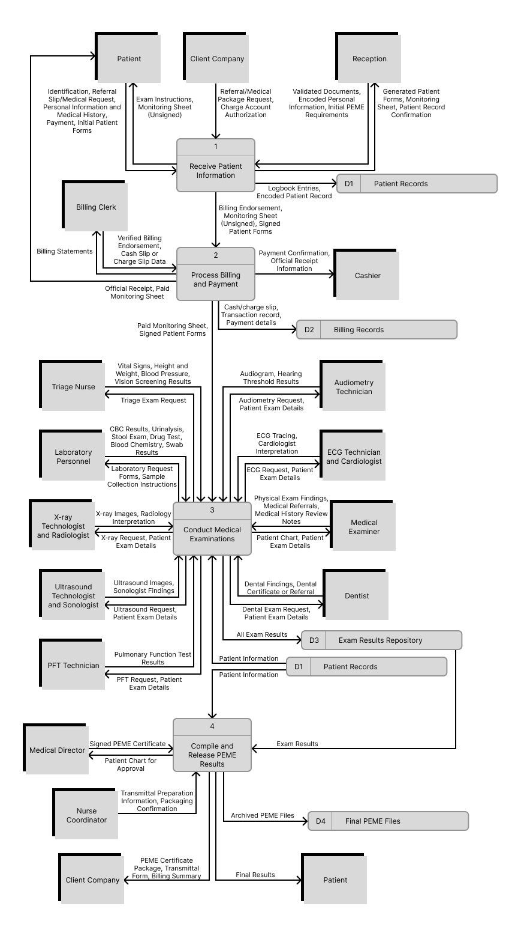

Figure 3.2 PEME - Level 0 Diagram
The subprocess on receiving patient information, primarily managed by the reception staff, handles admission procedures. The process begins with the patient providing the necessary documents—identification, the referral slip or medical request, personal information, and medical history. Then, the clinic validates these documents, logs the patient details, prepares the necessary forms, and encodes patient information into the patient records data store. The output of this process includes the patient monitoring sheet, exam instructions, as well as a billing endorsement forwarded to the billing process.

Following the reception endorsement, the billing department performs the subprocess on billing and payment, receiving the patient encoded information and billing endorsement from the previous subprocess as inputs. Depending on the payment method, it generates either a cash slip or charge slip and records payment details in the Billing Records data store. The patient receives an official receipt and a paid monitoring sheet stamped as “PAID”. This paid monitoring sheet is then sent to the succeeding process as authorization to proceed.

Using the paid monitoring sheet and patient information from the Patient Records data store, the subprocess on conducting medical examinations is the core operational subprocess where all required diagnostic tests are performed—laboratory, radiology, ECG, ultrasound, dental, physical exam, and psychological evaluation test. All diagnostic findings are consolidated and stored in the exam results repository data store. These stored results become the primary input for the final compilation process.

In the final subprocess on compiling and releasing PEME results, all accumulated medical findings are consolidated, reviewed, certified, and officially delivered to the client company. Exam results from the exam results repository and patient information from the patient records data store are retrieved as inputs for this subprocess. The nurse coordinator collates and reviews all results from the various service units, prepares a transmittal form, and then transcribes the results into the final PEME Certificate Encoder Form. The medical director then signs the final certificate. This subprocess outputs the final PEME certificate, which is stored in the final PEME files data store. The packaged set of results are sealed and delivered to the client company along with a transmittal form.

3.1.4 Explosion Levels
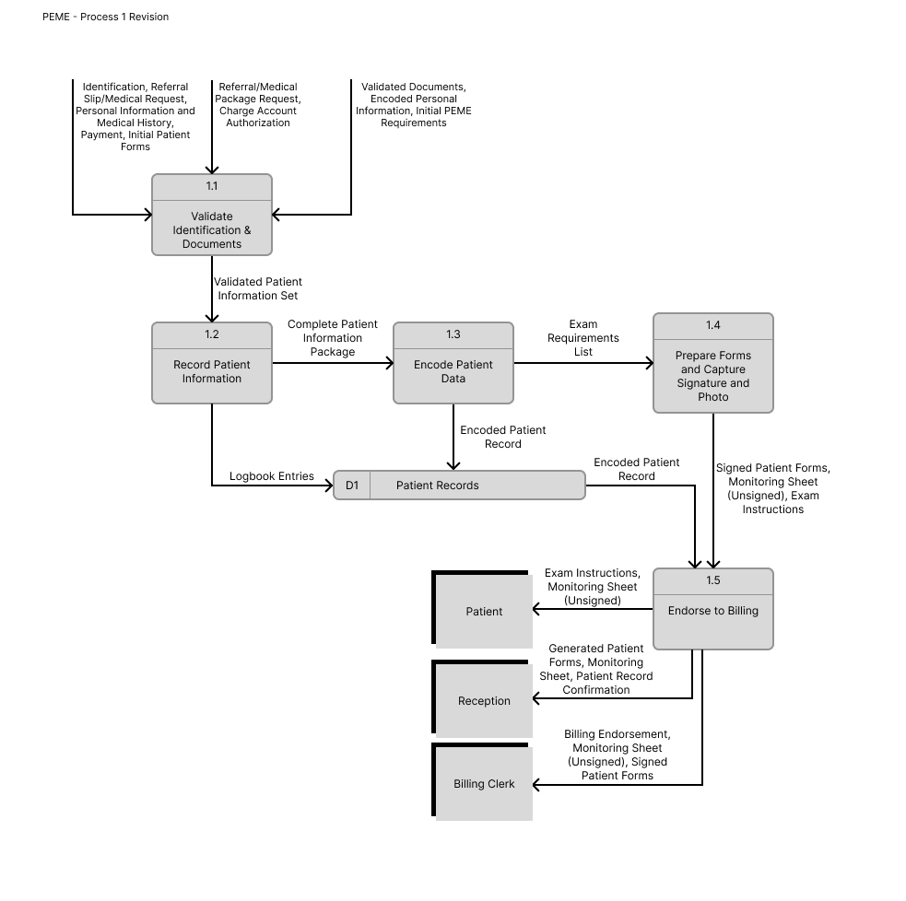
Figure 3.3 Process 1 - Patient Receiving Data Flow
Process 1, patient receiving, manages patient check-ins and registration for pre-employment medical examinations. First, the patient provides all identification documents, referral slips, medical requests, and personal or medical history forms, as requisites to be validated by the reception staff. Once the documents are validated, the patient information and declared history are logged and encoded into the system, creating an official patient record stored in the Patient Records data store. After encoding, the system generates the necessary PEME documents such as the monitoring sheet, exam instructions, and patient forms. Concurrently, a photograph and signature are captured from the patient. When all forms and data have been completed, the patient is endorsed to the billing and payment process, along with the billing endorsement, monitoring sheet, and signed patient forms.

This process is the starting point of the operation’s reliance on a paper-based and department-segment system. The sub-processes, particularly 1.1 and 1.2, involve handling initial patient forms. Since the system lacks automated queue management or integrated flow monitoring at this entry point, the manual handling and documentation verification directly contribute to the fact that patient waiting time averages 2.6 hours across all departments. This reliance on physical records also contributes to the heavy manual burden later faced by the releasing staff and nurse coordinators involved when performing historical retrieval for re-medical examinations.
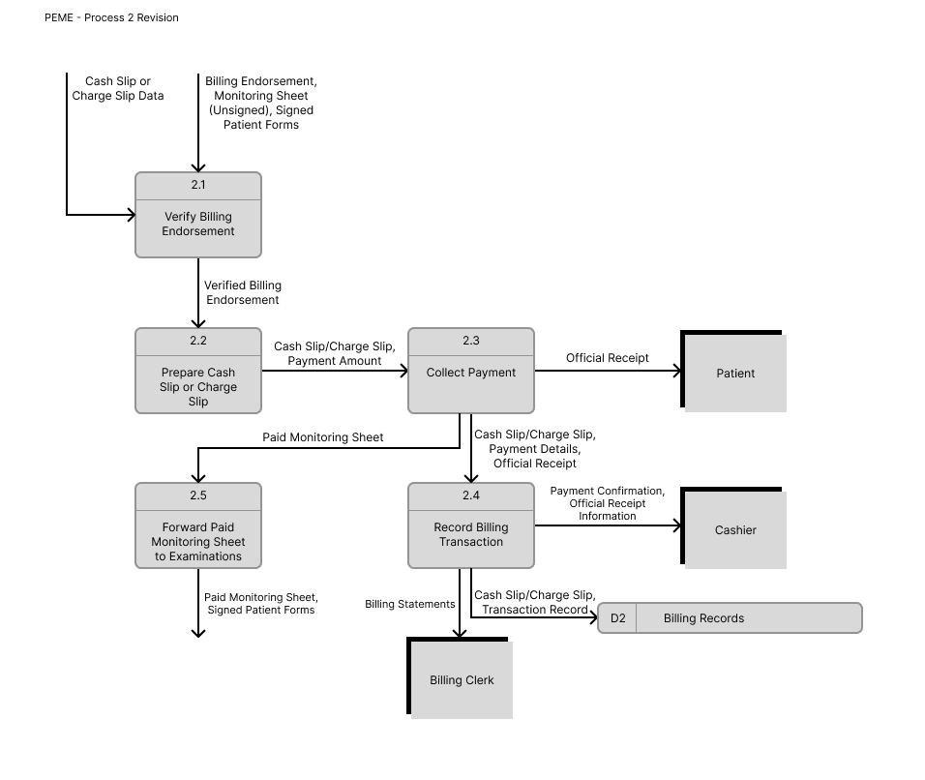
Figure 3.4 Process 2 - Billing and Payment Data Flow
Process 2, billing and payment, handles cash and charge payments and ensures that the correct amount is paid by the patients. The process begins when the documents—billing endorsement and monitoring sheet—from the previous process are received and checked by the billing clerk. This is to ensure that the correct examination package is assigned based on the patient’s company requirements or PEME referral details. Following this, the billing clerk prepares either a cash slip or charge slip, which serves as the basis for payment. The patient then proceeds to payment collection, where the cashier collects the cash payment, checks the correctness of the amount, issues an official receipt (OR), and marks the monitoring sheet as “PAID.” Details from the transaction—including the cash or charge slip, payment information, and receipt—are recorded into the Billing Records data store. The paid monitoring sheet is then forwarded to the medical examinations process, allowing the patient to proceed with their diagnostic tests.

From verifying billing endorsement to manually stamping on the patient monitoring sheet, like process 1, the time consumed in this sequential, manual verification and payment step contributes to the overall average patient waiting time to 2.6 hours. Furthermore, the lack of immediate status confirmation during this process means that external entities, particularly agencies, submit 50 to 60 status inquiries weekly because they cannot automatically verify if the patient has completed the initial administrative and payment phases.
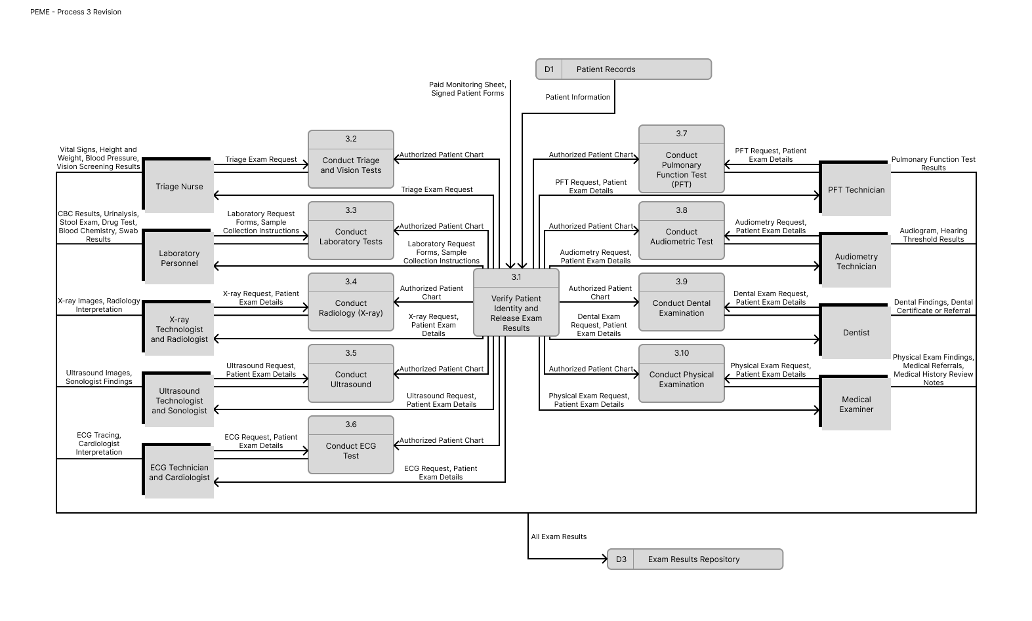
Figure 3.5 Process 3 - Medical Examinations Data Flow
Process 3, medical examinations, encompasses all medical and diagnostic tests. It receives the paid monitoring sheet, signed patient forms, and patient information from the billing and patient receiving processes. The system first verifies the identity of the patient using these documents and prepares an authorized patient chart, which consolidates all encoded data and serves as the central reference for every diagnostic test. Using the authorized patient chart, the patient proceeds through a branch of examinations such as triage and vision checking, laboratory tests, radiology, ultrasound, ECG, pulmonary function testing, audiometric testing, dental examination, and physical examination. Each examination generates its own outputs, including vital signs and vision test results, laboratory results, x-ray images and interpretations, ultrasound reports, ECG readings, audiograms, dental findings, and physical examination findings. All these diagnostic outputs are submitted to the Exam Results Repository, where they are stored as part of the complete PEME result set of the patient.

The most significant operational failure occurs within this process, where the flow of patient requests and results is fragmented across numerous external medical departments. Figure 3.5 shows sub-process 3.1 connecting flows with entities like laboratory personnel and the X-ray technologist. Major bottlenecks can be identified in these points, where the examination is manually tracked through the patient monitoring sheet. This reliance on a segmented, paper-based system results in 224 documented result collation incidents monthly. In addition, because there is no systemic notification where departments finish their work, completed results remain idle for one to three hours after completion, as mentioned in chapter 1.

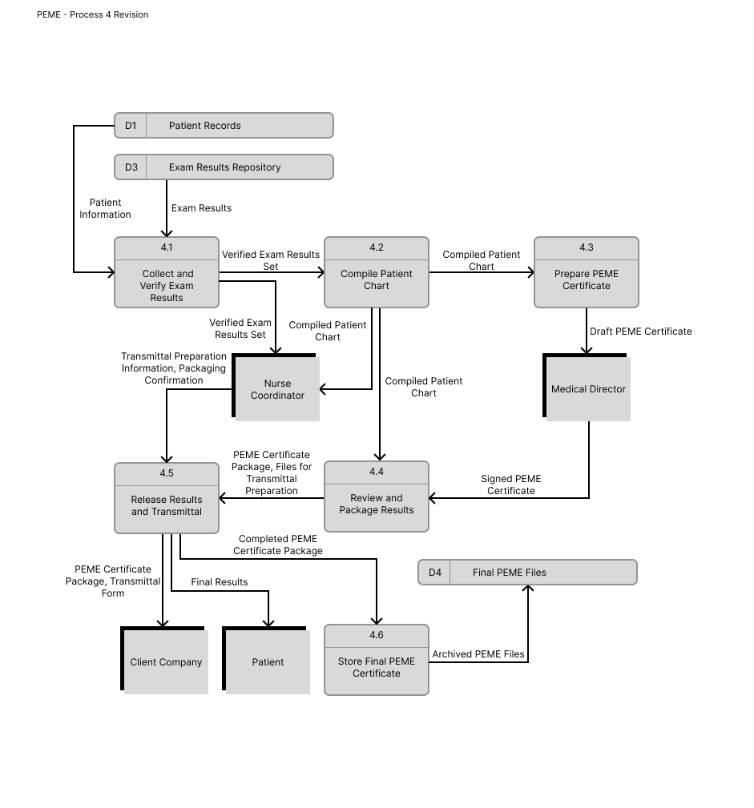
Figure 3.6 Process 4 - Compilation and Releasing of Results Data Flow
Process 4 involves the consolidation, certification, packaging, and final release of the patient PEME results. The patient examination results are retrieved from the exam results repository, along with their personal information from the patient records data store. These documents are collated and reviewed by a nurse-coordinator to create a collated patient chart. This chart is encoded and used to prepare the draft of the PEME certificate. This draft is then reviewed and formally signed by the medical director to create the official signed PEME certificate. Afterwards, the certificate and examination results are compiled into a PEME certificate package, which is forwarded to the client company. A transmittal form is also prepared and sent to the company to document the release of results. Concurrently, the signed certificate and collated patient chart are archived as a final PEME certificate file in their data store for record-keeping.

This final administrative process introduces failures related to quality control and finalization. The nurse coordinator manages sub-processes like 4.1 and 4.3, which require manually retrieving exam results from the exam results repository and patient information from the patient records. This necessary collation and transcription step is where data duplication occurs, such that all patient information is entered twice. This results in the documented encoding and transcription incidents that occur monthly, and leads to delays in release of results, where medical examinations fail to meet the time completion targets for both regular and rushed cases.

3.1.5 Business Process Modeling and Notation (BPMN)
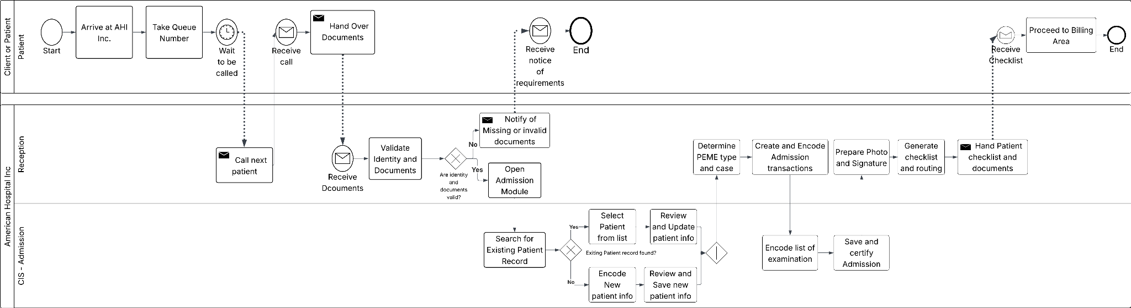
Figure 3.7 Process 1 – Receive and Admit Patient
Figure 3.7 begins when the patient arrives at American Hospital Inc. and joins the queue at Reception. The patient waits until called to the counter. The receptionist then verifies identity through valid ID and checks the company referral slip and logbook entry. Patients with incomplete or invalid requirements are informed and advised to return once requirements are complete, while only those with complete documents move forward in the process.

For patients who pass verification, the receptionist opens the Admission module and searches for an existing patient record. If a record exists, demographic and employer details are reviewed and updated as needed, then saved. If no record exists, the receptionist encodes the patient’s demographic information, employer or agency details, and identifiers such as passport number, and the system creates a new patient record with a unique identifier. The receptionist then determines the type of PEME case based on the referral, such as initial PEME, re-medical, additional tests, or repeat exam, and whether it is land-based, sea-based, or country-specific. When necessary, the receptionist clarifies unclear instructions with the agency.

Once the PEME type is identified, an Admission transaction is created that links the patient record, the agency, and the case classification. The receptionist encodes an initial list of required examinations according to the employer package and age group, which Billing will later verify. The Admission transaction is saved, and the system generates a patient checklist or route form listing all departments the patient must visit, with spaces for signatures and time in and time out. The receptionist explains the next steps, hands the checklist and documents to the patient, and directs the patient to the Billing area. At this point, Process 1 ends and the case is handed off to Process 2.

Process Issue and Flow Mistake in Process 1
In the current Process 1, Reception acts as a bottleneck because the queue and processing times are not measured or monitored. Patients wait in line without any recorded timestamps for arrival, calling, or completion, so staff cannot see how long patients have been waiting or how many are in the queue. Chapter 1 already identifies long waiting times and turnaround failures as key problems, but the admission process does not generate any data that would allow AHI to analyze or manage congestion at this entry point. This lack of basic time and queue monitoring in Reception is a process mistake because it hides a critical source of delay in the PEME workflow.
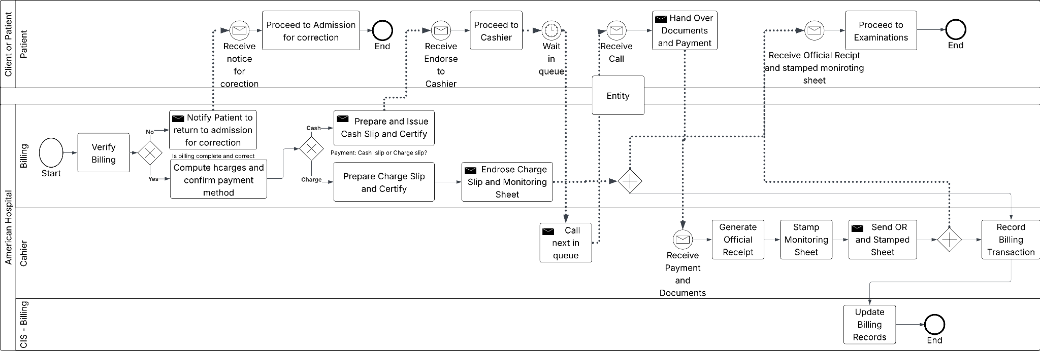
Figure 3.8 Process 2 – Assess Fees and Process Payment (Billing & Cashier)
Figure 3.8 begins when an admitted patient from Process 1 is endorsed to Billing together with the monitoring sheet and supporting documents. The billing clerk retrieves the Admission transaction in the billing module, verifies that the patient identity, employer, PEME type, and initial list of examinations match the referral and company instructions, and checks that the monitoring sheet and signed forms are complete. If any information is inconsistent or incomplete, the clerk informs the patient and sends the case back to Admission for correction. Only when the endorsement is complete and correct does the billing clerk continue with costing.

For a correct endorsement, the billing clerk computes the total charges for the PEME package and any additional tests based on the verified exam list. The clerk confirms the payment mode, either cash payment by the patient or charge to the company. This decision is represented in the BPMN by a gateway that separates the flow into a cash branch and a charge branch. In the cash branch, the clerk prepares and issues a cash slip and certifies the bill. The cash slip, monitoring sheet, and documents are endorsed to the Cashier, while the patient proceeds to the cashier area and waits in the queue.

In the Cashier lane, the cashier calls the next patient in the queue, receives the cash slip and payment, and confirms that the amount is correct. The cashier issues the official receipt, stamps “PAID” and the receipt number on the monitoring sheet, and returns the receipt and paid monitoring sheet to the patient. The billing record in the system is updated to reflect full payment, and the transaction becomes ready for use by the examination departments. In the charge branch, the billing clerk prepares and certifies a charge slip instead of a cash slip. The charge slip and monitoring sheet are endorsed directly to photo capturing and the examinations flow, and the system records the transaction as a company charge rather than a cash payment. In both branches, Process 2 ends when the billing transaction is recorded and the paid or charge-endorsed monitoring sheet is forwarded to examinations.

Process Issue and Flow Mistake in Process 2
In the current Process 2, Billing and Cashier perform separate manual verification, costing, payment collection, and stamping steps without any real-time link to examination progress or to the incident and turnaround metrics identified in Chapter 1. Charges are computed and recorded per case, but the system does not automatically check that the final list of examinations billed is identical to the examinations actually performed, and it does not track queue times at Billing and Cashier or the number of cases waiting at each stage. Chapter 1 showed that result collation has 224 incidents per month and that overall waiting time averages 2.6 hours, with failures to meet 24-hour and 72-hour turnaround targets. However, the billing and payment process does not generate or surface the operational data needed to see mismatches between billed tests and completed tests or to manage congestion at the financial counters. This lack of integrated validation and queue monitoring in Process 2 is a flow mistake because it contributes to downstream collation errors and extended turnaround times, even though these are already recognized as major problems in the earlier chapters.
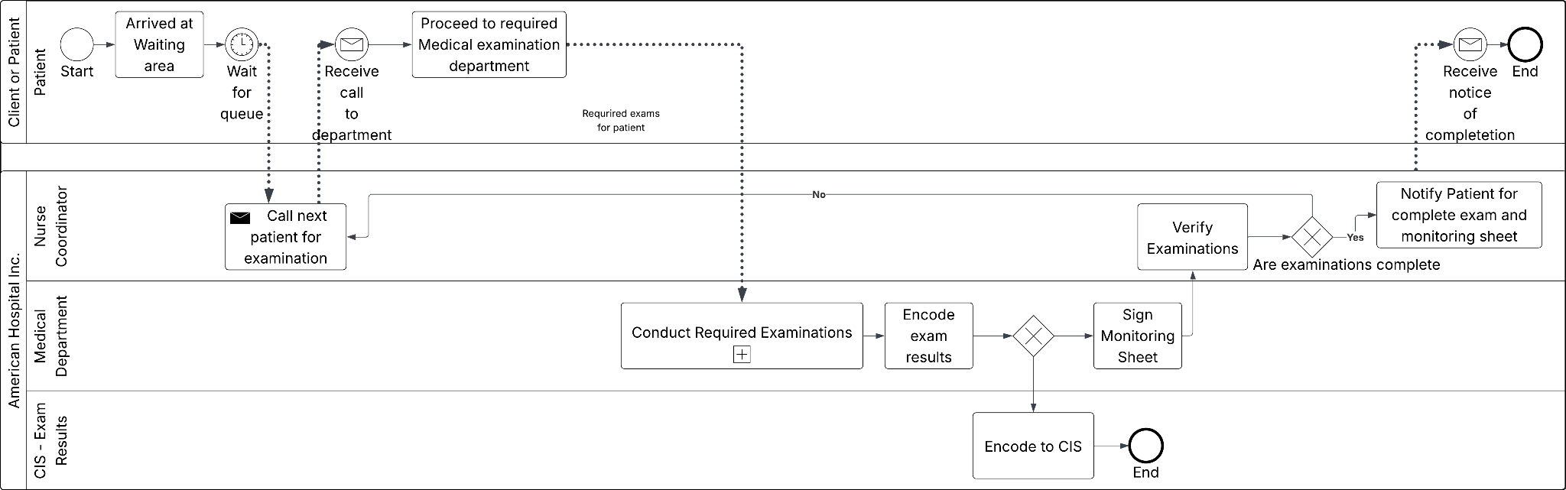
Figure 3.9 Process 3 – Conduct Medical Examination
Figure 3.9 begins when the paid or charge-endorsed monitoring sheet and signed patient forms from Billing are received at the examination area. The patient proceeds to the examination waiting area, presents the monitoring sheet, and waits until called. The exam reception or nurse coordinator receives the chart, verifies the patient’s identity against a valid ID and the monitoring sheet, and checks that the PEME package, agency, and list of required examinations match what was endorsed from Billing and encoded in the system. If there are discrepancies or missing documents, the nurse coordinator clarifies the case or sends the patient back to Billing or Admission for correction. Only when the chart and monitoring sheet are complete does the nurse coordinator authorize the patient chart for examinations and log the start of the examination phase in the clinical information system.

Once the chart is authorized, the process enters the subprocess Conduct Required Examinations. In this subprocess, the patient moves between several clinical departments according to the required PEME package. At triage, the nurse records vital signs and vision findings on the chart and in the system. In the laboratory, staff collect specimens, run the ordered tests, and record results on laboratory forms and in the laboratory module. Radiology performs chest X-ray and issues a formal interpretation. Other departments such as ultrasound, ECG, pulmonary function testing, audiometry, dental, and physical examination follow similar patterns. Each unit verifies patient identity, performs the ordered procedure, documents findings on paper forms and logbooks, signs the monitoring sheet, and encodes results in its respective CIS module. The examinations may occur in different orders depending on patient flow and resource availability, and coordination relies on the monitoring sheet and department logbooks rather than a shared real-time status view. When the patient has completed the sequence of required examinations, the chart returns to the nurse coordinator, who manually checks the monitoring sheet and department outputs to determine whether all examinations defined in the PEME package have been completed and encoded before endorsing the chart to the next process for collation and final medical evaluation.

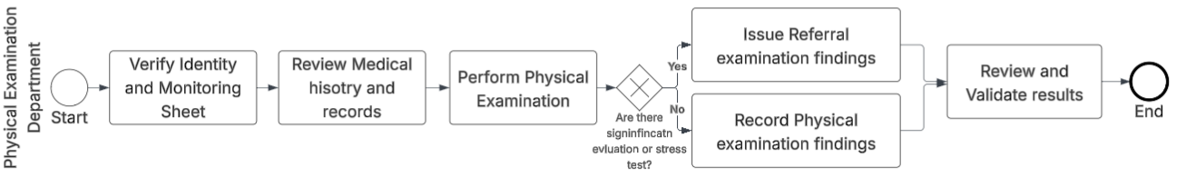

Figure 3.10 Physical Examination Department
Figure 3.10 shows how the Physical Examination Department conducts the core clinical assessment for a PEME case. After the patient is identified and signs the PE logbook, the physician or PE nurse interviews the patient to obtain past medical, family, and social history, then performs a focused physical examination and orders referrals if needed. The encounter ends with the completion of the physical examination portion of the PEME working copy, which becomes a key input for the physician’s final fitness decision and for downstream departments that may require clinical context.
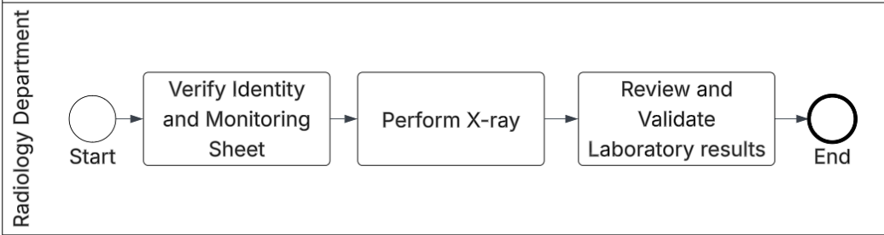
Figure 3.11 Laboratory Department
Figure 3.11 describes the end-to-end handling of laboratory tests requested for the PEME. The process starts when staff receive the printed lab request forms, verify patient identity against the logbook, and print or prepare specimen labels based on the order details. Specimens (blood, urine, stool, and other samples) are then collected and processed according to test protocols, after which results are run on analyzers, validated, and recorded in the laboratory results repository. The completed and verified lab results are subsequently made available to the physician and releasing staff as part of the consolidated PEME findings.
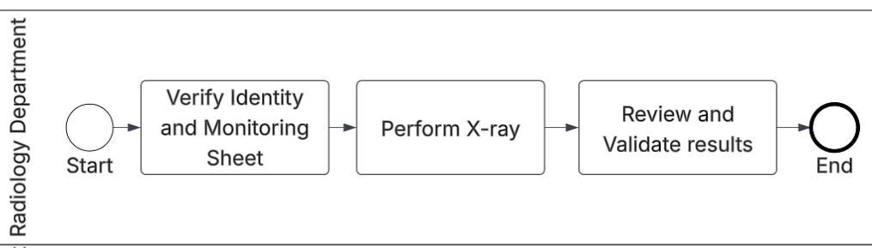
Figure 3.12 X-Ray Department
Figure 3.12 outlines the workflow for radiographic examinations within the PEME. Staff encode the patient’s details and requested view (for example, chest PA) in the X-ray information system, then perform the radiographic procedure following standard positioning and radiation-safety protocols. After image acquisition, a radiologist reviews the films or digital images, documents radiologic impressions and significant findings, and finalizes the X-ray report. The approved report is then returned to the PEME record as an official diagnostic input for fitness assessment.

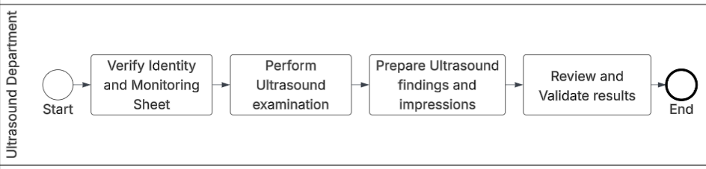
Figure 3.13 Ultrasound Department
Figure 3.13 presents the ultrasound examination flow for PEME clients. The process begins with verification of the patient’s identity and logging in the ultrasound (UTZ) logbook, after which the sonologist or sonographer carries out the requested ultrasound study (such as abdominal or OB scan). Once scanning is completed, the sonologist prepares a structured ultrasound report summarizing key measurements and observations, signs or validates the findings, and forwards the original report to the PEME file. This ensures that imaging-based information is properly documented and can be reviewed by the physician during decision-making.
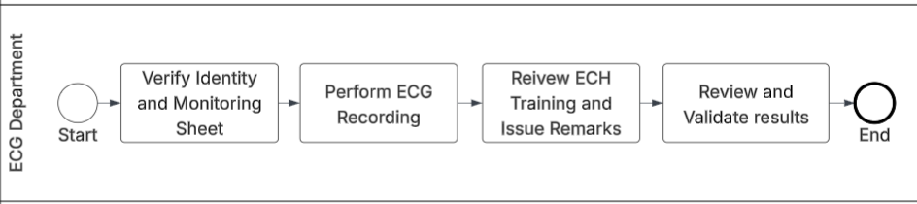
Figure 3.14 ECG Department
Figure 3.14 captures the ECG department’s handling of cardiac tracing for PEME clients. Staff first confirm patient identity and record the visit in the ECG logbook, then apply electrodes and conduct the ECG recording according to standard protocol. The raw tracing is printed or stored, and a cardiologist or designated interpreter reviews the strip, annotates any abnormalities, and records the final ECG interpretation. The signed interpretation sheet is then attached to the PEME record as objective evidence of cardiac status.
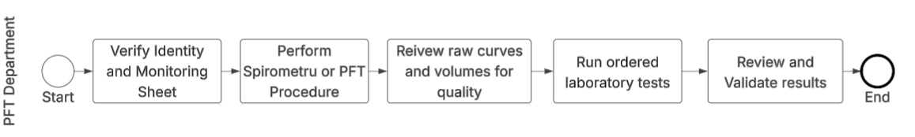
Figure 3.15 Pulmonary Function Test (PFT) Department
Figure 3.15 explains the spirometry or PFT workflow used to evaluate pulmonary function as part of PEME. After verifying the patient’s identity and logging the visit, the PFT nurse or technician performs the spirometry test, guiding the patient through repeated maneuvers to obtain acceptable and reproducible curves. The system prints the spirometry result with key parameters (such as FEV₁ and FVC), which is then reviewed by the attending physician or pulmonologist. The physician documents an interpretation (normal, obstructive, restrictive, or mixed pattern) and this signed interpretation is filed into the PEME chart for final fitness evaluation.
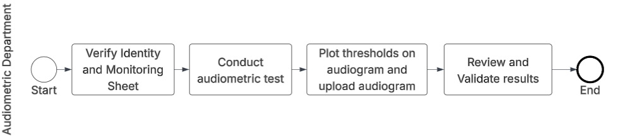
Figure 3.16 Audiometry Department
Figure 3.16 summarizes the audiometry process for assessing hearing status. The visit begins with identity verification and registration in the audiology logbook. The technician then positions the patient inside the audiometric booth, provides instructions on how to signal perceived sounds, and runs the audiometric test by presenting tones at varying frequencies and intensities. Thresholds are plotted to produce an audiogram, which is interpreted to determine the degree and type of hearing loss, if any. The completed audiogram and interpretation are added to the PEME record to inform decisions for noise-exposed or safety-sensitive jobs.
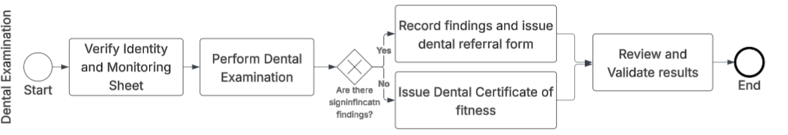
Figure 3.17 Dental Department
Figure 3.17 describes the dental examination workflow and its decision branch. After confirming patient identity and logging the visit, the dentist conducts an oral examination to check for caries, periodontal disease, and other conditions. The process then diverges based on the findings: if no disease requiring treatment is detected, the dentist issues a dental certificate indicating clearance for deployment; if active disease is found, the dentist issues a dental referral and instructs the patient to return with proof of completed treatment before clearance can be given. In both cases, the outcome (certificate or referral) is documented and linked back to the PEME record as part of the overall fitness assessment.

Process Issue and Flow Mistake in Process 3
In the current Process 3, examination progress is controlled by a paper-based and department-segmented system of monitoring sheets, charge slips, and manual logbooks rather than an integrated, real-time view of patient status across departments. Staff in each unit perform and encode their own results, but there is no automatic confirmation that all examinations required by a specific PEME package have corresponding entries in the clinical information system before the case is treated as complete. The nurse coordinator discovers missing or delayed examinations only during manual status verification across departments near the end of the process. Chapter 1 reported that result collation encounters 224 documented incidents monthly, including 85 pending laboratory results, 64 incomplete radiology submissions, and additional incomplete ECG, dental, physical, and psychology results, and that completed results can remain idle for one to three hours because releasing staff have no systematic notification when all departments have finished their work. Patient waiting time averages 2.6 hours and both regular and rush PEME cases fail to meet the 72-hour and 24-hour service level targets respectively.

This examination-stage design is a concrete manifestation of the structural problem identified in Chapter 1, which is the absence of real-time visibility into patient progress and examination status. Because Process 3 does not generate or expose continuous completion status across departments, staff must rely on manual status verification and paper-based coordination before collation and releasing can proceed. This process mistake directly contributes to the high number of result collation incidents, idle completed cases, and prolonged turnaround times that the study seeks to address.
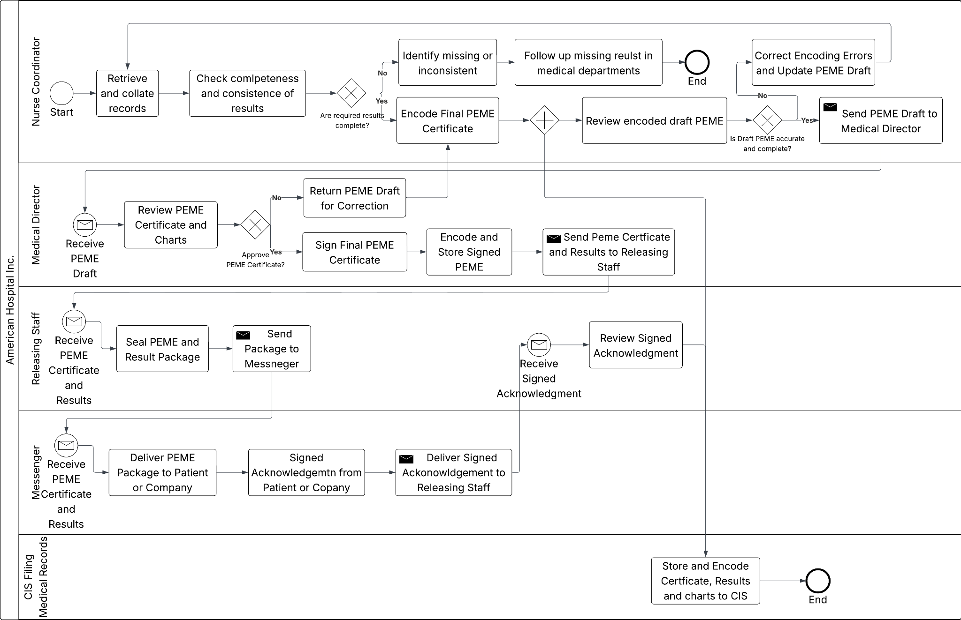
Figure 3.18 Complete Chart & Release PEME
Figure 3.18 starts when the nurse coordinator receives the authorized patient chart and examination results from the previous process. The nurse coordinator retrieves and collates records from the chart, monitoring sheet, and exam results repository, then checks whether all required results for the PEME package are complete and consistent. If any result is missing or inconsistent, the coordinator identifies which department is responsible and follows up with the concerned unit. In this case the process for that patient temporarily stops at the collating stage and only resumes once the missing results have been supplied. When all required results are present and consistent, the nurse coordinator proceeds to encode the final PEME certificate in the releasing module, selecting the correct template for land based, sea based or country specific formats and summarising the examination findings.

After encoding, the nurse coordinator reviews the draft PEME certificate against the collated chart and working forms. If there are encoding errors or omissions, the draft is corrected and updated in the system before being sent to the Medical Director. Once the draft is accurate and complete, the nurse coordinator transmits it to the Medical Director, who reviews both the PEME certificate and the supporting chart. If the Medical Director does not approve the certificate, it is returned for correction and the nurse coordinator revises the draft. If the certificate is approved, the Medical Director signs the final PEME certificate and the signed version is encoded and stored in the final certificates repository. The signed PEME certificate and supporting examination results are then sent to the releasing staff.

In the releasing lane, staff receive the signed PEME certificate and results, assemble the PEME package including the certificate, laboratory reports, imaging reports, and other required documents, and seal the package for release. The package is endorsed to the messenger who delivers it either to the patient or to the client company and obtains a signed acknowledgement of receipt. The messenger returns the signed acknowledgement to the releasing staff, who review it and confirm that the package was received by the correct party. Finally, the filing and records staff store the collated patient chart and final PEME certificate in accordance with the clinic’s filing policies and encode the completion of the case in the clinical information system, marking the end of the PEME episode for that patient.

Process Issue and Flow Mistake in Process 4
In the current Process 4, result collation and certificate preparation rely on a paper-based and department-segmented workflow instead of a single, reliable system view. The nurse coordinator manually retrieves results from multiple departments, checks completeness by inspection, and then re-types key findings and final decisions into the PEME certificate template. The Medical Director then reviews this manually compiled draft and, if errors or omissions are found, returns it for further manual correction and re-encoding. The same information is encoded again when the signed certificate is stored and when the completion of the case is marked in records. Chapter 1 reported that result collation encounters 224 documented incidents per month, including numerous pending or incomplete laboratory and radiology results and additional incomplete ECG, dental, physical, and psychology outputs, and that completed results may remain idle for one to three hours because releasing staff have no systematic notification that all departments have finished their work. These incidents include encoding errors, transcription errors, and collation errors that arise precisely because the final PEME certificate is constructed through repeated manual compilation and re-encoding of data that already exist in separate CIS modules. This design in Process 4 is therefore a direct manifestation of the structural problem identified in Chapter 1, the absence of real-time visibility and automated cross-checking of examination status and results and it contributes to the high collation incident counts and prolonged turnaround times that the study aims to address.

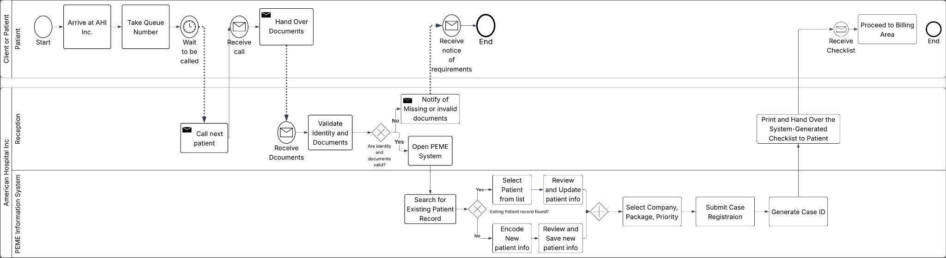

Figure 3.19 - With PEME System for Admit Patient
The process begins when a patient arrives at AHI, takes a queue number, and waits to be called. The reception staff calls the next patient, receives their documents, and validates identity and submitted requirements through the PEME Information System. If documents are invalid or incomplete, the system sends an automated notification to the patient detailing thse missing or invalid items, and the process ends at that branch. If documents pass validation, the reception staff opens the PEME System, which then searches for an existing patient record. If a record is found, the system presents it for review and update; if no record exists, staff encode a new patient profile and save it. Either path converges at package assignment, where staff select the company, PEME package, and priority level , regular or rush , before submitting case registration. The system generates a unique Case ID, after which the reception staff prints and hands over a system-generated checklist to the patient, who then receives it and proceeds to the billing area.
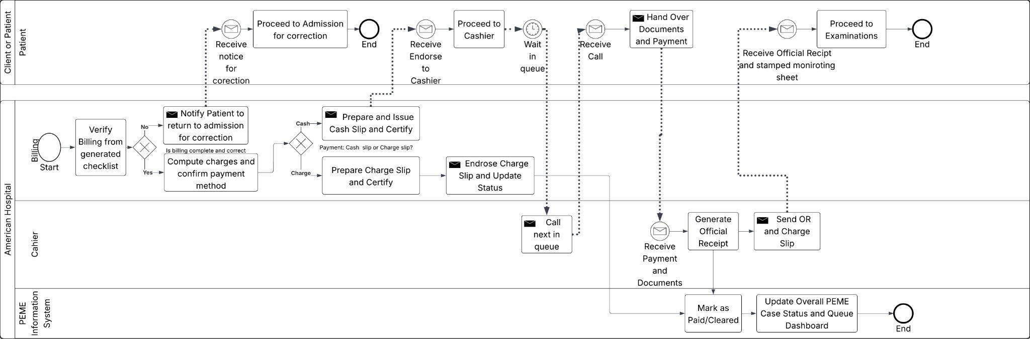
Figure 3.20 - With PEME System for Billing
The billing process begins when the Billing staff verify the billing details pulled from the system-generated checklist produced in Process 1. The system checks whether the billing is complete and correct if not, the Billing staff send an automated notification to the patient to return to admission for correction, the patient receives the notice, proceeds back to admission, and the process closes at that branch. If billing is correct, the Billing staff compute the total charges and confirm the payment method. For cash payments, a cash slip is prepared and certified; for charge or corporate accounts, a charge slip is prepared, certified, endorsed, and the payment status is updated in the system. The Cashier lane then takes over the system calls the next patient in queue, and once the patient receives the call, they proceed to the cashier, wait in queue, and upon being called, hand over their documents and payment. The Cashier receives the payment and documents, generates an official receipt, and sends both the official receipt and charge slip back through the system. The PEME Information System then automatically marks the case as paid and cleared, updates the overall PEME case status, and refreshes the queue dashboard to reflect the cleared patient formally signaling that the patient is ready to proceed to examinations. The patient receives the official receipt and stamped monitoring sheet and proceeds to the examination area, ending Process 2.
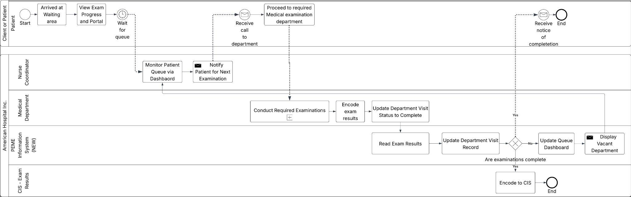
Figure 3.21 - With PEME System for Conduct Medical Examination
Once cleared from billing, the patient arrives at the waiting area and immediately gains access to the Patient Portal to view their real-time examination progress and pending departments. The nurse coordinator monitors the patient queue through the system dashboard and sends a notification to call the next patient for their required examination. Upon receiving the call, the patient proceeds to the designated medical department, where department staff conduct the required examinations via a collapsed sub-process covering up to eight units physical, laboratory, X-ray, ultrasound, ECG, PFT, audiometry, and dental. After completing the exam, staff encode results and update the department visit status to "Completed" directly in the system. The PEME Information System reads the encoded exam results from the CIS in read-only mode, updates the department visit record, and then checks whether all package-required examinations are complete. If they are not, the system updates the queue dashboard, displays the next vacant department, and loops back to the nurse coordinator to call the patient for the next exam. Once all required exams are confirmed complete, the system triggers automated email notifications to the patient, who receives a notice of completion and the process ends for that patient's examination cycle.
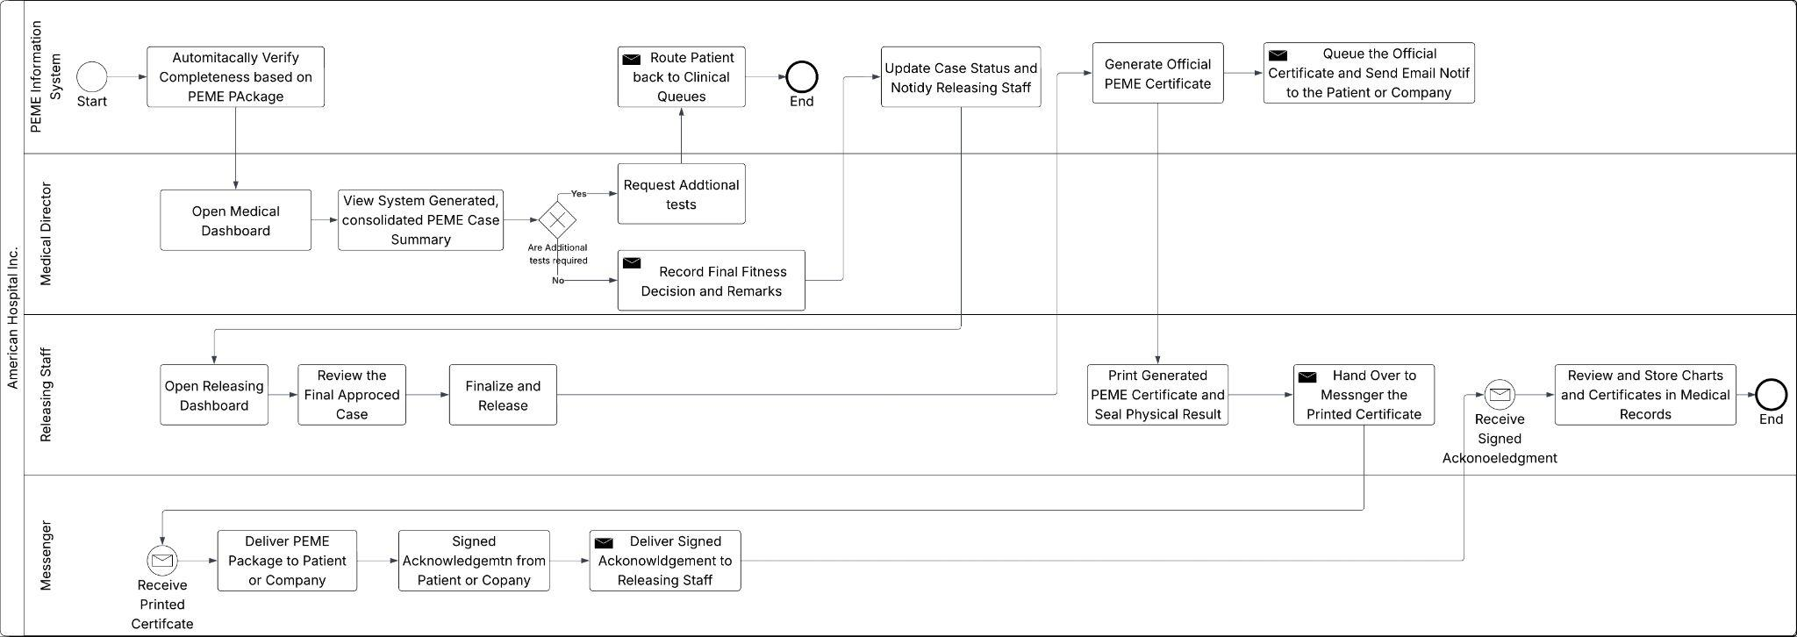
FIgure 3.22 - With PEME System for Result Relase
The PEME Information System automatically verifies completeness based on the assigned PEME package upon all department visits being marked complete, triggering the Medical Director's dashboard to display a system-generated, consolidated PEME case summary. The Medical Director reviews the case and decides whether additional tests are required if yes, a request is routed back to the clinical queues and the patient re-enters the examination cycle; if no, the Medical Director records the final fitness decision and remarks directly in the system. Simultaneously, the Releasing Staff open the releasing dashboard, review the final approved case, and finalize and release it. The system then updates the case status, notifies the Releasing Staff, generates the official PEME certificate, and queues it for delivery by sending automated email notifications to the patient or company. The Releasing Staff print the generated certificate, seal it with the physical result package, and hand it over to the Messenger. The Messenger delivers the package to the patient or company, collects a signed acknowledgement, and returns it to the Releasing Staff, who receive the acknowledgement, review and store all charts and certificates in medical records, and close the case.

3.2 Program Design
This section presents the technical design of the proposed American Hospital Inc. (AHI) Pre-Employment Medical Examination (PEME) Information System. The design specifies how the system will represent data, support user interactions, and enforce business rules in order to (1) provide real-time visibility of patient flow across PEME departments and (2) offer a secure web portal for authorized external stakeholders to access PEME result summaries.

AHI operates as a general clinic and diagnostic center that serves both PEME applicants and non-PEME patients. In this study, however, the proposed information system is scoped strictly to the PEME service line. As a result, the models that follow describe how the PEME module functions within the broader AHI environment rather than attempting to replace the hospital’s entire information system.

The models and specifications that follow are derived from the problems, objectives, and scope discussed in Chapter 1. In particular, the design preserves AHI’s current sequence of PEME-related clinical steps and documentation requirements while introducing additional structures needed for queue monitoring, time-and-motion measurement, and controlled electronic access to results.

The system is designed using a UML-oriented approach. The data structures are first articulated through a logical data model and data dictionary; the functional scope is then expressed by the use case model; and the static and dynamic behaviour is captured by class diagrams, sequence diagrams, activity diagrams, and statecharts. These models serve as the blueprint for implementation and as the basis for defining and validating the functional and non-functional requirements that will be evaluated in the latter part of the study.

3.2.1 External Design
The proposed AHI PEME Information System utilizes a modern, decoupled cloud-native architecture designed for high availability, real-time synchronization, and cross-platform accessibility. The presentation layer is a Single Page Application (SPA) developed using React.js (via the Next.js framework) and styled with Tailwind CSS, utilizing a mobile-first, responsive design methodology. This ensures that internal complex dashboards scale efficiently on desktop monitors, while the external Patient and Agency portals automatically adapt to smartphone and tablet viewports, providing a native-like mobile experience without requiring users to download a dedicated mobile application.

The backend infrastructure is powered by Supabase, an open-source Backend-as-a-Service (BaaS) built on top of a robust PostgreSQL database. Supabase manages data persistence, secure user authentication, and WebSocket-driven real-time database subscriptions. External access for patients and client representatives is routed through secure HTTPS endpoints natively handled by the cloud hosting provider, ensuring the database remains completely isolated from direct public internet exposure.

To ensure strict compliance with the Data Privacy Act of 2012 (RA 10173) and DOH guidelines, all health data is encrypted at rest (AES-256) and in transit (TLS 1.2+). Furthermore, while the primary deployment utilizes secure cloud hosting to facilitate seamless external portal access, the open-source nature of the Supabase stack allows the entire backend and database to be containerized via Docker. This provides a critical architectural fallback: should AHI's internal IT policies mandate strict on-premises data residency, the system can be deployed directly onto the clinic’s local servers without requiring codebase rewrites.

3.2.2 Internal Design
Internally, the AHI PEME Information System is organized around an API-driven, client-server model. The React frontend handles all state management, user interactions, and dynamic rendering of real-time queue dashboards and portal views. It communicates with the backend exclusively via secure REST and GraphQL APIs provided by the Supabase client library.

The backend layer enforces strict business logic and data security directly at the database level using PostgreSQL Row Level Security (RLS). Instead of relying solely on application-layer checks, RLS policies dictate that external users, such as patients or agency representatives, can only query rows where the associated identifier matches their cryptographic authentication token.

Because clinical staff will actively encode examination findings directly into the PEME system, the application operates as a specialized EMR module. When a department staff member submits a clinical result, the backend instantly broadcasts a payload via WebSockets to all subscribed clients. This triggers real-time updates on the Reception, Releasing, and Medical Director dashboards simultaneously, entirely eliminating the need for manual page refreshes and resolving the manual polling bottlenecks identified in Chapter 1. Where necessary, the system can utilize secure API endpoints to cross-reference patient admission or billing data from the legacy Clinical Information System (CIS), establishing a unified, single source of truth for the releasing staff.

3.2.3 Data Structures of the Program
This section describes the data design of the AHI PEME Information System. Building on the three-tier architecture described in Section 3.1 and the selection of a bespoke PEME module in Chapter 2, it specifies how information about patients, companies, PEME cases, departmental visits, clinical results, and user activity is structured and stored. The data structures are scoped strictly to the Pre-Employment Medical Examination service line and are designed to support real-time queue monitoring, time-and-motion measurement, reduction of result collation and encoding errors, and controlled viewing of released PEME results.

Overview of Data Architecture
The system uses a centralized relational database as the authoritative repository for PEME information. The database resides in the data layer of the three-tier architecture and is accessed only through the application services described in Section 3.1.2. All internal users interact with the data through the staff dashboard and role-specific screens, while external users access released results through the patient and client representative portals.

The database stores only PEME-related information. Non-PEME encounters such as outpatient visits, emergency care, and general diagnostics continue to be recorded in AHI’s existing systems, which the PEME module may consult through read-only interfaces when necessary. This approach aligns with the system scope and the decision in Chapter 2 to implement a PEME-focused module rather than replace the broader hospital information system.

The schema contains three groups of data elements:
  - Core operational entities that represent the PEME workflow, including patients, companies, PEME cases, departmental visits, structured results, and physician decisions.
  - Security and audit entities that represent user accounts, roles, and audit logs.
  - Configuration entities that represent departments, PEME packages, and status codes.

Indexes are defined on key columns such as case identifiers, patient identifiers, department identifiers, status fields, and timestamps to support responsive queue views and reporting as the database grows. Archiving flags and status-based access rules are included to support long-term data retention and privacy compliance.

This separation of operational, configuration, and security entities supports data integrity, maintainability, and security. It also contributes to the functional suitability, performance efficiency, reliability, and security characteristics discussed in the ISO and IEC quality section of this chapter.

Core Operational Entities
The core operational entities reflect the PEME journey from registration through departmental visits, completion of tests, physician decision-making, and releasing. The same data structures used during operations also generate the indicators used in Chapter 1 and in the evaluation procedure, including waiting times, completion rates, error incidents, and result visibility.

Patient
The Patient entity represents a person undergoing one or more PEME examinations. A patient may have multiple PEME cases over time, but each PEME case belongs to exactly one patient. For non-PEME encounters, the hospital’s existing systems remain the primary record; within this PEME module, the patient record serves as the parent for all PEME cases and their associated departmental visits and results.

Company
The Company entity represents an agency, employer, or client organization that sends workers for PEME. A company may have multiple PEME cases linked to it, but each PEME case is associated with at most one company. This supports accurate reporting and controlled portal access for authorized client representatives.

PEME Case
The PEME Case entity serves as the central record for a single PEME episode. Each case is linked to exactly one patient and to one company when applicable. A PEME case must include at least one department visit and may include several, depending on the required package and additional tests requested.

A PEME case stores data such as the case identifier, patient identifier, company identifier, PEME package, case category, rush indicator, registration time, and overall case status. Case statuses follow the lifecycle defined in the state diagram, which includes Registered, In Progress, Pending Additional Tests, For Decision, For Releasing, Released, and Archived. These statuses and timestamps support measurement of case completion and cycle times relative to baseline metrics reported in Chapter 1.

Department Visit
The Department Visit entity represents a single visit of a PEME case to a named clinical department such as Laboratory, Radiology, ECG, Psychology, Dental, or Physical Examination. Each department visit is linked to exactly one PEME case. A PEME case must have at least one visit and may have several if multiple tests or follow-up examinations are required.

The system records the department involved, the queue number, the current visit status such as Waiting, Called, In Service, On Hold, Completed, or Cancelled, and timestamps indicating when the visit was queued, when the patient was called, when the service began, and when the service was completed. These timestamps and statuses form the basis for real-time queue monitoring and time-and-motion measurement. They allow the system to compute waiting and service times per department and across the entire PEME workflow, and they are used to evaluate improvements over the baseline waiting time of two point six hours.

Result Item
The Result Item entity captures structured findings produced by clinical departments. Examples include laboratory test values, radiology impressions, ECG interpretations, psychological assessments, and physical examination findings. Each result item belongs to one department visit. A department visit may have none, one, or many result items depending on the nature of the tests performed.

Each result item includes information such as test code, description, measured value, reference range, units, abnormality indicators, and verification status. Structured results support accurate collation for physician review and reduce missing or duplicated entries, directly addressing errors identified in Chapter 1.

PEME Decision
The PEME Decision entity records the physician’s overall assessment once all required department visits are completed. A PEME case may have only one decision record. The decision includes the decision type, decision timestamp, and remarks or recommendations. The decision record determines whether a PEME case may move to releasing and whether results may become visible to external users through the portal.

Security and Audit Entities
User Account
The User Account entity represents an individual who can access the system. Each user account is linked to one role. The account stores login credentials or external authentication identifiers, user information, and account status.

Role
The Role entity defines a set of permissions associated with a user group such as reception staff, triage staff, department staff, physicians, releasing staff, client representatives, or system administrators. Each role may be assigned to multiple user accounts.

Audit Log
The Audit Log entity records sensitive actions that require traceability. These include logins, status changes, result updates, physician decisions, releasing actions, and portal views of medical results. Each audit log entry is linked to one user account and records what action occurred, which record was affected, and the exact time of the action. These entities implement role-based access control and auditability and support the security requirements and quality characteristics defined in the later sections of this chapter.

Configuration and Reference Entities
Department
The department entity stores the list of clinical departments that participate in PEME. Each department may be referenced by multiple department visits and schedule records. This table supports changes to departmental structure without modifying source code.

Package
The Package entity stores the standard PEME packages offered by AHI. Each package may be referenced by many PEME cases. The package determines the set of departments and tests that must be completed for a given case.

Status Code
The Status Code entity defines the allowable status values used by PEME cases and department visits. Each status code may be used by many cases or visits. Aligning these values with the lifecycle defined in the state diagrams ensures consistency across the data model and application logic.

By keeping departments, packages, status codes, and schedules in editable master tables, administrators can make operational adjustments without modifying the application. These configuration entities complement the operational, security, and audit structures and complete the data model that will be implemented in the database and referenced in detail in the ERD and data dictionary in the following sections.

3.2.4 Use Case Diagram
The use case diagrams in this section describe how different actors interact with the AHI PEME Information System to accomplish their PEME-related responsibilities. Because the system is scoped specifically to the PEME service line, each use case focuses on registering and managing PEME cases, updating departmental processing and results, issuing fitness decisions, releasing cases, and providing controlled portal access to released summaries.

At the system level, the AHI PEME Information System is represented as a single boundary that exposes use cases to external actors through a web-based interface. All interactive actors authenticate through a common login process before accessing role-specific functions, and each use case represents a distinct goal that contributes to the end-to-end PEME workflow. The overview first presents the main actors and use cases at a system level, after which the subsequent diagrams, Figures 3.5.1 to 3.5.8, detail the responsibilities and interactions of each actor group: Reception and Billing Staff, Triage Nurse, Department Staff, Physician, Releasing Staff, Client Representative, Patient, and System Administrator.

Use Case Diagram Overview
The overview use case diagram shows the eight primary actors that interact with the AHI PEME Information System and the shared and role-specific use cases available to them. All staff-facing actors and the client representative depend on a common Login use case that authenticates their credentials, checks account status, and establishes their role.

Once authenticated, internal staff see a role-based dashboard that allows them to search and view PEME cases or queues relevant to their responsibilities. The reception and billing staff initiate and update cases. The triage nurse performs initial clinical assessments and marks cases as ready for departments. Department staff manage queues and encode results for their respective departments. The physician reviews consolidated information and records the fitness decision. The Releasing Staff performs final verification, updates case status to Released, and controls portal visibility. The client representative uses a separate portal view to access released summaries for workers associated with their company. The patient uses a dedicated portal to view the status and released summary of their own PEME case. The system administrator maintains accounts, roles, configuration data, and audit logs. The system administrator maintains accounts, roles, configuration data, and audit logs but does not participate directly in clinical or releasing activities.

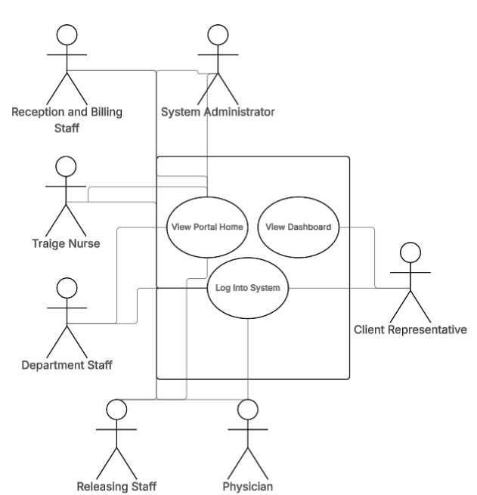
Figure 3.23 AHI PEME Information System
Figure 3.19 shows the AHI PEME Information System as a single system used by seven actors: Reception and Billing Staff, Triage Nurse, Department Staff, Physician, Releasing Staff, Client Representative, and System Administrator. All actors go through a common login step, after which internal staff access a role-based dashboard and client representatives access a portal home view that lists released cases for their company. The overview links each actor to the part of the PEME workflow they handle, from case registration and triage to departmental processing, decision, release, external viewing of results, and configuration and security administration.
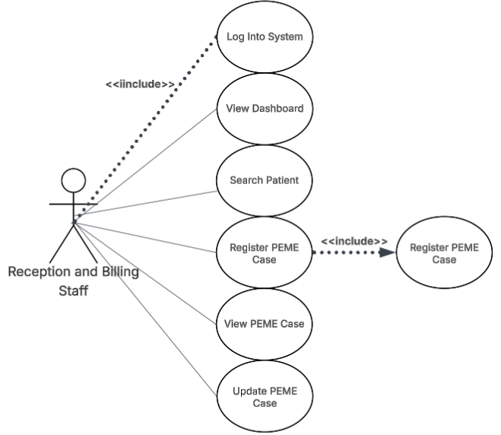
Figure 3.24 Reception and Billing Staff
Figure 3.20 shows how Reception and Billing Staff initiate and manage the earliest stages of the PEME workflow. After logging into the system, they search for an existing patient, register new PEME cases, encode patient and company information, and assign key case attributes such as package, category, and rush status. They may also view or update case details to correct non-clinical encoding errors. These use cases emphasize that Reception and Billing Staff establish the accuracy of core records, create the required departmental visits, and ensure that downstream departments receive complete and correct information for processing.
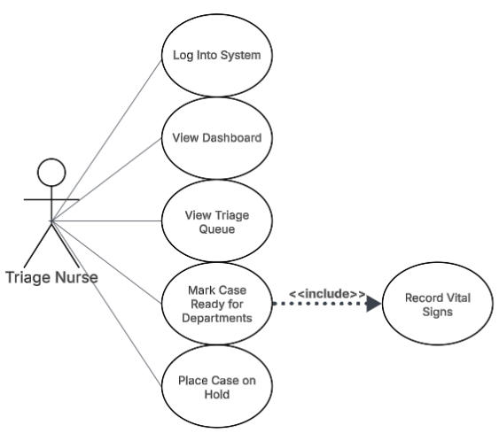
Figure 3.25 Triage Nurse
Figure 3.21 presents the use case diagram for the Triage Nurse. After logging into the system, the triage nurse views a role-based dashboard and accesses the triage queue that lists PEME cases waiting for initial assessment. For each case, the nurse records vital signs and basic observations, and this behaviour is included whenever the nurse marks a case ready for departments. The diagram shows that triage transforms newly registered cases into clinically cleared cases that can safely proceed to the diagnostic departments, while ensuring that key assessment data is encoded in the system from the start of the PEME workflow.

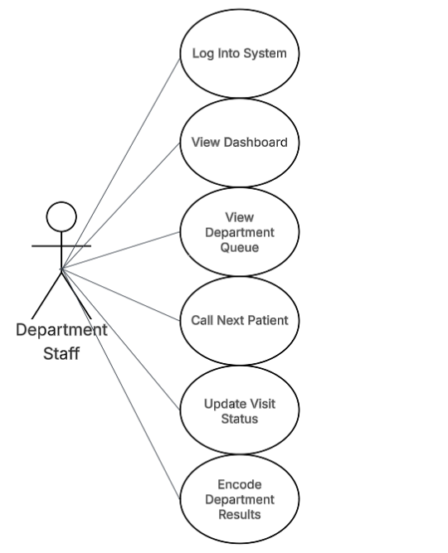
Figure 3.26 Department Staff
Figure 3.22 presents the use case diagram for Department Staff, who handle the processing of PEME cases within their assigned clinical department. After logging into the system and viewing their department-specific dashboard, staff access the department queue to see patients awaiting service. From this queue, they call the next patient in line, update the visit status as the examination progresses, and encode the corresponding clinical results once the procedure is completed. The diagram also reflects the ability to verify or correct results when necessary, ensuring that encoded findings remain accurate and usable for physician review and later releasing. These use cases collectively show how Department Staff manage the day-to-day operational flow in each department and ensure that all departmental outputs are captured in a structured and traceable manner.

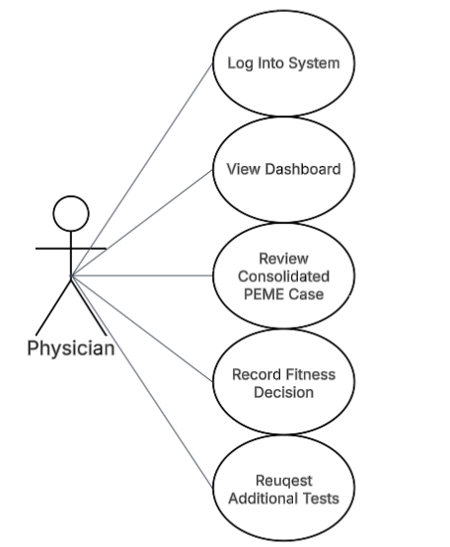
Figure 3.27 Physician
Figure 3.23 presents the use case diagram for the Physician, whose role is to review completed PEME cases and issue the final fitness decision. After logging into the system and opening the physician dashboard, the physician accesses consolidated PEME case summaries that combine patient and company information, departmental visit statuses, and encoded results. From this view, the physician reviews significant findings, records the overall fitness decision, and when needed requests additional tests that create new department visits for the case. The diagram shows that the physician interacts with the system mainly at the decision stage and depends on accurate data from previous steps to produce a clear, accountable outcome for each PEME case.

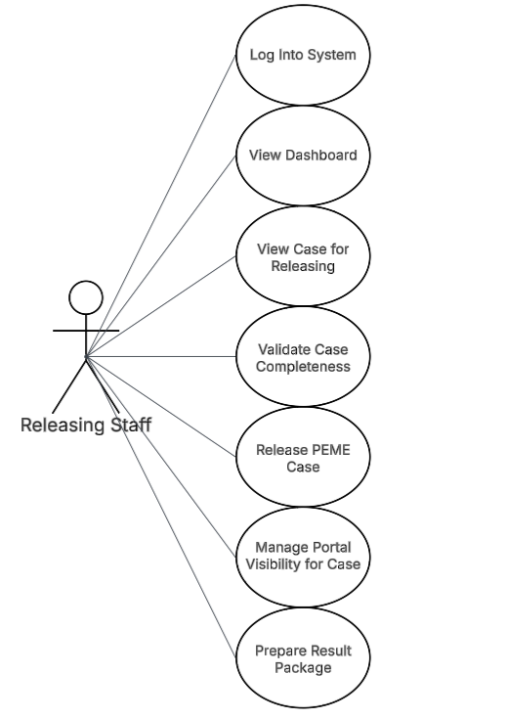
Figure 3.28 Releasing Staff
Figure 3.24 presents the use case diagram for the Releasing Staff, who finalize the administrative closure of completed PEME cases. After logging into the system and viewing the releasing dashboard, staff locate cases that have passed all required departmental visits and have an approved physician decision. They then validate the completeness and consistency of the case, confirm that all required results are present, and proceed to update the case status to Released. Releasing Staff also manage whether the result summary becomes visible through the client portal and may regenerate or reprint result packages when needed. The diagram emphasizes that releasing functions serve as the final quality control checkpoint and determine when a PEME case becomes officially accessible to external stakeholders.
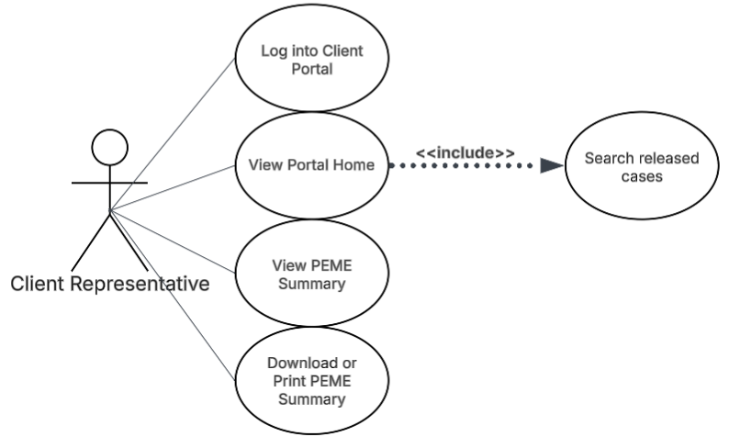
Figure 3.29 Client Representative
Figure 3.25 presents the use case diagram for the client representative, an external user who accesses the AHI PEME Information System through the dedicated portal. After logging into the portal, the representative views released PEME cases associated with their company and searches for specific workers as needed. They can open each released case to view the corresponding PEME summary and may download or print the summary for internal processing. Access is strictly limited to cases that have already been released and are linked to the representative’s organization. The diagram highlights that the client portal provides controlled, read-only visibility of PEME results without exposing any internal operational or administrative functions.
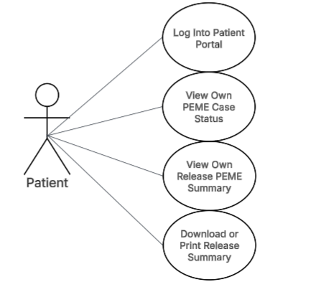
Figure 3.30 Patient
Figure 3.26 presents the use case diagram for the Patient, who accesses the AHI PEME Information System through the patient portal. After logging into the portal with assigned credentials, the patient can view the status of their own PEME case, including which departments have completed examinations and whether the case is still in progress, for decision, or released. Once a case has been released and marked as visible on the portal, the patient may open the corresponding PEME summary and, where allowed by policy, download or print a copy for personal records. Access is strictly limited to cases that are associated with the patient’s identity in the system; patients cannot view data for other individuals. These use cases emphasize transparency for applicants while preserving privacy through identity-linked portal accounts.
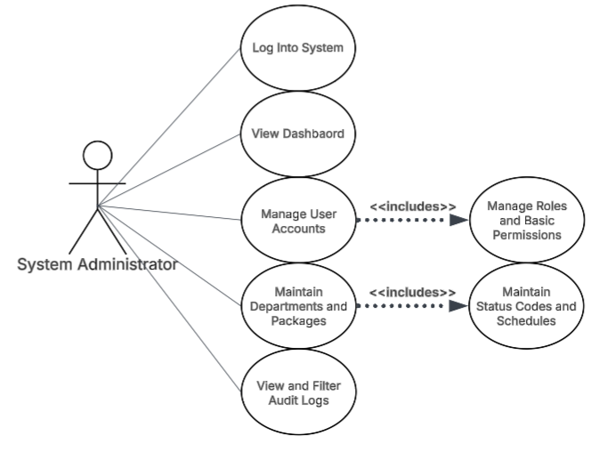
Figure 3.31 System Administrator
Figure 3.27 presents the use case diagram for the System Administrator, who is responsible for maintaining the configuration, security, and overall integrity of the AHI PEME Information System. After logging in with elevated privileges, the administrator manages user accounts, assigns roles and permissions, updates departments and PEME packages, configures valid status codes and clinic schedules, and reviews audit logs that record sensitive system actions. These use cases show that the System Administrator does not participate in clinical or releasing workflows but instead ensures that the system’s structure, access controls, and master data remain accurate, consistent, and aligned with organizational policies.

3.2.5 Class Diagram
The class diagram specifies the static object-oriented structure of the AHI PEME Information System. It formalizes the main business concepts, their data attributes, and the relationships among them, and serves as the blueprint for the implementation of the application layer. The classes are derived from the entities identified in the data structures, the existing PEME workflow captured in the DFD and BPMN models, and the functional behaviour described in the use cases.

Domain Model Classes
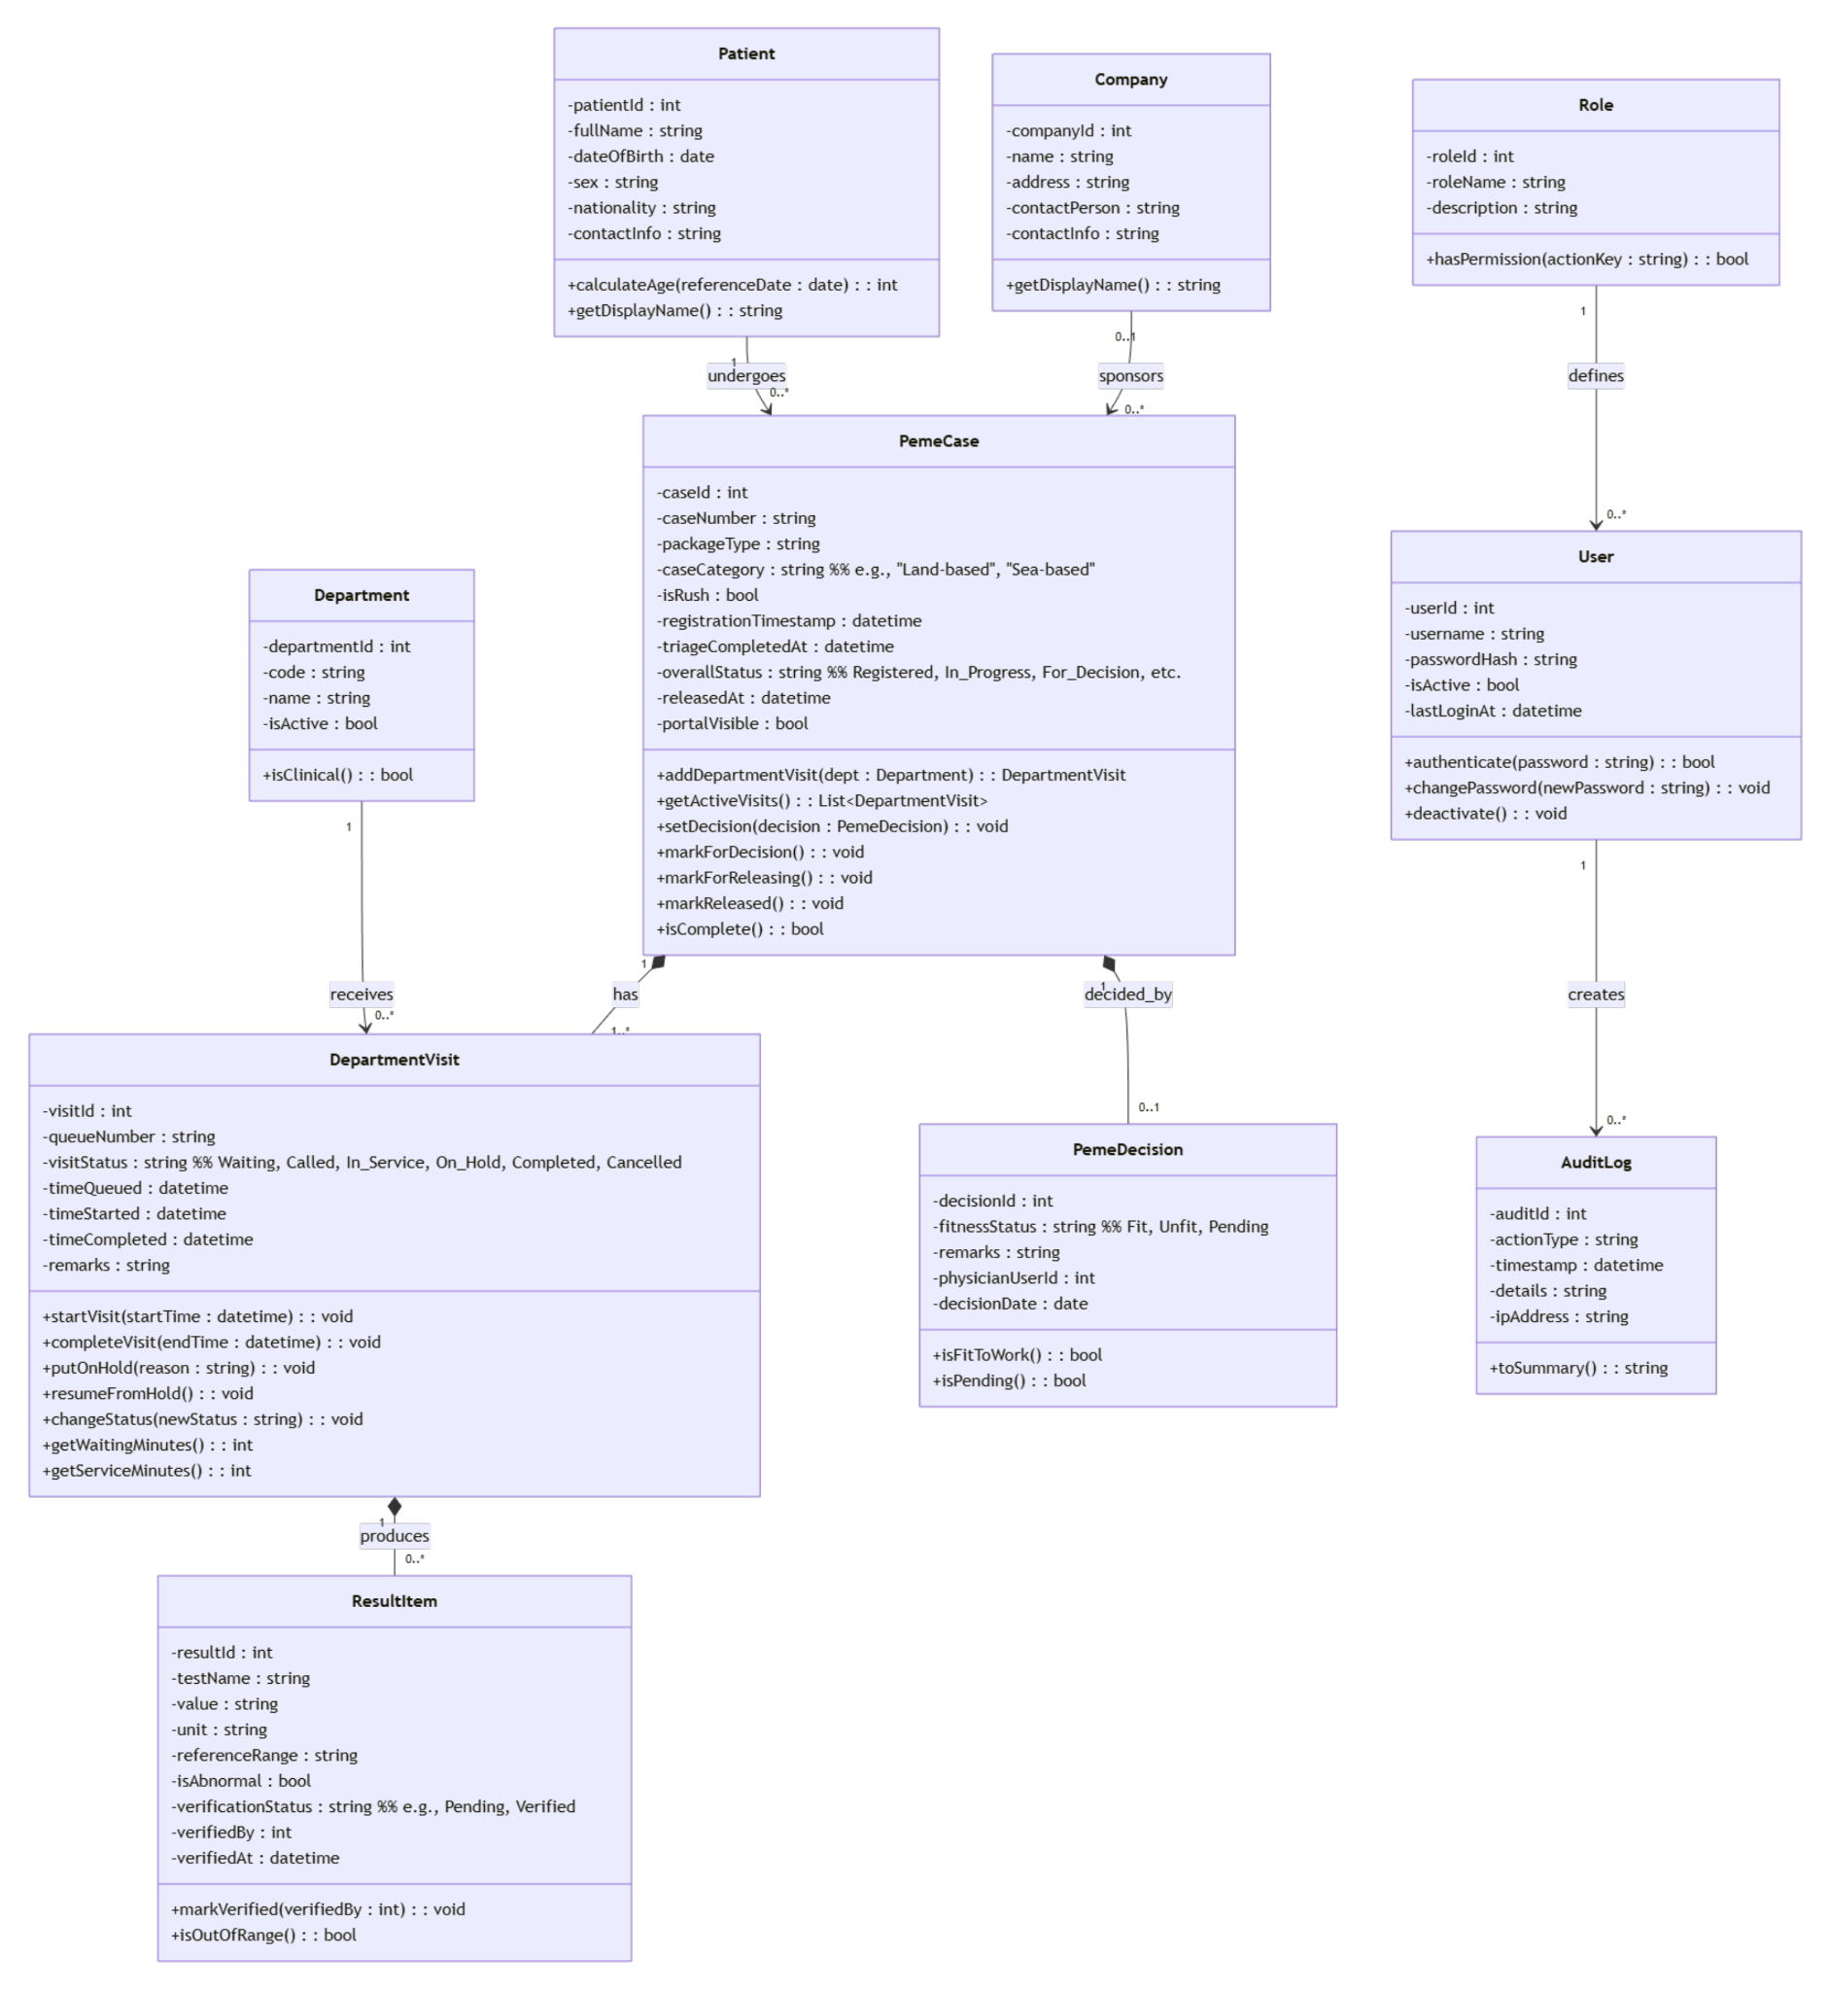
Figure 3.32 Domain Model Classes
The class diagram in Figure 3.28 presents the core domain model of the AHI PEME Information System. It focuses on the main business objects and their relationships, independent of user interface and technical implementation details. The diagram serves as the conceptual bridge between the data structures in Section 3.2 and the behavioral models in the rest of this chapter.

At the center of the model is the PemeCase class, which represents one Pre-Employment Medical Examination episode for a specific patient and a company. The Patient class holds demographic and identifying information, while the Company class represents client organizations or manning agencies. Each Patient may be linked to zero or more PemeCase objects over time, and each PemeCase is associated with exactly one Patient and at most one sponsoring Company. PemeCase encapsulates case-level attributes such as caseNumber, packageType, caseCategory, isRush, registrationTimestamp, triageCompletedAt, overallStatus, releasedAt, and portalVisible. Its methods represent the main lifecycle transitions used in the PEME workflow.

Within a PEME case, departmental processing is modelled by the Department and DepartmentVisit classes. The department represents clinical service units involved in PEME and provides a master list of active departments. A single PemeCase has one or more DepartmentVisit instances, each linked to exactly one Department. DepartmentVisit captures per-department operational details: queueNumber, visitStatus such as Waiting, Called, In_Service, On_Hold, Completed, Cancelled, timeQueued, timeStarted, timeCompleted, and remarks, support queue management and time-and-motion analysis. DepartmentVisit objects in turn aggregate zero or more ResultItem objects, which store structured clinical findings. ResultItem includes attributes such as testName, value, unit, referenceRange, isAbnormal, verificationStatus, verifiedBy, and verifiedAt, and exposes behaviors like markVerified and isOutOfRange to support result verification and flagging of abnormal findings.

The PemeDecision class records the physician’s final evaluation of a PemeCase. Each PemeCase may have at most one PemeDecision, containing fitnessStatus, remarks, physicianUserId, and decisionDate. Methods such as isFitToWork and isPending reflect the key decision states that drive releasing and portal visibility. Once a decision is present and all required DepartmentVisit instances are completed, PemeCase can transition to For_Releasing and eventually Released, at which point portalVisible and releasedAt are updated.

Security and accountability are handled by the User, Role, and AuditLog classes. User represents internal staff and, where applicable, portal accounts, with attributes such as username, passwordHash, isActive, and lastLoginAt, and operations for authenticate, changePassword, and deactivate. Each User is linked to exactly one Role, which defines high-level access categories and provides a hasPermission operation for permission checks at the application level. The AuditLog class captures sensitive actions performed by users identified by actionType, timestamp, details, and ipAddress and is associated with the User that created each entry. This domain model is intentionally scoped to PEME-related activities; non-PEME encounters at AHI are handled by existing systems and are not represented as classes in this diagram.

3.2.6 Sequence Diagrams
This subsection presents UML sequence diagrams for the main scenarios of the AHI PEME Information System. Each diagram shows how actors, user interface components, application services, domain objects, and the database interact over time to carry out a specific PEME-related use case. The diagrams are derived from the core PEME use cases identified in Section 3.3 and are consistent with the domain classes defined in Section 3.4 and the data structures in Section 3.2.

Selection of Scenarios:
Sequence diagrams were prepared for four scenarios that represent the core functional behavior of the system across the PEME lifecycle:
- Registering a PEME case at reception.
- Managing departmental queues and updating visit status.
- Approving the physician’s PEME decision and finalizing the case for release.
- Viewing a released PEME result summary through the portal.
These scenarios illustrate how the system supports PEME case registration, departmental processing, decision-making, administrative releasing, and controlled external access to released results.

Sequence Diagram – Register PEME Case
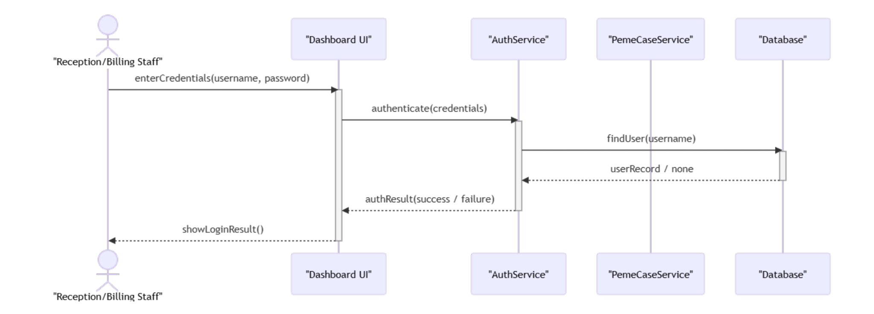
Figure 3.33 Register PEME Case
Figure 3.29 shows the sequence diagram for the Register PEME Case scenario. The reception and billing staff interacts with the DashboardUI to log in and open the registration form. The DashboardUI calls AuthService to authenticate the user, then passes the encoded case data to PemeCaseService. The service looks up or creates the corresponding Patient record, creates a new PemeCase, and invokes the Database to persist the case. The service then returns a confirmation with the assigned case identifier, which the DashboardUI displays to the staff.

Sequence Diagram – Manage Department Visit and Update Queue
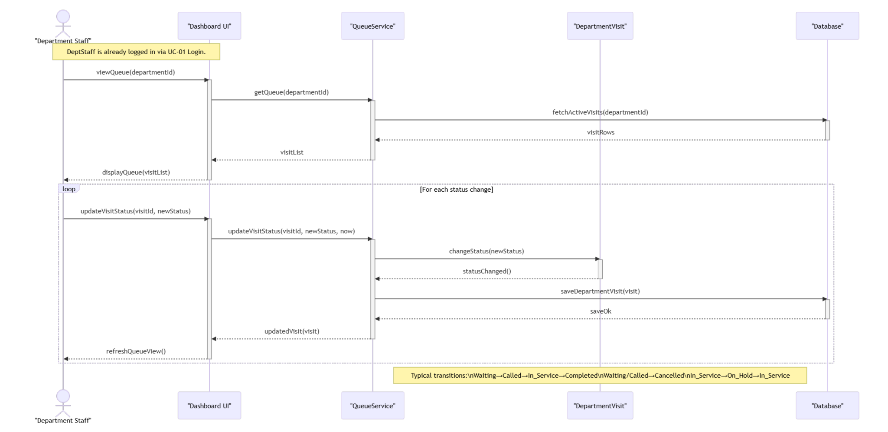
Figure 3.34 Manage Department Visit and Update Queue
Figure 3.30 shows how department staff use the system to view and update their PEME departmental queue. After the staff member requests the queue, the Dashboard UI calls QueueService, which retrieves active DepartmentVisit records for the department from the database and returns the list for display. While the queue is on screen, the staff member selects visits and changes their status, such as from Waiting to Called, In Service, Completed, or Cancelled. Each change is sent from the Dashboard UI to QueueService, which applies the changeStatus operation on the corresponding DepartmentVisit, updates key timestamps like timeQueued, timeStarted, and timeCompleted, and saves the modified visit to the database before refreshing the queue display. This interaction aligns with the class diagram where PemeCase aggregates DepartmentVisit objects and with the functional requirements for real-time queue monitoring and service time measurement.

Sequence Diagram – Approve Decision and Finalize PEME Case
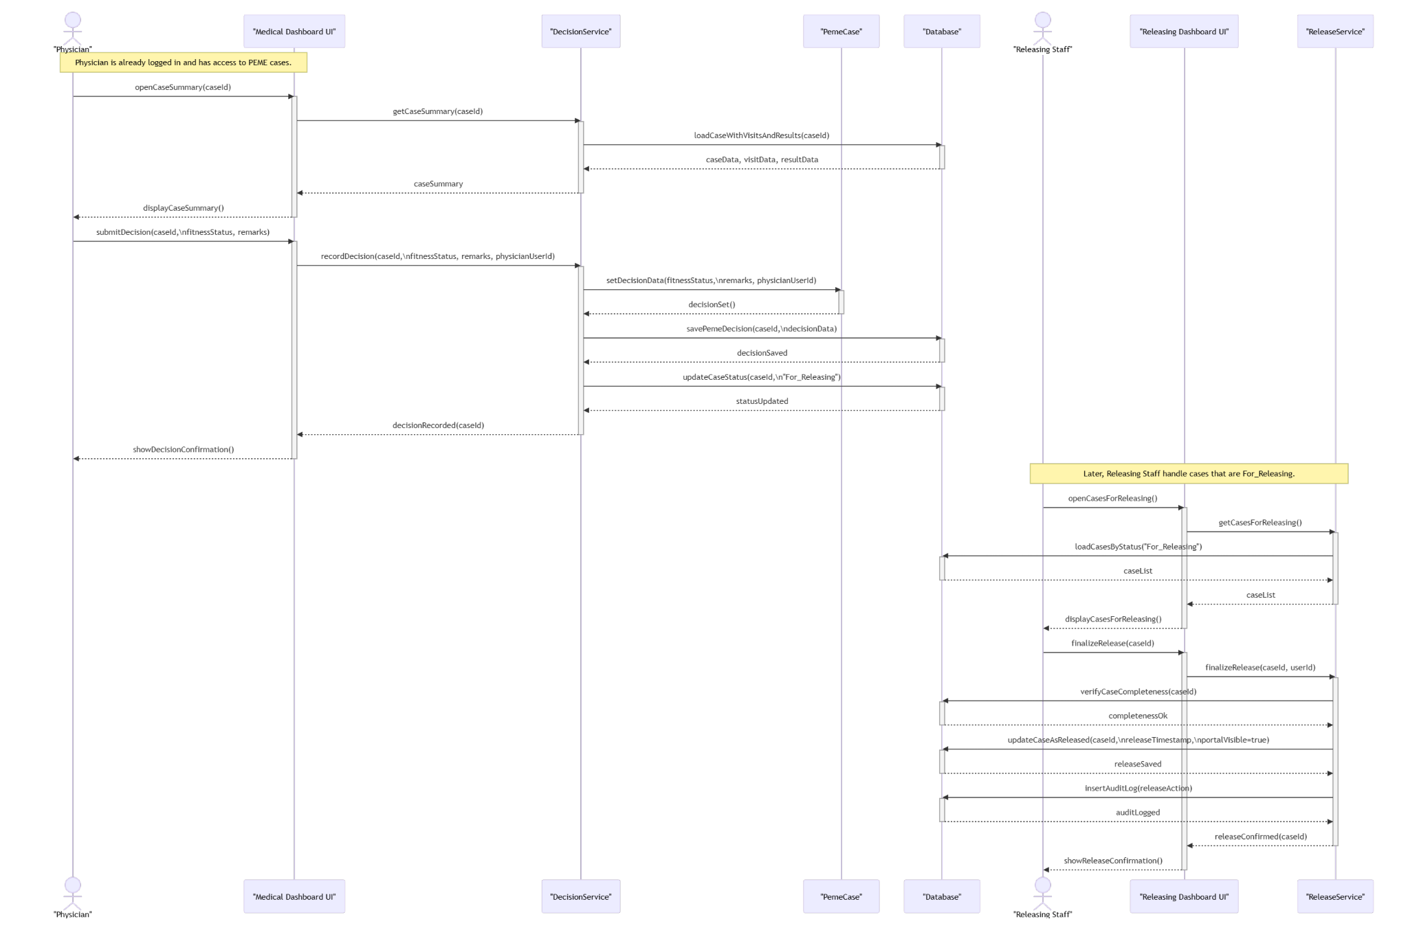
Figure 3.35 Approve Decision and Finalize PEME Case
Figure 3.31 shows how the Physician and Releasing Staff complete the final stages of a PEME case. First, the Physician uses the Medical Dashboard UI to open a case summary. The UI calls DecisionService, which loads the PEME case, departmental visits, and ResultItem data from the database and returns a consolidated summary for review. After reviewing the findings, the Physician submits a fitness decision and remarks. The Medical Dashboard UI sends this to DecisionService, which updates the PemeCase in memory, saves a PemeDecision record, and sets the case status to For Releasing in the database. In the second part of the diagram, Releasing Staff open the list of cases that are For Releasing through the Releasing Dashboard UI. The UI calls ReleaseService, which retrieves eligible cases from the database and displays them. When Releasing Staff choose to finalize a case, the UI calls ReleaseService to verify completeness, update the PEME case as Released with a release timestamp and portalVisible flag set to true, and insert an audit log entry. The Releasing Dashboard UI then confirms successful releasing to the staff member. This interaction matches the class diagram where PemeCase aggregates PemeDecision and carries releasedAt and portalVisible attributes, and it supports the functional requirements for physician decision, administrative releasing, and controlled portal visibility.

Sequence Diagram – View PEME Result Summary
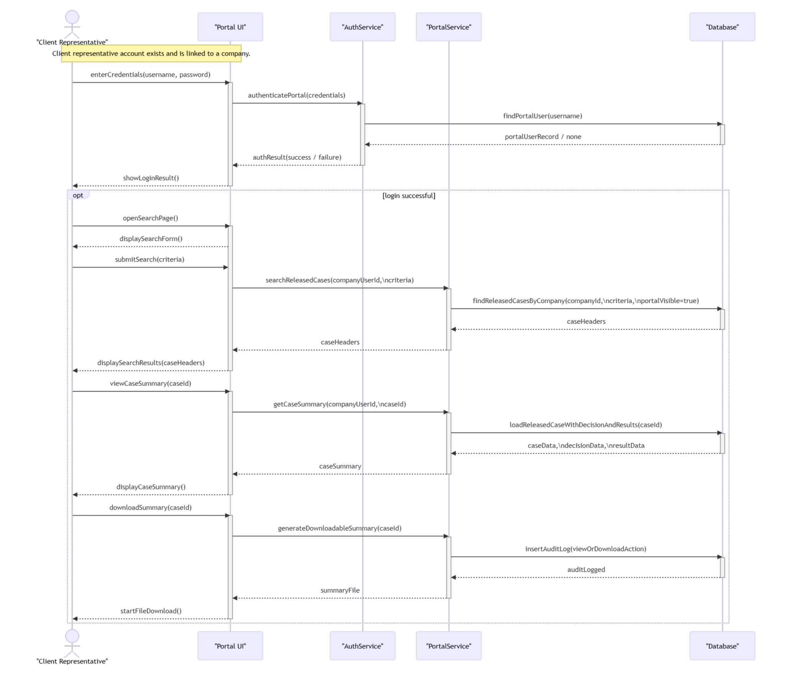
Figure 3.36 View PEME Result Summary
Figure 3.32 shows how a client representative uses the portal to log in, search released PEME cases for their company, view a consolidated result summary, and optionally download that summary. The client representative first submits credentials to the Portal UI, which calls AuthService to validate the portal user against the database and returns a login result. After a successful login, the external user (patient or client representative) opens the search page and submits search criteria. For client representatives, the PortalService filters cases by company; for patients, it filters by the patient’s identity. The Portal UI invokes PortalService, which queries the database for PEME cases that are in Released status, marked as portalVisible, and associated with the representative’s company, then returns a list of matching case headers for display. When the representative selects a specific case, the Portal UI calls PortalService to load the released PEME case together with its PemeDecision and aggregated ResultItem data from the database and returns a caseSummary that the UI renders as a result view. If the representative chooses to download the summary, the Portal UI requests a downloadable version from PortalService, which logs the view or download action in the AuditLog table and returns a file for download. This interaction is consistent with the use cases for portal search and viewing, the class diagram where PemeCase aggregates PemeDecision and ResultItem and carries releasedAt and portalVisible attributes, and the functional requirements for secure, company scoped access to released PEME result summaries.

3.2.7 Activity Diagrams
This subsection presents UML activity diagrams that describe the main workflows supported by the AHI PEME Information System. Unlike the BPMN models used in the analysis phase, these diagrams focus on system-triggered activities and decision points that drive data creation, status changes, and access to PEME results. Two activity diagrams are included: one for internal patient flow monitoring across departments and one for external result access through the portal.

Activity Diagram for Internal Patient Flow Monitoring
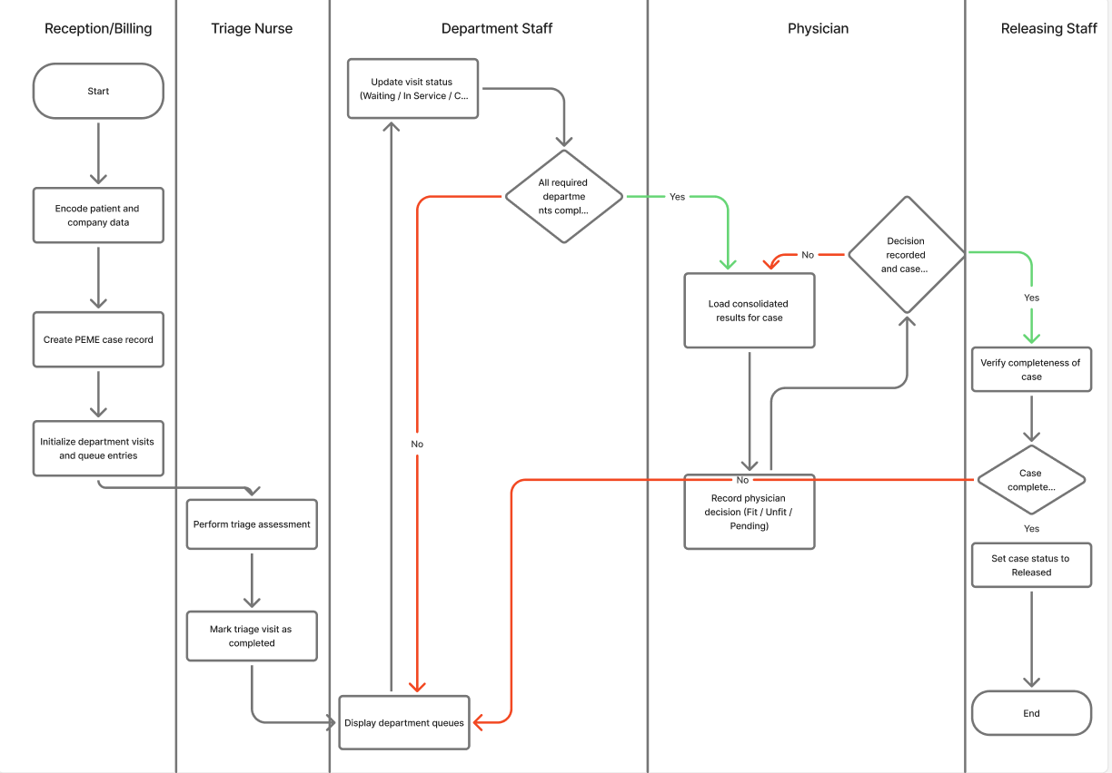
Figure 3.37 Internal Patient Flow Monitoring
Figure 3.33 shows the activity diagram for the internal PEME workflow, from case registration until releasing. The flow begins with encoding patient and company information, creating the PEME case record, and initializing departmental visits and queue entries. It then proceeds through triage assessment, departmental queue display and status updates, and a decision node that checks if all required departments have completed their visits. Once all departmental visits are completed, the system loads consolidated results, records the physician’s fitness decision, and sets the case status to For Releasing. The releasing step verifies case completeness, evaluates whether the case is ready for release, and, if so, updates the case status to Released, which marks the end of the internal flow and enables portal visibility.

Activity Diagram for External Result Access
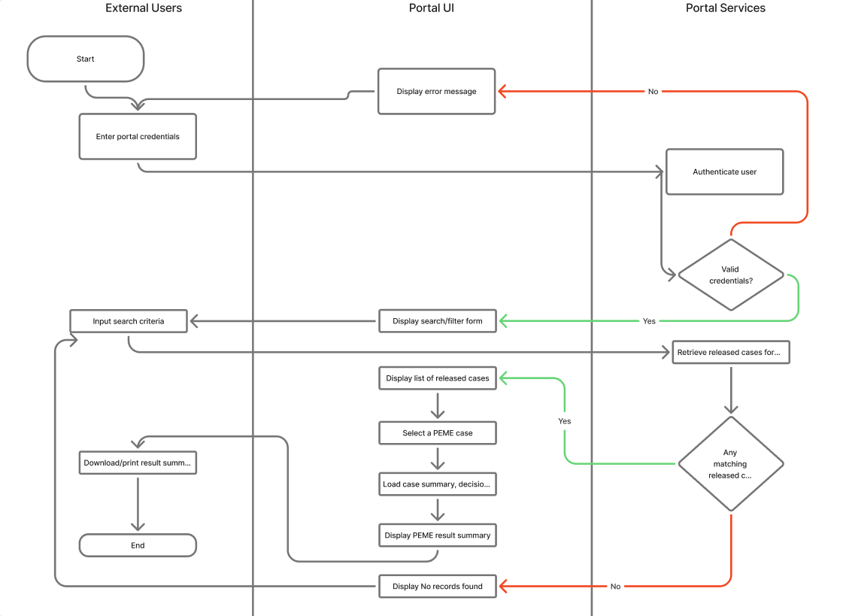
Figure 3.38 External Result Access
Figure 3.34 presents the activity diagram for external PEME result access via the web portal. After a login, the client representative or the patient enters portal credentials, and the system authenticates the user, with invalid logins causing a loop back to the credential entry. After successful authentication, the portal displays a search or filter form, accepts search criteria, and retrieves PEME cases for the client company that are in Released status. A decision node checks if any matching released cases exist; if none are found, a No records found message is shown and the user can refine the search. If matching cases exist, the system displays a list of released cases, allows the user to select a case, loads the associated summary, decision, and key results, and then displays the PEME result summary with an option to download or print it, concluding the activity flow.

3.2.8 Statechart Diagrams
This subsection presents UML state diagrams that describe how key entities in the proposed AHI PEME Information System change status over time. The models focus on the lifecycle of the PEME case and the departmental visit, and are consistent with the status values and transitions used in the data structures, sequence diagrams, and activity diagrams.

State Diagram for PEME Case
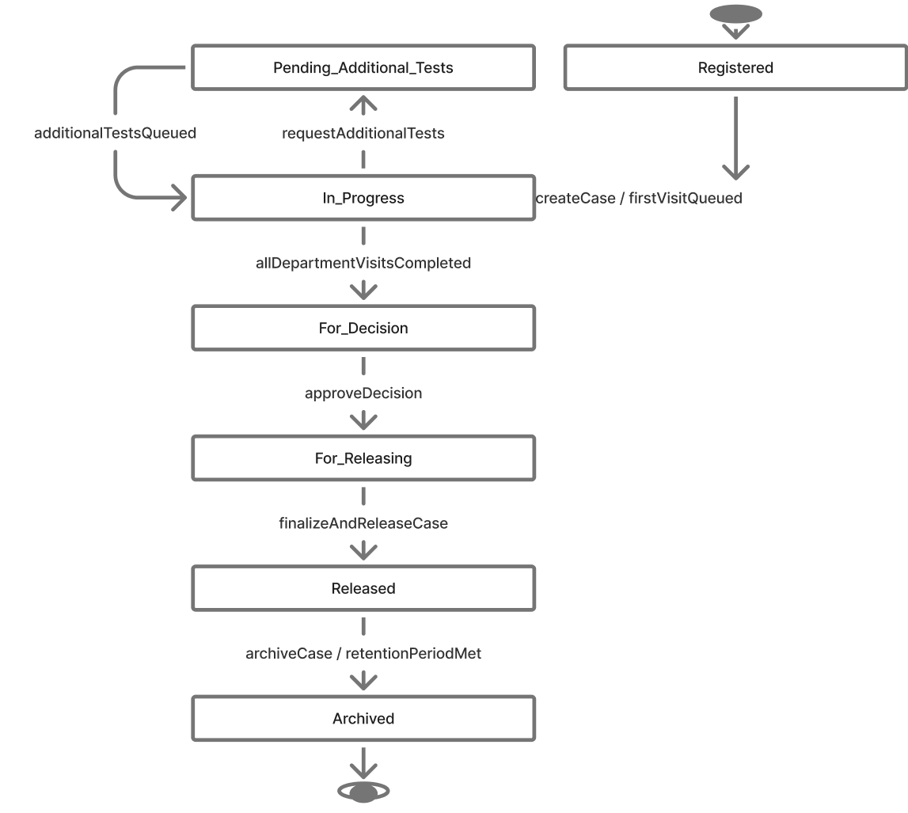
Figure 3.39 PEME Statechart Diagram
Figure 3.35 shows the behavioral state diagram for the PemeCase entity. A case is created in the Registered state after reception encodes patient and company data and saves the case record. When at least one department visit is queued or in progress, the case moves to In_Progress, reflecting that clinical activities are ongoing.

If the physician requests further examinations, the case may temporarily move to Pending_Additional_Tests, then return to In_Progress once additional visits are queued. When the system detects that all required DepartmentVisit entries are completed, the case transitions to For_Decision, indicating that it is ready for medical review. After the physician records the fitness decision, the case moves to For_Releasing. Once releasing staff verify completeness and finalize the case, the state changes to Released, at which point the result summary becomes eligible for portal access. Finally, cases may transition to Archived when a retention rule or administrative action closes the record, representing the end of the case lifecycle.

State Diagram for Department Visit
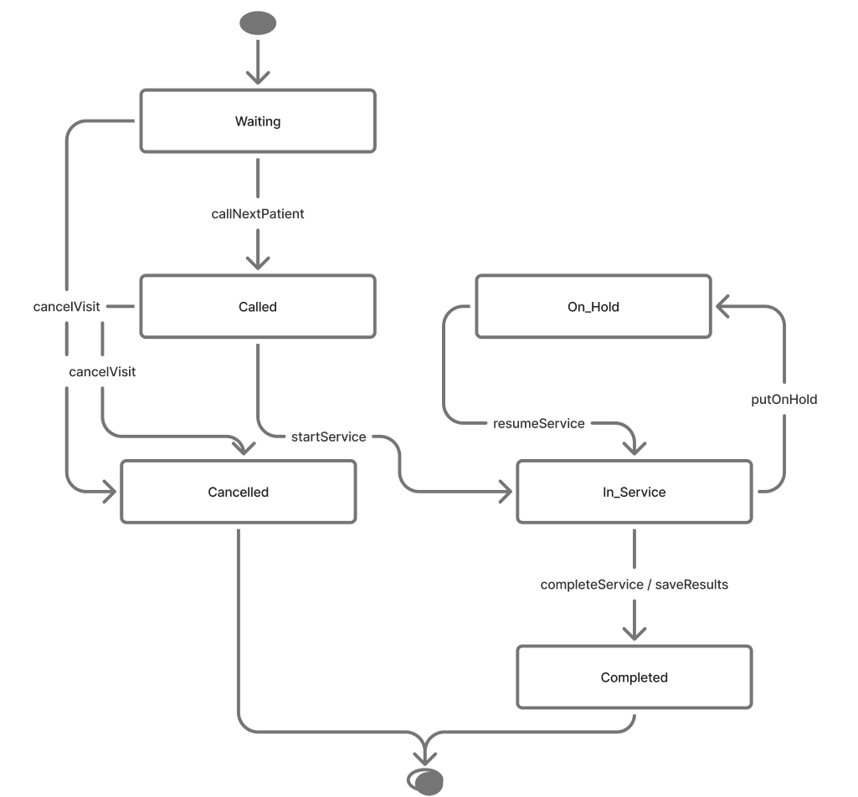
Figure 3.40 Department Visit
Figure 3.40 presents the state diagram for the DepartmentVisit entity, which models the status of a single departmental queue item using a simplified manual-pull kanban approach. A visit is created in the Pending state when the system initializes department visits for a new case or when additional tests are ordered. From Pending, staff monitor the list of waiting patients.

When the staff member calls the patient and they are physically present, the visit transitions to In_Service. If the patient is called but is absent or late, the staff member changes the status to Skipped, which moves the patient out of the active priority view until they physically arrive, at which point they are returned to Pending.
After examinations and data entry are completed, the visit moves to Completed, signifying that the department’s contribution to the case is finished. If a test is no longer required, it can be marked as Cancelled. Both Completed and Cancelled are terminal states. The combination of all visit states for a case is used by the system to determine when a PemeCase can progress to For_Decision and ultimately to Released.

3.2.9 Entity Relationship Diagram
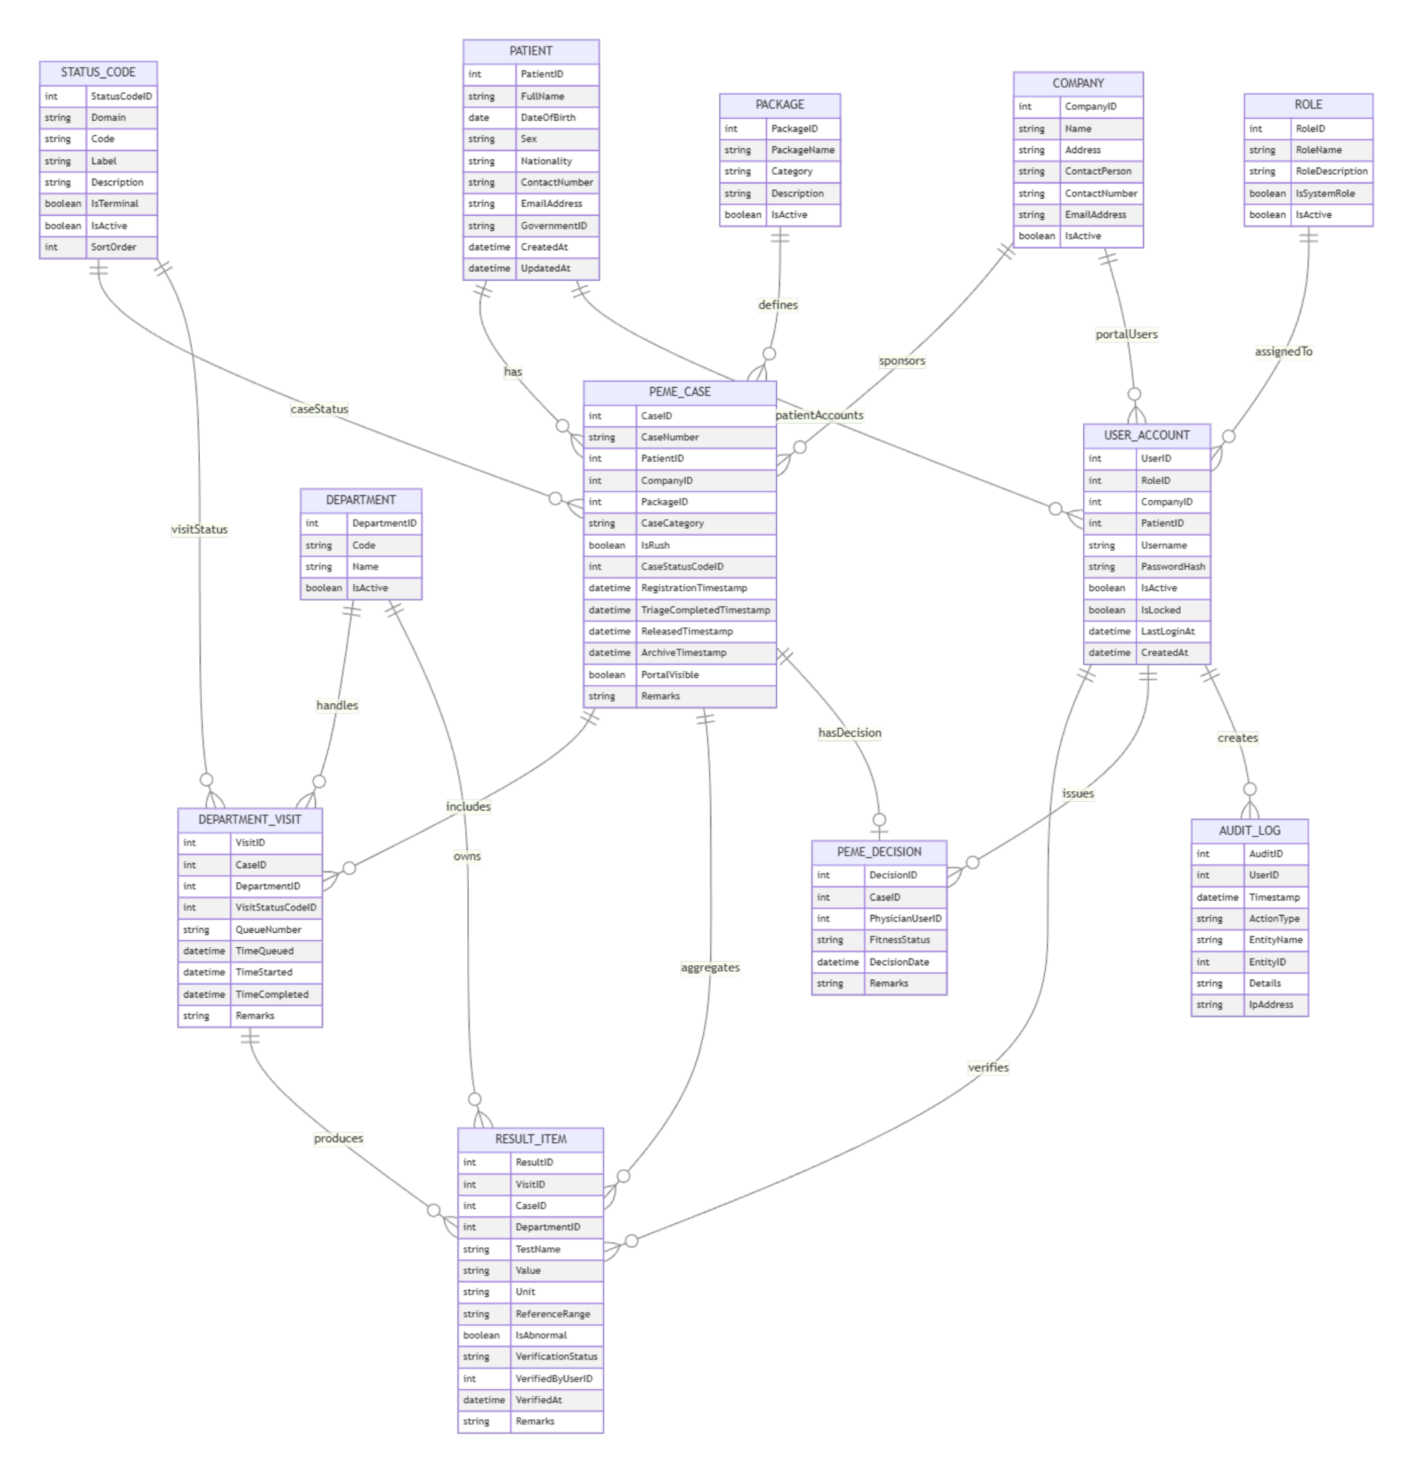
Figure 3.41 Entity Relationship Diagram
Figure 3.37 shows the database schema of the AHI PEME Information System, with PEME_CASE at the center. PATIENT and COMPANY provide the identities of the examinee and the sponsoring client, while PACKAGE and DEPARTMENT define configurable PEME packages and clinical service units. For each PEME case, the system records one or more DEPARTMENT_VISIT rows that track departmental processing and associated RESULT_ITEM rows that store detailed clinical findings. PEME_DECISION stores the physician’s final fitness decision for a case. USER_ACCOUNT and ROLE support role-based access control for internal staff, patient portal users, and client representatives, STATUS_CODE defines the valid lifecycle states for cases and visits, and AUDIT_LOG provides traceability for sensitive actions performed by authenticated users.

Discussion of Key Relationships
One patient can have many PEME_CASE records, and one company can sponsor many cases, which establishes one-to-many relationships from PATIENT and COMPANY to PEME_CASE. Each PEME_CASE has one or more DEPARTMENT_VISIT records and at most one PEME_DECISION, reflecting the lifecycle from registration through departmental work to final decision. Each DEPARTMENT_VISIT has zero or more RESULT_ITEM rows, allowing multiple tests or findings per visit while still tying each result to a specific department and case. STATUS_CODE standardises status values for cases and visits, ROLE groups permissions for multiple USER_ACCOUNT records, and PATIENT and COMPANY each may own multiple USER_ACCOUNT rows for patient and client representative portal access. Each user can create many AUDIT_LOG entries, ensuring that all critical operations in the PEME workflow are auditable.

3.2.10 Data Dictionary
The database is implemented using PostgreSQL, housed within the Supabase infrastructure. To enhance security against enumeration attacks—particularly for publicly accessible portal queries—primary keys for critical operational entities, such as PEME_CASE and PATIENT, will utilize UUIDs (Universally Unique Identifiers) in the physical database, though they are conceptually represented as standard identifiers in this dictionary.

Furthermore, the USER_ACCOUNT table integrates directly with Supabase Auth. Password hashing (using robust algorithms like Argon2 or bcrypt), token generation, and session management are securely delegated to the built-in authentication service, ensuring enterprise-grade credential protection.

Table 3.1 PATIENT
Field Name | Data Type | Description | Constraints
PatientID | INT | Internal identifier of the patient | Primary key, auto-increment
FullName | VARCHAR(100) | Full name of the patient | Not null
DateOfBirth | DATE | Date of birthproje | Not null
Sex | VARCHAR(10) | Sex of the patient | Not null
Nationality | VARCHAR(50) | Nationality of the patient | Nullable
ContactNumber | VARCHAR(30) | Primary contact number | Nullable
EmailAddress | VARCHAR(100) | Email address | Nullable
GovernmentID | VARCHAR(50) | Government-issued ID or passport number | Nullable, unique where present
CreatedAt | DATETIME | Date and time the patient record was created | Default current timestamp
UpdatedAt | DATETIME | Date and time the record was last updated | Nullable
Table 3.1 stores the demographic and contact information of each individual undergoing a PEME at AHI. Each patient record can be linked to multiple PEME_CASE entries across different examinations over time.

Table 3.2 COMPANY
Field Name | Data Type | Description | Constraints
CompanyID | INT | Internal identifier of the company | Primary key, auto-increment
Name | VARCHAR(150) | Registered name of the company or manning agency | Not null
Address | VARCHAR(255) | Mailing address | Nullable
ContactPerson | VARCHAR(100) | Primary contact person | Nullable
ContactNumber | VARCHAR(30) | Contact phone or mobile number | Nullable
EmailAddress | VARCHAR(100) | Contact email | Nullable
IsActive | BOOLEAN | Flag indicating if the company is active | Default true
Table 3.2 records client organizations such as manning agencies and employers that sponsor PEME cases. A single company may sponsor many PEME_CASE records and may also have portal user accounts linked to it.

Table 3.3 PACKAGE
Field Name | Data Type | Description | Constraints
PackageID | INT | Identifier of the PEME package | Primary key, auto-increment
PackageName | VARCHAR(100) | Name of the PEME package | Not null, unique
Category | VARCHAR(50) | Category (e.g., sea-based, land-based) | Nullable
Description | VARCHAR(255) | Brief description of the package | Nullable
IsActive | BOOLEAN | Flag indicating if the package is active | Default true
Table 3.3 defines the standard PEME packages offered by AHI, including their name, category, and activation status. Each PEME_CASE references exactly one package, which drives the set of required departmental visits and examinations.

Table 3.4 DEPARTMENT
Field Name | Data Type | Description | Constraints
DepartmentID | INT | Identifier of the clinical department | Primary key, auto-increment
Code | VARCHAR(20) | Short code used by the system | Not null, unique
Name | VARCHAR(100) | Department name | Not null
IsActive | BOOLEAN | Flag indicating if the department is active | Default true
Table 3.4 lists all clinical and diagnostic departments that participate in the PEME process. Each department can appear in many DEPARTMENT_VISIT and RESULT_ITEM records.

Table 3.5 STATUS_CODE
Field Name | Data Type | Description | Constraints
StatusCodeID | INT | Identifier of the status code | Primary key, auto-increment
Domain | VARCHAR(30) | Status domain (e.g., CASE, VISIT, DECISION) | Not null
Code | VARCHAR(30) | Machine-readable status code | Not null
Label | VARCHAR(50) | Human-readable label | Not null
Description | VARCHAR(255) | Explanation of when this status is used | Nullable
IsTerminal | BOOLEAN | True if this status ends the lifecycle in its domain | Default false
IsActive | BOOLEAN | Flag indicating if the status code is still in use | Default true
SortOrder | INT | Order for displaying status values | Nullable
Table 3.5 standardizes lifecycle states used by the system for cases and visits for example, Registered, In_Progress, Completed. Separate domains allow the same structure to be reused for case-level and department-visit-level status management.

Table 3.6 PEME_CASE
Field Name | Data Type | Description | Constraints
CaseID | INT | Identifier of the PEME case | Primary key, auto-increment
CaseNumber | VARCHAR(30) | Human-readable case number used on printed forms | Not null, unique
PatientID | INT | Identifier of the patient | Foreign key to PATIENT.PatientID, not null
CompanyID | INT | Identifier of the sponsoring company | Foreign key to COMPANY.CompanyID, nullable
PackageID | INT | Identifier of the selected PEME package | Foreign key to PACKAGE.PackageID, not null
CaseCategory | VARCHAR(20) | Category such as sea-based or land-based | Nullable
IsRush | BOOLEAN | Rush flag indicating expedited processing | Default false
CaseStatusCodeID | INT | Current case status | Foreign key to STATUS_CODE.StatusCodeID, Domain = CASE, not null
RegistrationTimestamp | DATETIME | Date and time the case was registered | Not null
TriageCompletedTimestamp | DATETIME | Date and time triage was completed | Nullable
ReleasedTimestamp | DATETIME | Date and time the case was released | Nullable
ArchiveTimestamp | DATETIME | Date and time the case was archived | Nullable
PortalVisible | BOOLEAN | Flag indicating if the released case is visible in portal | Default false
Remarks | VARCHAR(255) | General notes about the case | Nullable
WaiverSigned | BOOLEAN | Flag indicating if the patient signed the physical DPA consent form to share results with the company. | Default false
Table 3.6 is the central operational entity that represents a single PEME instance for a patient under a specific company and package. It tracks the overall case status, timestamps for key milestones, rush flag, and portal visibility.

Table 3.7 DEPARTMENT_VISIT
Field Name | Data Type | Description | Constraints
VisitID | INT | Identifier of the department visit | Primary key, auto-increment
CaseID | INT | Identifier of the PEME case | Foreign key to PEME_CASE.CaseID, not null
DepartmentID | INT | Identifier of the department | Foreign key to DEPARTMENT.DepartmentID, not null
VisitStatusCodeID | INT | Current visit status (e.g., Pending, In_Progress, Skipped, Completed, Cancelled) | Foreign key to STATUS_CODE.StatusCodeID, Domain = VISIT, not null
QueueNumber | VARCHAR(20) | Queue number shown to the patient | Nullable
TimePending | DATETIME | Date and time the visit entered the queue | Nullable
TimeStarted | DATETIME | Date and time service started | Nullable
TimeCompleted | DATETIME | Date and time service was completed | Nullable
Remarks | VARCHAR(255) | Visit-level notes from staff | Nullable
Table 3.7 represents each instance of a PEME case being processed in a specific department. For every PEME_CASE and participating DEPARTMENT, a corresponding DEPARTMENT_VISIT record tracks the visit’s queue number, status code, and key timestamps. These fields provide the basis for real-time queue monitoring and time-and-motion analysis of waiting and service times across departments.

Table 3.8 RESULT_ITEM
Field Name | Data Type | Description | Constraints
ResultID | INT | Identifier of the result item | Primary key, auto-increment
VisitID | INT | Identifier of the related department visit | Foreign key to DEPARTMENT_VISIT.VisitID, not null
CaseID | INT | Identifier of the PEME case for summary queries | Foreign key to PEME_CASE.CaseID, not null
DepartmentID | INT | Identifier of the department that produced the result | Foreign key to DEPARTMENT.DepartmentID, not null
TestName | VARCHAR(100) | Name of the test or parameter | Not null
Value | VARCHAR(100) | Recorded value or qualitative finding | Nullable
Unit | VARCHAR(20) | Measurement unit | Nullable
ReferenceRange | VARCHAR(50) | Reference or normal range | Nullable
IsAbnormal | BOOLEAN | True if the result is flagged as abnormal | Default false
VerificationStatus | VARCHAR(20) | Status such as Pending or Verified | Nullable
VerifiedByUserID | INT | User who verified the result | Foreign key to USER_ACCOUNT.UserID, nullable
VerifiedAt | DATETIME | Date and time the result was verified | Nullable
Remarks | VARCHAR(255) | Additional notes on the result | Nullable
Table 3.8 stores detailed findings for individual tests or parameters associated with a department visit. Each result item belongs to a specific DEPARTMENT_VISIT and PEME_CASE and includes value, unit, reference range, abnormality flag, and verification metadata.

Table 3.9 PEME_DECISION
Field Name | Data Type | Description | Constraints
DecisionID | INT | Identifier of the PEME decision | Primary key, auto-increment
CaseID | INT | Identifier of the PEME case | Foreign key to PEME_CASE.CaseID, not null, unique per case
PhysicianUserID | INT | User who issued the decision | Foreign key to USER_ACCOUNT.UserID, not null
FitnessStatus | VARCHAR(20) | Fitness status (e.g., Fit, Unfit, Pending) | Not null
DecisionDate | DATETIME | Date and time the decision was recorded | Not null
Remarks | VARCHAR(255) | Physician remarks and recommendations | Nullable
Table 3.9 records the physician’s overall fitness decision for a PEME_CASE. It links a case to the physician’s user account, the fitness status, the decision date, and any remarks or recommendations.

Table 3.10 ROLE
Field Name | Data Type | Description | Constraints
RoleID | INT | Identifier of the role | Primary key, auto-increment
RoleName | VARCHAR(50) | Role name (e.g., Reception, Physician, Patient) | Not null, unique
RoleDescription | VARCHAR(255) | Description of the role and its responsibilities | Nullable
IsSystemRole | BOOLEAN | True if this role is a predefined system role | Default true
IsActive | BOOLEAN | Flag indicating if the role is active | Default true

Table 3.10 stores the different system roles such as Reception, Department Staff, Physician, Patient, Client Representative, and Administration. These roles are referenced by USER_ACCOUNT and drive role-based access control throughout the system.

Table 3.11 USER_ACCOUNT
Field Name | Data Type | Description | Constraints
UserID | INT | Identifier of the user account | Primary key, auto-increment
RoleID | INT | Identifier of the assigned role | Foreign key to ROLE.RoleID, not null
CompanyID | INT | Company linked to this user (for client reps) | Foreign key to COMPANY.CompanyID, nullable
PatientID | INT | Patient linked to this user (for patient portal) | Foreign key to PATIENT.PatientID, nullable
Username | VARCHAR(50) | Unique username | Not null, unique
PasswordHash | VARCHAR(255) | Hashed password | Not null
IsActive | BOOLEAN | Flag indicating if the account is active | Default true
IsLocked | BOOLEAN | Flag indicating if the account is locked | Default false
LastLoginAt | DATETIME | Date and time of last successful login | Nullable
CreatedAt | DATETIME | Date and time of created account | Not Null
Table 3.11 holds login credentials and status flags for all system users, including internal staff, patient portal users, and client representatives. Each account references a ROLE and may optionally be linked to either a PATIENT or a COMPANY.

Table 3.12 AUDIT_LOG
Field Name | Data Type | Description | Constraints
AuditID | INT | Identifier of the audit log entry | Primary key, auto-increment
UserID | INT | User who performed the action | Foreign key to USER_ACCOUNT.UserID, nullable
Timestamp | DATETIME | Date and time of the action | Not null
ActionType | VARCHAR(50) | Type of action | Not null
EntityName | VARCHAR(50) | Name of the affected entity | Nullable
EntityID | INT | Identifier of the affected record | Nullable
Details | TEXT | Additional details of the action | Nullable
IpAddress | VARCHAR(45) | IP address or host of the client | Nullable

Table 3.12 records security-relevant and operationally important actions performed in the system, such as logins, status changes, and result verifications. Each entry links to the USER_ACCOUNT that initiated the action and captures when it occurred and which entity was affected.

3.3 Functional Requirements
This section specifies the functional behavior of the proposed American Hospital Inc. (AHI) PEME Information System. Requirements are grouped by user role and written as user requirements (UR) followed by detailed, testable functional requirements (FR).

User requirements describe the goals of the user, while functional requirements specify in measurable terms what the system shall do to support those goals. Each requirement is written so that it can be verified through inspection, testing, or review.

3.3.1 Reception and Billing Staff
- Reception and billing staff shall be able to register PEME cases with complete patient and case information so that cases are correctly linked to companies, packages, and rush categories.
  - The system shall allow reception and billing staff to search for an existing patient by full name, date of birth, passport number, or government ID before creating a new patient record.
  - The system shall allow reception and billing staff to create a new patient record with required fields: full name, date of birth, sex, primary contact number, and at least one identification number before saving.
  - The system shall require the selection of a company before a PEME case can be saved.
  - The system shall require the selection of a PEME package before a PEME case can be saved.
  - The system shall require the selection of a Case Category value before a PEME case can be saved.
  - The system shall require the reception staff to check a boolean indicator confirming whether the patient has signed the physical Data Privacy Act (DPA) consent waiver before a PEME case can be saved.
  - The system shall require the IsRush flag to be set to either Regular or Rush before a PEME case can be saved.
  - The system shall automatically generate a unique Case ID or Case Number when a PEME case is saved.
  - The system shall automatically record the registration time stamp when a PEME case is saved.
  - The system shall prevent changes to patient demographic data for a PEME case once the overall case status is beyond Registered, except for authorized users with elevated privileges as configured by the System Administrator.
  - The system shall not allow deletion of a PEME case once it has been saved; instead, cases that will not proceed shall be marked using a "Cancelled" or equivalent status.
- Reception and billing staff shall be able to monitor and filter active PEME cases during admission to support queue management and corrections.
  - The system shall provide a dashboard that lists active PEME cases with columns for patient name, company, case category, rush flag, and overall case status.
  - The system shall allow filtering of cases by registration date range on the dashboard.
  - The system shall allow filtering of cases by company on the dashboard.
  - The system shall allow filtering of cases by a rush flag on the dashboard.
  - The system shall allow filtering of cases by overall case status on the dashboard.
  - The system shall allow opening of a PEME case from the dashboard when the overall case status is Registered or In Progress.
  - The system shall prevent changes to patient demographic data once the case status is beyond Registered, except by authorized roles, to preserve audit integrity

3.3.2 Nurse
- The nurse shall be able to perform triage and readiness assessment for PEME cases scheduled for the current day.
  - The system shall allow the nurse to view a triage list of PEME cases in Registered or In_Progress status that are scheduled for triage on the current day.
  - The system shall allow the nurse to filter the triage list by rush flag.
  - The system shall allow the nurse to open the triage form for a selected PEME case from the triage list.
  - The system shall record a Triage Completion Time Stamp for the PEME case when the nurse submits the triage form.
- The nurse shall be able to manage the triage queue and prioritize rush PEME cases.
  - The system shall allow department staff to open a clinical data entry form for a department visit currently in the In_Service status.
  - The system shall allow department staff to actively encode and save required test results, flags, and clinical parameters associated with the specific examination package.
  - The system shall immediately broadcast a real-time WebSocket event upon the completion and saving of a department visit, updating the global case progress without requiring a manual system refresh.
Department Staff
- Department staff shall be able to manage departmental queues for PEME visits assigned to their department.
  - The system shall allow department staff to view a departmental queue that displays only DepartmentVisit records for the staff member’s department.
  - The system shall display for each entry in the departmental queue the patient name, Case ID or Case Number, rush flag, queue number, and DepartmentVisit status.
  - The system shall sort the departmental queue first by rush flag and then by TimeQueued.
  - The system shall allow department staff to view a list of department visits currently in the Pending status.
  - The system shall allow department staff to change a department visit status from Pending to In_Service when a patient is physically present and the examination begins.
  - The system shall allow department staff to change a department visit status from Pending to Skipped if a called patient is absent, moving them down the queue.
  - The system shall allow department staff to return a Skipped department visit back to Pending once the absent patient physically arrives at the department.
  - The system shall allow department staff to change a department visit status from In_Service to Completed once the examination and result encoding are finished.
  - The system shall allow department staff to change a department visit status from Pending to Cancelled if the test is no longer required.
  - The system shall automatically record the TimePending timestamp when a DepartmentVisit first enters the Pending status.
  - The system shall automatically record the TimeStarted timestamp when a DepartmentVisit status changes to In_Service.
  - The system shall automatically record the TimeCompleted timestamp when a DepartmentVisit status changes to Completed.
- Department staff shall be able to review summarized test completion and flags for DepartmentVisit records using data from the existing clinic information system (CIS).
  - The system shall allow department staff to open a read-only result summary view for a department visit in completed status for their department.
  - The system shall display, in the result summary view, a configured set of key test indicators retrieved from the CIS.
  - The system shall not allow editing clinical test values or verification statuses stored in the CIS from within the PEME Information System.
  - The system shall display a notification when no result data is yet available from the CIS for a DepartmentVisit marked Completed.

3.3.3 Physician
- The physician shall be able to review consolidated PEME case findings and record a fitness decision.
  - The system shall allow the physician to view a list of PEME cases in the For_Decision status.
  - The system shall allow the physician to open a case summary that displays patient demographics, company, package, case category, rush flag, and overall case status.
  - The system shall display in the case summary a consolidated, auto-generated summary of all examination results encoded by the respective clinical departments, eliminating the need for manual chart collation.
  - The system shall display in the case summary a consolidated list of ResultItem entries grouped by department with values and normal flags.
  - The system shall allow the physician to select a fitness status value from a controlled list before saving the decision.
  - The system shall allow the physician to enter decision remarks as free text with a configured maximum length.
  - The system shall record the physician user identifier and decision time stamp when the fitness decision is saved.
  - The system shall allow the physician to review all encoded ResultItem entries, but restrict the physician from modifying raw data encoded by other departments to preserve audit integrity; only the final fitness decision and physician remarks may be edited.
- The physician shall be able to request additional examinations and revise decisions when needed.
  - The system shall allow the physician to change a PEME case status from For_Decision to Pending_Additional_Tests.
  - The system shall require the physician to select one or more departments for additional tests before confirming the Pending_Additional_Tests status.
  - The system shall automatically create new DepartmentVisit records for each selected department when additional tests are requested.
  - The system shall update the overall case status from Pending_Additional_Tests to In_Progress when additional DepartmentVisit records are created.
  - The system shall allow the physician to revise the fitness decision while the overall case status is For_Decision.

3.3.4 Releasing Staff
- Releasing staff shall be able to verify PEME case completeness and finalize cases for release.
  - The system shall allow releasing staff to view a list of PEME cases in the For_Releasing status.
  - The system shall allow releasing staff to open a release checklist for a selected PEME case.
  - The system shall display for the selected PEME case the completion status of each required DepartmentVisit.
  - The system shall display for the selected PEME case the presence or absence of a recorded fitness decision.
  - The system shall prevent finalization of a PEME case when at least one required DepartmentVisit is not in Completed or Cancelled status.
  - The system shall prevent finalization of a PEME case when a fitness decision record is not present.
  - The system shall allow releasing staff to confirm the final release of a PEME case that satisfies all checklist conditions.
  - The system shall update the overall case status from For_Releasing to Released when final release is confirmed.
  - The system shall record the releasing user identifier and release time stamp when a PEME case is marked as released.
- Releasing Staff shall be able to generate release documents, control portal visibility, and trigger notifications for released PEME cases.
  - The system shall allow releasing staff to generate a printable PEME certificate for a released case.
  - The system shall allow releasing staff to generate a transmittal summary per company and date range that lists released cases.
  - The system shall mark a released case as portal-visible after finalization.
  - The system shall allow releasing staff to hide a released case from the external portal when internal correction is required.
  - The system shall require releasing staff to enter a reason when a released case is hidden from the external portal, and this action shall be recorded in the audit log.
  - The system shall record an audit log entry whenever portal visibility for a released case is changed.
  - The system shall automatically queue an email notification to the configured client representative email address of the case company when a released case is marked portal-visible.
  - The system shall record an audit log entry indicating whether the email notification for a released case was successfully queued or failed.

3.3.5 Client Representative
- The Client Representative shall be able to search released PEME cases for their company through the external portal.
  - The system shall allow the client representative to log in to the external portal using a username and password.
  - The system shall display only PEME cases that are in Released status, marked as portal-visible, and linked to the company associated with the logged-in client representative.
  - The system shall allow the client representative to search for released PEME cases by applicant name.
  - The system shall allow the client representative to search for released PEME cases by passport number.
  - The system shall allow the client representative to search for released PEME cases by registration date range.
  - The system shall display search results as a list with columns for applicant name, Case ID or Case Number, registration date, fitness status, and release date.
- The Client Representative shall be able to view and obtain PEME result summaries for released cases.
  - The system shall permit the client representative to open a PEME result summary for a selected released case only if the system verifies that the WaiverSigned flag for that specific case is marked as true.
  - The system shall display in the PEME result summary the applicant’s demographics, company, package, case category, rush flag, and release date.
  - The system shall display in the PEME result summary the final fitness status and decision remarks.
  - The system shall limit the PEME result summary for the Client Representative to a configurable subset of test findings and flags, as defined by the System Administrator in accordance with AHI policy.
  - The system shall allow the client representative to download a printable PEME result summary in a fixed layout format.
  - The system shall prevent the client representative from opening a PEME result summary for any case that is not in released status.
  - The system shall provide a mobile-responsive view of the PEME result summary, allowing client representatives to review fitness statuses clearly on mobile devices without horizontal scrolling.
  - The system shall display a standardized compliance notice to the client representative stating that the displayed medical records are shared in accordance with the patient's signed Data Privacy Act waiver at the time of admission.

3.3.6 Patient
- Patients shall be able to view the progress and final status of their own PEME cases and access released examination summaries without needing to ask staff at every step.
  - The system shall allow a patient to access a patient portal using a unique combination of identifiers (e.g., Case ID and date of birth or passport number), as configured by the System Administrator.
  - The system shall display, for an authenticated patient, the current overall PEME case status (e.g., Registered, In Progress, For Physician, For Release, Released).
  - The system shall display, for an authenticated patient, a list of required examination groups and their status.
  - Once a case has been marked Released, the system shall allow the patient to view a summary of findings and the final PEME decision, using read-only data from the existing clinic information system (CIS) and configured fields.
  - The system shall not display detailed clinical notes or raw test values beyond what the clinic’s privacy policy and Data Privacy Act provisions allow for patient portal viewing, as determined by the system administrator.
  - The system shall allow the system administrator to configure which summary fields and indicators are visible in the patient portal so that only information approved under AHI policy is shown.
  - The system shall render the patient portal using touch-friendly UI components and responsive layouts, ensuring that patients can navigate the progress tracker and download PDF certificates directly from standard mobile web browsers.

3.3.7 System Administrator
- The system administrator shall be able to manage user accounts and roles for internal and external users.
  - The system shall allow the system administrator to create a user account with a unique username and an assigned primary role.
  - The system shall allow the system administrator to lock a user account to prevent login.
  - The system shall allow the system administrator to disable a user account permanently.
  - The system shall display the last login time stamp for each user account.
  - The system shall allow the system administrator to reset a user password through a controlled procedure.
- The system administrator shall be able to configure reference data for departments, packages, and status codes.
  - The system shall allow the system administrator to create a department record with a department name and active flag.
  - The system shall allow the system administrator to deactivate a department while preserving existing references.
  - The system shall allow the system administrator to create a PEME package record with a package name and description.
  - The system shall allow the system administrator to map a PEME package to one or more departments through a configuration screen.
  - The system shall allow the system administrator to activate or deactivate a PEME package.
  - The system shall allow the system administrator to define PEME case status codes through a configuration screen.
  - The system shall allow the system administrator to define department visit status codes through a configuration screen.
  - The system shall prevent deletion of a status code that is referenced by at least one record.
  - The system shall allow the System Administrator to create and maintain Company records with at least a company name and active flag.
  - The system shall allow the System Administrator to associate a Client Representative user account with one or more Company records to control which PEME cases are visible in the external portal.
- The system administrator shall be able to maintain audit logs, system parameters, and email settings.
  - The system shall record an audit log entry for each successful login.
  - The system shall record an audit log entry for each failed login attempt.
  - The system shall record an audit log entry for each creation, update, or deletion of a PEME_CASE record.
  - The system shall record an audit log entry for each change in DepartmentVisit status.
  - The system shall record an audit log entry for each change in PEME fitness decision.
  - The system shall record an audit log entry for each change in case release status.
  - The system shall allow the system administrator to view audit log entries filtered by date range.
  - The system shall allow the system administrator to filter audit log entries by user account.
  - The system shall allow the system administrator to export filtered audit log entries to a secure file format for external review.
  - The system shall provide an administrative screen that displays the application version, database version, and last backup time stamp to support troubleshooting.
  - The system shall allow the system administrator to configure SMTP server settings used for outbound email notifications.
  - The system shall allow the system administrator to configure email templates for result-availability notifications sent to client representatives.

3.4 Non-Functional Requirements
This section specifies non-functional requirements that describe how well the AHI PEME Information System must perform in terms of usability, reliability, performance, supportability, and security. All requirements are stated so that they can be quantitatively verified.

3.4.1 Usability
- The system shall enable a trained reception and Billing Staff member to complete registration of an
existing patient’s PEME case in 5 minutes or less during pilot testing.
- The system shall enable a trained Department Staff member to move a DepartmentVisit from Waiting to In_Service in 5 clicks or less from the departmental queue screen.
- The system shall enable a trained releasing staff member to locate and open a case in For_Releasing status in 3 clicks or less from the releasing list.
- The system shall enable a client representative to log in, search for a released case, and open the PEME result summary within 2 minutes without using a printed manual during usability testing.
- The system shall display consistent navigation menus and page titles across all external portal pages as verified during interface review.
- The system shall achieve a System Usability Scale (SUS) score of at least 70 from 80 percent of participating internal users during post-deployment evaluation.
- The system shall achieve a System Usability Scale (SUS) score of at least 70 from 80 percent of participating external users, specifically client representatives, during post-deployment evaluation.
- The external Patient and Client Representative portals shall adaptively scale to fit standard mobile viewports, ranging from 360px to 428px in width, without requiring the user to horizontally scroll or manually zoom to read text.
- All primary interactive elements (buttons, links, dropdowns) on the mobile view shall maintain a minimum touch target size of 44x44 pixels to ensure touch accessibility.

3.4.2 Reliability
- The system shall achieve at least 99.0 percent uptime during AHI clinic operating hours, excluding scheduled maintenance, as measured by server monitoring logs.
- The system shall achieve a mean time to repair of 2 hours or less for incidents that cause complete unavailability during clinic operating hours, measured from incident logging to restoration of service.
- The system shall guarantee that once a PEME case, DepartmentVisit, or ResultItem save operation is confirmed, the corresponding record exists in the database as verified by transaction logs.
- The system shall restore all committed PEME data after an application server restart without
requiring re-entry of previously saved records.

3.4.3 Performance
- The system shall load the active PEME case dashboard for internal users in 3 seconds or less for at least 95 percent of requests under a load of up to 20 concurrent internal users
- The system shall refresh the departmental queue screen in 2 seconds or less for at least 95 percent of requests under a load of up to 20 concurrent internal users.
- The system shall load search results for released cases in the client portal in 3 seconds or less for at least 95 percent of requests under a load of up to 10 concurrent external users.
- The system shall generate a printable PEME result summary in 5 seconds or less for at least 95 percent of requests during performance testing.
- The system shall support at least 30 simultaneous logged-in users, combining internal and external
users, without violating the specified response-time limits during performance testing.
- The system shall make a PEME case available in the external portal within 2 hours or less after the case status is set to Released, as verified by audit logs comparing the Release Time Stamp and the portal-visibility Time Stamp.
- The external Patient Portal shall achieve a First Contentful Paint (FCP) of 2 seconds or less and fully load within 4 seconds when accessed over a simulated standard 4G mobile network.

3.4.4 Supportability
- The system shall utilize Continuous Integration/Continuous Deployment (CI/CD) pipelines via GitHub Actions or Vercel to allow developers to push code updates to the production environment seamlessly.
- The system's backend infrastructure shall be capable of being containerized via Docker to support transition to an on-premises local server environment within 4 hours, should clinic policy require it.
- The system shall allow changes to departments, PEME packages, and status codes through configuration screens without modifying application source code.
- The system shall store configuration values for departments, PEME packages, and status codes in database tables or configuration files that can be updated without recompilation.

3.4.5 Security
- The system shall enforce a minimum password length of 8 characters for all user accounts.
- The system shall delegate user authentication, password hashing, and session token generation to a Supabase Auth, ensuring no plain-text or weakly-hashed passwords are stored in the application database.
- The system shall automatically log out inactive user sessions after a configurable inactivity period.
- The system shall restrict access to PEME case data based on assigned roles so that internal users can view only cases needed for their responsibilities as verified in role-based access control tests.
- The system shall restrict external portal access so that a client representative can view only released cases linked to the company associated with the representative’s user account.
- The system shall record an audit log entry for every successful login attempt with user identifier, time stamp, and source IP address.
- The system shall record an audit log entry for every failed login attempt with the attempted
username, time stamp, and source IP address.
- The system shall record an audit log entry for every creation, update, or deletion of PEME cases, DepartmentVisit records, ResultItem entries, fitness decisions, and release actions.
- The system shall allow authorized administrators to filter audit log entries by date range and user account.
- The system shall allow authorized administrators to export filtered audit log entries to a secure file format for external review.
- The system shall require HTTPS for all browser connections to the production web server using a valid server certificate.
- The system shall send email notifications for released cases using SMTP over TLS or a comparable secure email transport.
- The system shall ensure that email notifications for released cases do not include detailed medical
findings in the email body and instead direct recipients to log into the portal to view results.
- The system shall ensure that fields and indicators displayed in patient and client representative portals are limited to those explicitly configured as visible by the system administrator, in accordance with AHI’s privacy policy and Data Privacy Act requirements.

3.5 Project Details

3.5.1 Project Development Methodology
The system development follows an Iterative and Incremental Development methodology organized into four iterations. Each iteration delivers functional system components, enables stakeholder review, incorporates feedback during development, and identifies technical problems before they become costly to resolve. Each iteration completes planning, requirements analysis, design, implementation, testing, and pilot deployment.

Iteration 1: Cloud Infrastructure and Foundational Architecture
This iteration establishes the core cloud-native environment. The development team sets up the Supabase PostgreSQL database, configures built-in authentication, and initializes the Next.js/React frontend repository. Database schemas are migrated to establish normalized structures for patients, departments, and packages. Row Level Security (RLS) policies are implemented to secure baseline data access. Testing verifies secure frontend-to-backend API communication, user authentication flows, and the successful deployment of the web application via CI/CD pipelines.

Iteration 2: Active Encoding and Real-Time Dashboard Expansion
This iteration develops the core clinical workflow, transitioning the clinic from paper routing to active digital encoding. Interfaces are built for Reception to register cases and for Department Staff to encode clinical findings directly into the system. Real-time WebSocket subscriptions are implemented so that as departments complete tests, the progress status automatically updates across all staff dashboards. Testing verifies that the package mapping logic accurately calculates completion percentages and validates that real-time state changes occur efficiently under concurrent user load, directly addressing the manual collation bottlenecks identified in Chapter 1.

Iteration 3: Patient and Agency Portal Development
This iteration creates two external-facing interfaces. The patient interface displays personal examination progress based on assigned package, showing completed tests, pending tests, and next required department. The agency portal enables recruitment agency representatives to view examination status and access results for their assigned workers. Secure authentication distinguishes staff users, individual patient users, and agency representative users with role-based permissions. The system generates downloadable PDF certificates. Email notification functionality triggers alerts to releasing staff, agency representatives, and patients when results become available in the portal. Security testing identifies and remediates vulnerabilities through OWASP ZAP scanning and manual penetration testing. This iteration addresses the 50 to 65 weekly agency status inquiries and provides patients direct visibility into personal progress.

Iteration 4: Completion, Validation, and Deployment Preparation
This iteration fixes remaining defects, optimizes performance for 20 to 30 concurrent staff users and 50 to 100 external users, completes comprehensive documentation, and conducts full compliance review against ISO 9001:2015, DOH Administrative Orders 2012-0012 and 2013-0006, and Data Privacy Act requirements. The team prepares a production deployment plan, develops training materials, and conducts staff training sessions. The formal evaluation period for baseline and post-implementation data collection begins.

Between iterations, the development team incorporates feedback from clinic staff and stakeholders. Research activities are scheduled during low-volume operational periods and kept brief to minimize service disruption while maintaining continuous clinic operations.

3.5.2 Evaluation Procedure
The evaluation employs before-and-after comparison design collecting identical measurements pre-implementation and post-implementation (Mansoor et al., 2024). This approach measures system impact on documented operational problems.

3.5.3 Pre-Implementation Baseline Measurement
Direct observation records complete patient journeys from admission through result release following time-and-motion study methodology adapted from Karthikeyan et al. (2024). While their approach was developed for tertiary outpatient department workflow analysis, the fundamental observation techniques and timestamp recording methods apply to specialized secondary clinic workflows. Observers document 40 to 60 complete patient journeys capturing cumulative waiting time across all ten departments, total cycle time from admission to result availability, department-specific wait times, and manual coordination activities between units.

Baseline performance metrics include 2.6-hour average cumulative patient waiting time, laboratory 65-minute peak wait times, radiology 55-minute peak wait times, 224 monthly result collation incidents requiring 50 to 85 minutes daily staff time for manual status checking, 160 monthly encoding incidents from repeated data entry, 92 percent regular PEME completion rate representing 72 monthly failures to meet 72-hour targets, 89 to 90 percent rush PEME completion rate representing 11 monthly failures to meet 24-hour targets, and 50 to 65 weekly agency status inquiries.

Staff interviews document causes of delays including coordination challenges between departments, difficulties locating patient status without systematic notification of completion, bottlenecks in result compilation when releasing staff manually poll departments, and time consumed responding to agency status inquiries.

3.5.4 Post-Implementation Measurement
Following staff familiarization with the system, identical measurement methods repeat. Observers record patient waiting time to assess reduction from 2.6-hour baseline. Result release timing measures interval from final department completion to portal availability, targeting reduction in idle time of 1 to 3 hours when completed results await manual discovery by releasing staff.

System logs automatically capture complete patient journey timestamps enabling precise calculation without relying solely on manual observation. Portal usage metrics document access patterns by patients and agency representatives. Agency status inquiry frequency measures reduction from baseline of 50 to 65 weekly calls. Staff coordination time measures reduction from baseline of 50 to 85 minutes daily spent manually checking department completion status. Email notification delivery times are recorded to verify alert functionality.

3.5.5 User Feedback Collection
Staff users complete System Usability Scale (SUS) after a minimum of two weeks of use, focusing on whether the system helps locate patient status quickly and coordinate result releases without manual department polling (Hyzy et al., 2022). Patient portal users complete usability surveys assessing ease of viewing personal examination progress and accessing results. Agency portal users complete surveys evaluating status visibility and result access compared to phone or email inquiries.

Structured compliance audit checklist verifies Data Privacy Act adherence under Republic Act No. 10173, ISO 9001:2015 requirements, and DOH standards under Administrative Orders 2012-0012 and 2013-0006 through systematic review of documentation control, record management, security measures, and audit trail capabilities.

3.5.6 Analysis and Comparison
Statistical tests determine whether observed improvements exceed random variation. Analysis examines whether the system reduces 2.6-hour average cumulative patient waiting time, decreases 224 monthly result collation incidents, decreases 160 monthly encoding incidents, reduces staff coordination time from 50 to 85 minutes daily, decreases 8 percent regular PEME late completion rate, decreases rush PEME late completion rate from 10 to 11 percent, reduces agency status inquiries from 50 to 65 weekly, reduces idle time of 1 to 3 hours between department completion and result availability, and successfully delivers email notifications for result availability.

3.5.7 Software Quality Characteristics
System quality is assessed across eight dimensions using ISO/IEC 25010:2023 standard for software products in context of clinic requirements supporting 45 staff members, 50 daily patients, 1,000 monthly PEME cases, and maintaining 50,000 to 70,000 active patient records (International Organization for Standardization, 2023).

Functional Suitability – All planned features work correctly. Read-only integration accurately retrieves data from existing CIS modules without modification. Package mapping logic correctly matches completed tests against requirements. Staff dashboard displays accurate real-time status aggregated from CIS modules. The patient interface shows correct personal progress. Agency portal displays authorized worker information only. Role-based access control enforces permissions preventing unauthorized data access. PDF certificate generation produces accurate documents. Email notification system triggers alerts when results become available in the portal.

Performance Efficiency – Dashboard pages load within 2 seconds. Database queries return results quickly when searching through 50,000 to 70,000 patient records. Real-time status aggregation from multiple CIS modules completes promptly. Email notifications deliver within acceptable timeframes. The system handles concurrent usage by 20 to 30 staff users and 50 to 100 external users without degradation. Performance testing simulates peak conditions verifying maintained responsiveness under maximum load conditions reaching 60 to 70 patients during mid-week rush periods.

Compatibility – The system integrates with existing CIS modules through read-only database connections. It functions on clinic server infrastructure and network. The system does not conflict with existing operations where staff continue entering data into CIS modules following current practices. Email notification integrates with existing email infrastructure currently used for result distribution to agencies.

Usability – Users accomplish tasks quickly with minimal errors. Interface terminology matches how staff think about patient flow across ten departments. The internal staff dashboard utilizes expansive desktop layouts for dense data tables, while the external Patient and Agency portals employ a mobile-first responsive design. This ensures progress tracking and result access are straightforward and legible on smartphones. System Usability Scale scores target 68 or above, indicating above-average usability following Hyzy et al. (2022) benchmarking for digital health applications.

Reliability – The system operates continuously without crashing or losing data. Automatic recovery mechanisms restore operation after errors. Uptime target is 99 percent during clinic hours representing less than 24 minutes monthly downtime. Email notification system demonstrates reliable delivery of alerts.

Security – Patient data is protected from unauthorized access meeting Data Privacy Act requirements for managing 50,000 to 70,000 patient records and approximately 12,000 annual PEME examinations. Secure user authentication, encrypted data transmission using HTTPS, encrypted data storage, comprehensive audit logging of all access events, and role-based permissions preventing unauthorized viewing protect sensitive information. Read-only CIS integration eliminates risk of accidental data modification. Email notifications contain secure portal links rather than sensitive patient data.

Maintainability – Code is organized logically with clear documentation enabling future updates. Modular design allows component modification without affecting the entire system. Read-only integration approach simplifies maintenance by avoiding complex bidirectional synchronization. Email notification functionality uses standard protocols enabling straightforward troubleshooting and updates.

Portability – The system operates on different server hardware using standard database structures and web technologies. It avoids vendor lock-in through use of open-source technologies. Email notification uses standard SMTP protocols ensuring compatibility with various email service providers.

3.5.8 Data Gathering Procedure
Document Review – Clinic operating manuals, workflow procedures, audit reports, and historical records documenting 1,000 monthly PEME cases are examined. Particular attention goes to records showing 224 monthly result collation incidents, 160 monthly encoding incidents, 72 monthly regular PEME late completions, and 11 monthly rush PEME late completions.

Direct Observation – Trained observers watch complete patient journeys recording cumulative waiting time across departments and total cycle time following time-and-motion methodology adapted from Karthikeyan et al. (2024). Observation sessions span different days and operational conditions capturing both low-volume days with 30 to 35 patients and peak days reaching 60 to 70 patients. Observers document coordination activities, manual status checking procedures, and result compilation processes to understand sources of 2.6-hour average waiting time and delays causing missed deadlines.

Surveys – Staff and external users complete System Usability Scale containing ten standardized questions after a minimum two weeks of use (Hyzy et al., 2022). Custom surveys ask about improvements in patient flow visibility, result release timeliness, coordination effort reduction, and satisfaction compared to manual processes. Open-ended questions invite detailed comments.

System Logs – The system automatically records user activities including login times, patient status checks, result validation timestamps, portal access by external users, email notification delivery times and success rates, and all data access events. These objective records enable precise calculation of time from final department completion to result availability, directly measuring improvements in the releasing process.

Interviews – Individual conversations with 8 to 12 key individuals including department heads, frontline staff, administrative coordinators, and agency representatives explore how the system affects patient flow monitoring, result release coordination, email notification utility, and agency communication. Interviews are brief at 20 to 30 minutes and scheduled during convenient times.

All data collection follows ethical standards requiring informed consent, voluntary participation without penalty, confidentiality through anonymization, and scheduling minimizing patient care disruption.

3.5.9 Population and Sampling
The study population comprises three groups at American Hospital Inc. Staff users include all 45 employees across ten departments involved in pre-employment medical examination processing. External portal users include patients undergoing examinations and recruitment agency representatives managing worker deployments, drawn from a monthly volume of approximately 1,000 examinations. Patient journeys represent complete examination workflows from admission through result release.

Staff Users
Survey participation targets 20 to 30 respondents from the 45-person workforce, representing 44 to 67 percent of total staff. Sampling includes diverse departments, roles, and experience levels. Time-and-motion observations document staff interactions across all ten departments.

This target is justified by statistical adequacy and operational constraints. Hyzy et al. (2022) meta-analysis of 37 digital health applications found that 20 to 30 participants provide reliable System Usability Scale mean score estimation with confidence intervals adequate to distinguish usability categories. The clinic cannot allocate all 45 staff simultaneously due to patient care requirements. The target balances statistical reliability with operational feasibility.

External Portal Users
Targets include 20 to 30 external users from approximately 1,000 monthly examinations, split between patient users and agency representative users with minimum 10 to 15 respondents per subgroup. Participation is voluntary among portal adopters.

Early adopters may differ from non-users in technical proficiency, representing an acknowledged limitation. However, early adopter feedback identifies usability barriers and acceptance factors informing broader deployment. The target enables detection of group-specific patterns while remaining achievable given voluntary participation and the two to four week familiarization period required before valid feedback.

Patient Journey Observations
Observations capture 40 to 60 complete patient journeys pre-implementation and post-implementation, representing two to three weeks of operations at 50 patients daily. Observations span different PEME types for land-based and sea-based workers, different company packages, different days capturing 30 to 35 patient low-volume days and 60 to 70 patient peak days, and different times including morning admission rushes and afternoon result releases.

Statistical power analysis justifies this sample size. Cohen (1988) guidelines indicate that detecting medium effect sizes defined as Cohen's d of approximately 0.5 requires minimum 34 paired observations for 80 percent power at significance level 0.05. The 40 to 60 target exceeds this threshold while accounting for incomplete patient journeys, interrupted observation periods, and outlier cases.

This sample detects meaningful reductions in 2.6-hour average waiting time. A 15 to 20 percent reduction target of 0.4 to 0.5 hours produces effect sizes of 0.4 to 0.8, detectable with 40 to 60 observations at high power given typical standard deviations of 0.6 to 1.0 hours in healthcare waiting time studies (Karthikeyan et al., 2024). For completion rates, observing 40 to 60 cases during two to three weeks captures approximately 8 to 12 percent of monthly volume, enabling detection of 4 to 6 percentage point improvements from 92 percent to 96 percent for regular cases and 89 to 90 percent to 95 percent for rush cases.

Limitations
Staff participation is voluntary and operationally constrained, potentially introducing selection bias toward technically proficient or enthusiastic staff. Mitigation includes deliberate recruitment across all departments, department head encouragement, and flexible scheduling.

External user sampling is limited to voluntary early adopters who may be more technically proficient than the general population. This limitation is inherent to technology adoption evaluation and provides valuable information about initial adoption patterns.

Patient journey observations exclude cases with abandoned processes or exceptional circumstances. Mitigation includes sampling across different days and times to capture normal operational variation and documenting reasons for incomplete observations.

The two to three week observation period per measurement phase may not capture seasonal variations. However, the focus on process-level improvements in coordination efficiency rather than volume-dependent outcomes makes short-term observation adequate for detecting system impact on targeted problems.

The sampling strategy balances statistical adequacy with operational feasibility. Sample sizes align with published healthcare information technology research methodologies (Hyzy et al., 2022; Karthikeyan et al., 2024; Mansoor et al., 2024) and enable valid conclusions about system impact on documented operational problems.

3.5.10 Research Instruments
System Usability Scale (SUS)
This standardized ten-question survey measures ease of learning, efficiency, and satisfaction using five-point scales from strongly disagree to strongly agree (Brooke, 1996). Scoring yields usability scores ranging from 0 to 100. Hyzy et al. (2022) established through meta-analysis of 37 digital health application studies that average scores center at 68 points with standard deviation of 12.5, providing a benchmark for above-average usability. Scores above 68 indicate above-average experience; scores from 70 to 80 represent good usability; scores above 80 suggest excellent usability. The instrument is administered separately to staff dashboard users on desktop workstations, and to patient and agency portal users testing the application on their personal mobile devices, ensuring usability is validated across all intended hardware platforms.

Custom Satisfaction Survey
This survey specifically addresses how the system improves patient flow visibility, facilitates result release coordination, reduces manual status checking burden, enables patient self-service progress tracking, reduces agency inquiry frequency, and provides useful email notifications. It uses five-point scales with open-ended questions for detailed feedback.

Time-and-Motion Template
This structured form adapts Karthikeyan et al. (2024) healthcare workflow research methodology developed for tertiary outpatient department studies to specialized secondary clinic context, recording exact times when patients enter and exit each department, cumulative waiting periods, total cycle time from admission to result release, and observed coordination activities. It includes fields tracking regular versus rush cases enabling analysis of whether the system improves current completion rates of 92 percent for regular cases and 89 to 90 percent for rush cases. The template ensures consistent measurement across observation sessions and observers.

Compliance Audit Checklist
This detailed checklist translates ISO 9001:2015, DOH Administrative Orders 2012-0012 and 2013-0006, and Data Privacy Act under Republic Act No. 10173 requirements into specific verifiable criteria for systems handling approximately 12,000 annual PEME exams and maintaining 50,000 to 70,000 active patient records. Items specify verification methods including document review, system function testing, and configuration examination. The checklist systematically verifies regulatory compliance.

3.5.11 Statistical Treatment of Data
Descriptive Statistics
Patient waiting times, cycle times, and other measurements are summarized using means and standard deviations. Baseline metrics characterized include 2.6-hour average waiting time, department-specific wait times such as laboratory 65-minute peaks and radiology 55-minute peaks, percentage distributions of on-time versus late completions, incident frequencies for result collation at 224 monthly and encoding errors at 160 monthly, agency inquiry counts at 50 to 65 weekly, and email notification delivery metrics. Charts and graphs visualize patterns and changes.

Comparison Tests
For continuous measurements covering waiting time, cycle time, and coordination time, paired t-tests compare pre-implementation and post-implementation values. If distributions are skewed, Wilcoxon signed-rank tests are used. For categorical outcomes covering on-time completion rates and error frequencies, McNemar tests or chi-square tests assess whether proportions improve significantly (Field, 2018).

Effect Sizes
Percentage improvements provide intuitive interpretation such as cumulative patient waiting time decreased from 2.6 hours to 2.1 hours representing 19 percent reduction. Cohen's d standardizes mean differences enabling comparison against published healthcare IT intervention studies where d values of 0.2, 0.5, and 0.8 represent small, medium, and large effects (Cohen, 1988).

Usability Scale Analysis
Individual SUS responses are scored following published Brooke (1996) methodology yielding scores from 0 to 100. Means and standard deviations are calculated separately for staff users, patient users, and agency users. One-sample t-tests compare observed scores against a 68-point benchmark established by Hyzy et al. (2022). Item-level analysis identifies specific interface strengths and weaknesses.

Qualitative Analysis
Open-ended responses and interview transcripts are systematically reviewed, identifying recurring themes about patient flow visibility, coordination efficiency, result release timeliness, progress tracking value, email notification utility, and remaining challenges. Representative quotations are selected while protecting participant privacy. Findings from different sources including surveys, interviews, observations, and system logs are compared verifying consistency and triangulating conclusions (Braun & Clarke, 2006).

All statistical analyses employ significance level p > 0.05. Assumptions underlying each test are verified and violations reported transparently. Confidence intervals accompany all estimates characterizing precision and enabling judgment of operational meaningfulness.

3.5.12 Project Cost
Table 3.13 Projected Cost
Item | Unit Cost (PHP) | Quantity | Subtotal (PHP)
Onsite travel to clinic | 600 | 5 trips | 3,000
Printing user manuals and materials | 20 per page | 40 to 60 pages | 800 to 1,200
Cloud Database (Supabase Pro) | ~1,400 / month | 2 months (Testing/Deployment) | 2,800
Frontend Hosting (Vercel/Netlify) | Free Tier | 1 | 0
Custom Domain Name | ~800 / year | 1 | 800
Contingency for unexpected expenses | — | — | 2,000
Total Estimated Cost |  |  | 9,400 to 9,800

Cost Assumptions
All development work is performed by students as coursework with no labor costs. Server hardware and software are provided at no cost by the clinic or university. Open-source tools including database, programming frameworks, and utilities are free. If expenses exceed budget, contingency reserves and voluntary team contributions cover differences. Thesis adviser approval is required if costs substantially exceed estimate.

Travel Budget
Five onsite trips at 600 pesos round-trip reflect travel from Pasig work location to Intramuros clinic covering requirements gathering and workflow observation, system testing with staff, deployment and training, and post-implementation evaluation data collection.

3.5.13 Project Risk Management Plan
Risk management identifies potential problems and establishes preventive and contingency strategies. Risks are assessed for likelihood and impact on scales from 1 to 5 with scores calculated as likelihood multiplied by impact.

Critical Priority Risks
Limited Staff Availability - Likelihood: 5, Impact: 4, Score: 20
Staff maintain continuous operations serving 50 daily patients. Patient care takes priority over research participation. Staff have limited time for interviews, observations, and testing.
- Mitigation: Schedule activities during low-volume periods; keep sessions brief at 15 to 30 minutes; offer refreshments; use flexible scheduling; leverage asynchronous methods including email questionnaires and video demonstrations; accept smaller samples focusing on key informants rather than comprehensive coverage.
- Contingency: If participation falls below targets, acknowledge limitations in methodology section; rely on intensive data from willing participants; supplement breadth with qualitative depth; extend evaluation period if possible.

Security Vulnerabilities – Likelihood: 3, Impact: 5, Score: 15
Insufficient experience with healthcare data protection could expose patient information affecting 50,000 to 70,000 records and approximately 12,000 annual examinations.
- Mitigation: Hold security planning meetings before coding; implement security controls from project start; use OWASP ZAP during testing; conduct security code reviews with experienced mentors before deployment; verify email notification security ensuring no sensitive data in email content.
- Contingency: If critical issues are discovered late, limit production deployment to internal staff dashboard only, deferring patient and agency portals until security hardening is verified.

High Priority Risks
Requirements Misunderstanding – Likelihood: 3, Impact: 4, Score: 12
Limited requirements gathering due to staff availability could result in features misaligned with workflow needs or scope expanding beyond feasibility.
- Mitigation: Conduct structured requirements gathering from multiple sources including staff interviews across departments, direct workflow observation, operational document review, and historical data analysis showing the 72 monthly regular cases and 11 monthly rush cases that miss deadlines; document requirements formally with management sign-off; demonstrate working features each iteration for validation; establish formal change control requiring adviser approval for scope additions.
- Contingency: If scope expansion threatens timeline, invoke minimum viable system definition deferring non-critical features including advanced reporting, analytics, and enhanced notification features while ensuring core patient tracking and result release functionality sufficient for evaluation.

Staff Resistance to New System – Likelihood: 3, Impact: 4, Score: 12
Staff accustomed to manual processes may resist digital workflows limiting system use and evaluation validity.
- Mitigation: Involve representative staff in requirements and testing fostering ownership; design interfaces minimizing workflow changes using existing terminology; emphasize that system reads existing CIS data requiring no additional data entry burden; produce training video demonstrating coordination effort reduction; identify department champions; run parallel processes briefly allowing gradual adaptation; respond quickly to usability problems.
- Contingency: If adoption remains low, evaluate using willing early adopters; acknowledge adoption limitations in the discussion section; recommend extended adoption support post-thesis.

Internet Connectivity and Cloud Dependency – Likelihood: 3, Impact: 4, Score: 12
Because the system relies on a cloud-native architecture (React frontend, Supabase backend), continuous internet access is required for real-time synchronization between clinical departments. Intermittent connectivity issues at the clinic could halt the encoding and releasing workflows.
- Mitigation: Design the React frontend with robust error handling and loading states to prevent data loss during brief connection drops; implement lightweight payloads to minimize bandwidth usage; verify the clinic possesses a backup internet service provider (ISP).
- Contingency: If internet reliability proves insufficient for clinical operations, execute the architectural fallback plan by containerizing the Supabase backend via Docker and deploying the entire system on a local area network (LAN) server within the clinic, eliminating the external internet dependency for internal staff.

Technology Unfamiliarity – Likelihood: 4, Impact: 3, Score: 12
Third-year IT student skill level with Java, HTML, CSS, JavaScript, MySQL, and limited Python may not cover all frameworks or integration patterns required including email notification implementation. Learning unfamiliar technologies during development could cause delays.
- Mitigation: Prioritize technology stack based on strongest existing skills; dedicate initial period to proof-of-concept testing frameworks including email notification protocols; leverage online documentation and Stack Overflow; utilize faculty consultations for challenging problems; employ pair programming and code reviews; build modular architecture allowing familiar technologies where possible.
- Contingency: If specific technology proves too difficult, substitute simpler alternatives including basic email notification using standard SMTP libraries rather than complex messaging frameworks, prioritizing working functionality over technical sophistication; adjust thesis scope acknowledging technology constraints.

Geographic Dispersion – Likelihood: 4, Impact: 3, Score: 12
Team members in Manila, Pasig, and Parañaque with the clinic in Intramuros face substantial travel time. Manila to Pasig requires 1.5 to 2 hours each way; Parañaque to Pasig requires 1 to 1.5 hours; Pasig to Intramuros requires approximately 1 hour.
- Mitigation: Establish Pasig as primary work location; employ online collaboration tools including GitHub for version control, Google Drive for documentation, Discord or Messenger for communication, and Zoom for virtual meetings; schedule around traffic patterns favoring weekends and off-peak hours; distribute tasks enabling parallel work; consolidate clinic visits into intensive days accomplishing multiple objectives including observation, interviews, and testing; plan five budgeted trips strategically.
- Contingency: If travel becomes prohibitively difficult, increase remote collaboration accepting some productivity loss; reschedule sessions to more convenient times.

Insufficient Testing Participation – Likelihood: 4, Impact: 3, Score: 12
Staff reluctance to participate in testing due to workload pressures may result in inadequate sample sizes requiring at least 20 staff respondents from a workforce of 45.
- Mitigation: Schedule sessions during breaks or low-volume periods; design efficient protocols keeping sessions to 15 to 30 minutes; allow flexible drop-in participation; offer modest incentives; employ multiple recruitment methods including direct requests to department heads, email invitations, and personal appeals; accept smaller samples ensuring minimum statistical adequacy of at least 15 to 20 responses for SUS.
- Contingency: If participation falls short, extend recruitment period; supplement with qualitative case studies providing depth despite limited breadth; acknowledge sample limitations in methodology section.

Medium Priority Risks
Budget Overruns – Likelihood: 3, Impact: 3, Score: 9
Track expenses monthly against a budget of 5,800 to 6,200 pesos; prioritize essential costs including travel and printing; maintain 2,000 peso contingency reserve. If exceeded, team members contribute personal funds; seek adviser assistance accessing discretionary funds.

System Performance Issues – Likelihood: 3, Impact: 3, Score: 9
Design database with proper normalization and indexing; conduct performance testing each iteration using realistic data volumes simulating 50,000 to 70,000 patient records and 50 concurrent daily users; employ profiling tools; test on clinic hardware early; verify email notification system performance under load. If issues arise, reduce real-time features with less frequent dashboard auto-refresh; limit historical data display windows; optimize for peak hours.

Competing Academic Commitments – Likelihood: 3, Impact: 3, Score: 9
Establish realistic schedule accounting for concurrent coursework; distribute workload equitably among three team members; maintain transparent communication; build schedule buffers at 10 to 15 percent time allocation. Accept variable weekly productivity compensating during lighter periods; rely on iterative methodology flexibility.

Deployment Delays – Likelihood: 2, Impact: 4, Score: 8
Engage clinic management early; prepare comprehensive deployment proposals addressing security measures, compliance verification, and rollback procedures; submit authorization requests 4 to 6 weeks advance; maintain regular communication. If delayed, conduct evaluation using pilot deployment in a test environment acknowledging limited real-world data.

Server Infrastructure Limitations – Likelihood: 2, Impact: 4, Score: 8
Conduct infrastructure assessment during planning documenting server specifications, database versions, network configuration, and email server capabilities; design with modest requirements; test on clinic server early in Iteration 2; maintain portable design. If the server is unsuitable, seek permission for temporary university-provided hosting.

Data Quality Issues – Likelihood: 3, Impact: 2, Score: 6
Assess historical data availability during requirements phase; employ multiple baseline measurement methods triangulating data from documents, interviews, and direct observation; accept that some metrics may be estimates based on staff recall. If baseline deficient, focus on prospective measurements from the evaluation period; rely on qualitative improvement evidence.

Workflow Disruption During Transition – Likelihood: 2, Impact: 3, Score: 6
Limit parallel operation to 1 to 2 weeks minimum necessary for staff adaptation; provide clear guidance distinguishing when to use new versus old system; monitor feedback actively; communicate transition plan clearly. Accept temporary productivity loss as unavoidable transition cost; ensure manual process remains fully functional as fallback.

Low Priority Risks
Low priority risks with scores of 5 or less including natural disasters, public health emergencies, connectivity failures, browser compatibility problems, transportation cost increases, regulatory changes, adviser changes, clinic operational disruptions, and ownership changes are monitored passively. Response relies on contingency reserves, project flexibility, and reactive problem-solving if materialized.

Risk Monitoring Process
Bi-weekly team meetings include risk review assessing current status, identifying new risks, and evaluating mitigation effectiveness. Monthly risk register updates document score changes and trigger mitigation for increasing priorities. End-of-iteration reviews conduct comprehensive risk assessment before proceeding to the next iteration. Risk monitoring responsibilities rotate among team members ensuring shared awareness. Risks increasing to critical priority or materializing despite mitigation escalate to thesis adviser immediately. Clinic management is notified of risks affecting deployment, operations, or compliance.

References
A Secure Multi-factor Authentication Protocol for Healthcare Services Using Cloud-based SDN. (2022). Computers, Materials and Continua, 74(2), 3711–3726. https://doi.org/10.32604/cmc.2023.027992
Adelusi, B. S., Osamika, D., Kelvin-Agwu, M. C., Mustapha, A. Y., Forkuo, A. Y., & Ikhalea, N. (2025). A Dynamic Resource Optimization Model for Enhancing Patient Flow and Reducing Wait Times in U.S. Hospitals. 9(4).
Adhicandra, I., Nurhidayati, S., & Fauzan, T. R. (2024). Optimization of Hospital Queue Management Using Priority Queue Algorithm and Reinforcement Learning for Emergency Service Prioritization. International Journal Software Engineering and Computer Science (IJSECS), 4(2), 512–522. https://doi.org/10.35870/ijsecs.v4i2.2772
Ahmed, H. H. (2025). Using Mathematical Programming to Analyze and Improve Robust Queue Management in Healthcare Systems. International Journal of Applied Mathematics and Computing, 2(3). https://doi.org/10.62951/ijamc.v2i3.229
Al Moteri, M., Aljuaid, J., Alsufyani, B., Alghamdi, A., Althobiti, E. S., & Althagafi, A. (2024). Bottleneck factors impacting nurses’ workflow and the opportunity to prioritize improvement efforts: Factor analysis. BMC Nursing, 23(1), 640. https://doi.org/10.1186/s12912-024-02311-2
Alfurayh, G. H., Alanazi, A. T., & Aldalham, H. S. (2025). Feasibility of Using Patient Portal to Enhance Patient Engagement and Patient-Generated Data in Tertiary Hospital. Healthcare, 13(5), 518. https://doi.org/10.3390/healthcare13050518
Alipour-Vaezi, M., Aghsami, A., & Jolai, F. (2022). Prioritizing and queueing the emergency departments’ patients using a novel data-driven decision-making methodology, a real case study. Expert Systems with Applications, 195, 116568. https://doi.org/10.1016/j.eswa.2022.116568
Almasi, S., Bahaadinbeigy, K., Ahmadi, H., Sohrabei, S., & Rabiei, R. (2023). Usability Evaluation of Dashboards: A Systematic Literature Review of Tools. BioMed Research International, 2023(1), 9990933. https://doi.org/10.1155/2023/9990933
Al-Moteri, M., Alzahrani, A. A., Althobiti, E. S., Plummer, V., Sahrah, A. Z., Alkhaldi, M. J., Rajab, E. F., Alsalmi, A. R., Abdullah, M. E., Abduelazeez, A. E. A., Caslangen, M. M., Ismail, M. G., & Alqurashi, T. A. (2023). The Road to Developing Standard Time for Efficient Nursing Care: A Time and Motion Analysis. Healthcare, 11(15), 2216. https://doi.org/10.3390/healthcare11152216
Alomar, D., Almashmoum, M., Eleftheriou, I., Whelan, P., & Ainsworth, J. (2024). The Impact of Patient Access to Electronic Health Records on Health Care Engagement: Systematic Review. Journal of Medical Internet Research, 26(1), e56473. https://doi.org/10.2196/56473
AlQudah, A. A., Al-Emran, M., Daim, T. U., & Shaalan, K. (2024). Toward an Integrated Model for Examining the Factors Affecting the Acceptance of Queue Management Solutions in Healthcare. IEEE Transactions on Engineering Management, 71, 6116–6132. https://doi.org/10.1109/TEM.2022.3223520
Aminah, A., Manalu, H. L. L., Silaban, V. F., Munthe, D. S., & Harahap, R. F. (2025). Queueing theory and simulation for reducing patient waiting time in emergency departments. International Journal of Basic and Applied Science, 13(4), 179–190. https://doi.org/10.35335/ijobas.v13i4.639
Amor C. Tinam-isan, M., & F. Naga, J. (2024). Exploring the Landscape of Health Information Systems in the Philippines: A Methodical Analysis of Features and Challenges. International Journal of Computing and Digital Systems, 15(1), 225–237. https://doi.org/10.12785/ijcds/160118
An Optimized Role-Based Access Control Using Trust Mechanism in E-Health Cloud Environment. (n.d.). Retrieved December 1, 2025, from https://ieeexplore.ieee.org/abstract/document/10327710
Ariff, H., Kamardan, M., Sufahani, S., & Ali, M. (2018). Review on Queueing Problem in Healthcare. International Journal of Engineering & Technology, 7, 304. https://doi.org/10.14419/ijet.v7i4.30.22291
Avruscio, G., Ragazzo, S., & Ceccato, D. (2022). Implementation of a quality management system according to ISO 9001:2015 standards in an Angiology Unit: An Italian experience. ANNALI DI IGIENE MEDICINA PREVENTIVA E DI COMUNITÀ. https://doi.org/10.7416/ai.2022.2501
Baballe, M. (2022, September 24). Hospital Queue Management Systems’ Effects.
Benaich, R., El Mendili, S., & Gahi, Y. (2024). Securing EHRs With a Novel Token-Based and PPoS Blockchain Methodology. IEEE Access, 12, 83183–83204. https://doi.org/10.1109/ACCESS.2024.3412793
Benjamin, E. (2024). The work of patient flow management: A grounded theory study of emergency nurses. International Emergency Nursing, 74, 101457. https://doi.org/10.1016/j.ienj.2024.101457
Bettina D. Evio, M. a. N., & Sheila R. Bonito, D. (2024). Formative Evaluation of the Implementation of eHealth in the Philippines: A Qualitative Study. Acta Medica Philippina, 58(12). https://doi.org/10.47895/amp.v58i12.9289
Bhatt, L. D., Ghimire, S., & Khanal, K. (2024). Patient satisfaction and their determinants in outpatient department of a tertiary public hospital in Nepal: A cross-sectional study. Journal of Patient-Reported Outcomes, 8(1), 26. https://doi.org/10.1186/s41687-024-00696-x
Brand, M., Boehm, F., Kaisers, U. X., Fehling, P., Hoffmann, T. K., Rotter, N., Ludwig, S., & Theodoraki, M.-N. (2025). Bicentric evaluation of employee satisfaction, patient safety and treatment quality: Comparing different Health Information System (HIS) solutions. BMC Health Services Research, 25(1), 1470. https://doi.org/10.1186/s12913-025-13559-y
Brands, M. R., Gouw, S. C., Beestrum, M., Cronin, R. M., Fijnvandraat, K., & Badawy, S. M. (2022). Patient-Centered Digital Health Records and Their Effects on Health Outcomes: Systematic Review. Journal of Medical Internet Research, 24(12), e43086. https://doi.org/10.2196/43086
Braun, V., & Clarke, V. (2006). Using thematic analysis in psychology. Qualitative Research in Psychology, 3(2), 77–101. https://doi.org/10.1191/1478088706qp063oa
Brooke, J. (1996). SUS -- a quick and dirty usability scale (pp. 189–194).
Bruno, B., Steele, S., Carbone, J., Schneider, K., Posk, L., & Rose, S. L. (2022). Informed or anxious: Patient preferences for release of test results of increasing sensitivity on electronic patient portals. Health and Technology, 12(1), 59–67. https://doi.org/10.1007/s12553-021-00628-5
Bugdol, M. (2024). Quality Objectives in Standardized Quality Management Systems. Quality Management in Healthcare, 33(3), 200. https://doi.org/10.1097/QMH.0000000000000426
Bush, J. R. (DOH). (n.d.). Medical records-documentation, access, retention, storage, disposal, and closing a practice.
Butt, A. U. R., Mahmood, T., Saba, T., Bahaj, S. A. O., Alamri, F. S., Iqbal, M. W., & Khan, A. R. (2023). An Optimized Role-Based Access Control Using Trust Mechanism in E-Health Cloud Environment. IEEE Access, 11, 138813–138826. https://doi.org/10.1109/ACCESS.2023.3335984
Chen, Y., Lehmann, C. U., & Malin, B. (2024). Digital Information Ecosystems in Modern Care Coordination and Patient Care Pathways and the Challenges and Opportunities for AI Solutions. Journal of Medical Internet Research, 26(1), e60258. https://doi.org/10.2196/60258
Chingale, N. D., Walunj, S. D., Kikale, M. S., Devade, O. A., & Redasani, V. (n.d.). DOCUMENTATION ESSENTIALS IN THE PHARMACEUTICAL INDUSTRY: A REGULATORY PERSPECTIVE.
Chung, C. A., Dabu, J. A. V., Norada, F. R. A., Loreche, A. M., Pepito, V. C. F., & Dayrit, M. M. (2025). Improving Health Information Systems for Universal Health Coverage in the Philippines. Public Health Challenges, 4(2), e70050. https://doi.org/10.1002/puh2.70050
Cohen, J. (2013). Statistical Power Analysis for the Behavioral Sciences (2nd ed.). Routledge. https://doi.org/10.4324/9780203771587
Cronin, M., Munishi, L., Olomi, G. A., Mitao, M., Mmbaga, B. T., Somi, J., Khanga, J., Khashan, A. S., Pima, F. M., & Woodworth, S. (2025). Exploring healthcare staff experiences with a hybrid paper/digital health management information system and their perspectives on digitalization as an alternative – A Tanzanian qualitative case study on perinatal data. PLOS One, 20(11), e0335644. https://doi.org/10.1371/journal.pone.0335644
Dehghani Mahmoodabadi, A., Dehghan, H., Kimiafar, K., Karami, M., Mousavi Baigi, S. F., & Farsi Mehrabadi, M. (2025). Usability evaluation methods for hospital information systems: A systematic review. BMC Health Services Research, 25, 1540. https://doi.org/10.1186/s12913-025-13745-y
Deshpande, N., Arora, V. M., Vollbrecht, H., Meltzer, D. O., & Press, V. (2023). eHealth Literacy and Patient Portal Use and Attitudes: Cross-sectional Observational Study. JMIR Human Factors, 10(1), e40105. https://doi.org/10.2196/40105
Design and validation of a new Healthcare Systems Usability Scale (HSUS) for clinical decision support systems: A mixed-methods approach | BMJ Open. (n.d.). Retrieved December 1, 2025, from https://bmjopen.bmj.com/content/13/1/e065323
DOH ADMINISTRATIVE ORDER NO. 1, s. 2003—OPERATIONAL GUIDELINES IN THE CONDUCT OF PRE-EMPLOYMENT MEDICAL EXAMINATION OF OVERSEAS WORKERS AND SEAFARERS - Supreme Court E-Library. (n.d.). Retrieved December 1, 2025, from https://elibrary.judiciary.gov.ph/thebookshelf/showdocs/10/42203
DOH ADMINISTRATIVE ORDER NO. 2013-0006—GUIDELINES TO “RULE XI: ROLE OF DOH IN THE OMNIBUS RULES AND REGULATIONS IMPLEMENTING THE MIGRANT WORKERS AND OVERSEAS FILIPINOS ACT OF 1995, AS AMENDED BY REPUBLIC ACT NO. 10022”—Supreme Court E-Library. (n.d.). Retrieved November 30, 2025, from https://elibrary.judiciary.gov.ph/thebookshelf/showdocs/10/69068
Ezeanyim, O. C., Nwabunwanne, E. C., Igbokwe, N. C., & Nwamekwe, C. O. (2025). Patient Flow and Service Efficiency in Public Hospitals. Journal Health of Indonesian, 3(2), 104–124.
Fareed, M., & Yassin, A. A. (2022). Privacy-preserving multi-factor authentication and role-based access control scheme for the E-healthcare system. Bulletin of Electrical Engineering and Informatics, 11(4), 2131–2141. https://doi.org/10.11591/eei.v11i4.3658
Farzandipour, M., Nabovati, E., & Sadeqi Jabali, M. (2022). Comparison of usability evaluation methods for a health information system: Heuristic evaluation versus cognitive walkthrough method. BMC Medical Informatics and Decision Making, 22(1), 157. https://doi.org/10.1186/s12911-022-01905-7
Fattahi, M., Keyvanshokooh, E., Kannan, D., & Govindan, K. (2023). Resource planning strategies for healthcare systems during a pandemic. European Journal of Operational Research, 304(1), 192–206. https://doi.org/10.1016/j.ejor.2022.01.023
Ferreira, D. C., Vieira, I., Pedro, M. I., Caldas, P., & Varela, M. (2023). Patient Satisfaction with Healthcare Services and the Techniques Used for its Assessment: A Systematic Literature Review and a Bibliometric Analysis. Healthcare, 11(5), 639. https://doi.org/10.3390/healthcare11050639
Field, A.P. (2018) Discovering Statistics Using IBM SPSS Statistics. 5th Edition, Sage, Newbury Park. - References—Scientific Research Publishing. (n.d.). Retrieved December 1, 2025, from https://www.scirp.org/reference/referencespapers?referenceid=3504991
Gelisanga, M. A. P., Ocden, J. H. A., & Angeles, J. V. S. (2024). Duration of In-patient Physical Therapy at a Tertiary Hospital: Implications of a Time and Motion Study. Acta Medica Philippina, 58(20), 98–106. https://doi.org/10.47895/amp.v58i20.9535
Guidelines on the medical examinations of seafarers | International Labour Organization. (2011, September 30). https://www.ilo.org/resource/other/guidelines-medical-examinations-seafarers
Harbi, S. A., Aljohani, B., Elmasry, L., Baldovino, F. L., Raviz, K. B., Altowairqi, L., & Alshlowi, S. (2024). Streamlining patient flow and enhancing operational efficiency through case management implementation. BMJ Open Quality, 13(1). https://doi.org/10.1136/bmjoq-2023-002484
Harrison, M. W., Molina, A. L., Wu, C. L., & Shaughnessy, E. E. (2025). Enhancing Hospital Throughput: A Multidisciplinary Approach to Facilitating Discharges in a Pediatric Setting. Pediatric Quality & Safety, 10(2), e799. https://doi.org/10.1097/pq9.0000000000000799
Hartika, A., Fitridiani, M., & Asbari, M. (n.d.). Analysis of ISO 9001:2015 Implementation in Hospitals: A Narrative Literature Review.
Hartono, S., Ramli, Y., Astini, R., Widayati, C. C., & Ali, A. J. (2024). The Clinical Information System That Effects The Patients’ Satisfaction Of The Healthcare Services. Jurnal Manajemen, 28(1), 1–22. https://doi.org/10.24912/jm.v28i1.1463
Hassan, H., Ibrahim, S., Abd El Salam, M., & Badran, F. (2022). Queue Management system and its relation with Patient Satisfaction of Outpatient Clinics. Egyptian Journal of Nursing and Health Sciences, 3(1), 225–245. https://doi.org/10.21608/ejnhs.2023.327887
Hospodková, P., & Caithamlová, M. (2025). Hybrid Management in Healthcare: Lessons Learned from Case Studies in Czech Hospitals (M. Kral, P. Maresova, K. Firlej, & I. Soukal, Eds.; pp. 77–88). https://doi.org/10.36689/uhk/hed/2025-01-007
Hulter, P., Langendoen, W., Pluut, B., Schoonman, G. G., Luijten, R., Wetten, F. van, Ahaus, K., & Weggelaar-Jansen, A. M. (2023). Patients’ choices regarding online access to laboratory, radiology and pathology test results on a hospital patient portal. PLOS ONE, 18(2), e0280768. https://doi.org/10.1371/journal.pone.0280768
Hyzy, M., Bond, R., Mulvenna, M., Bai, L., Dix, A., Leigh, S., & Hunt, S. (2022). System Usability Scale Benchmarking for Digital Health Apps: Meta-analysis. JMIR mHealth and uHealth, 10(8), e37290. https://doi.org/10.2196/37290
Ibrahim, A. M., Abdel-Aziz, H. R., Mohamed, H. A. H., Zaghamir, D. E. F., Wahba, N. M. I., Hassan, Ghada. A., Shaban, M., EL-Nablaway, M., Aldughmi, O. N., & Aboelola, T. H. (2024). Balancing confidentiality and care coordination: Challenges in patient privacy. BMC Nursing, 23(1), 564. https://doi.org/10.1186/s12912-024-02231-1
ISO 9001:2015. (n.d.). ISO. Retrieved November 30, 2025, from https://www.iso.org/standard/62085.html
ISO/IEC 25010:2023. (n.d.). ISO. Retrieved November 17, 2025, from https://www.iso.org/standard/78176.html
Javaid, M., Haleem, A., & Singh, R. P. (2024). Health informatics to enhance the healthcare industry’s culture: An extensive analysis of its features, contributions, applications and limitations. Informatics and Health, 1(2), 123–148. https://doi.org/10.1016/j.infoh.2024.05.001
Jedwab, R. M., Franco, M., Owen, D., Ingram, A., Redley, B., & Dobroff, N. (2022). Improving the Quality of Electronic Medical Record Documentation: Development of a Compliance and Quality Program. Applied Clinical Informatics, 13(4), 836–844. https://doi.org/10.1055/s-0042-1756369
Johnson, A. M., Brimhall, A. S., Johnson, E. T., Hodgson, J., Didericksen, K., Pye, J., Harmon, G. J. C., & Sewell, K. B. (2023). A systematic review of the effectiveness of patient education through patient portals. JAMIA Open, 6(1), ooac085. https://doi.org/10.1093/jamiaopen/ooac085
Kalne, P. S., & Mehendale, A. M. (2022). The Purpose of Time-Motion Studies (TMSs) in Healthcare: A Literature Review. Cureus. https://doi.org/10.7759/cureus.29869
Kammrath Betancor, P., Boehringer, D., Jordan, J., Lüchtenberg, C., Lambeck, M., Ketterer, M. C., Reinhard, T., & Reich, M. (2025). Efficient patient care in the digital age: Impact of online appointment scheduling in a medical practice and a university hospital on the “no-show”-rate. Frontiers in Digital Health, 7. https://doi.org/10.3389/fdgth.2025.1567397
Kang, M.-J., Rossetti, S. C., Lowenthal, G., Knaplund, C., Zhou, L., Schnock, K. O., Cato, K. D., & Dykes, P. C. (2024). Designing and testing clinical simulations of an early warning system for implementation in acute care settings. JAMIA Open, 7(4), ooae092. https://doi.org/10.1093/jamiaopen/ooae092
Karthikeyan, S., Rajan, T. P., Shanu, J. E. J., & Pandi, S. (2024). The time motion study of an out-patient department in a tertiary care hospital in Tamil Nadu. International Journal Of Community Medicine And Public Health, 11(7), 2729–2737. https://doi.org/10.18203/2394-6040.ijcmph20241831
Khanbhai, M., Symons, J., Flott, K., Harrison-White, S., Spofforth, J., Klaber, R., Manton, D., Darzi, A., & Mayer, E. (2022). Enriching the Value of Patient Experience Feedback: Web-Based Dashboard Development Using Co-design and Heuristic Evaluation. JMIR Human Factors, 9(1), e27887. https://doi.org/10.2196/27887
Kowalski-Mcgraw, M., McLellan, R. K., Berenji, M., Saito, K., Green-McKenzie, J., Thompson, H., & Hudson, T. W. I. (2023). Electronic Health Records and Occupational Data: A Call for Promoting Interoperability. Journal of Occupational and Environmental Medicine, 65(7), e520. https://doi.org/10.1097/JOM.0000000000002888
Lear, R., Freise, L., Kybert, M., Darzi, A., Neves, A. L., & Mayer, E. K. (2022). Perceptions of Quality of Care Among Users of a Web-Based Patient Portal: Cross-sectional Survey Analysis. Journal of Medical Internet Research, 24(11), e39973. https://doi.org/10.2196/39973
Leow, H. T., & Liew, S. M. (2022). A cross sectional study on patient satisfaction and its association with length of consultation at the University Malaya Medical Centre Primary Care Clinic. Malaysian Family Physician: The Official Journal of the Academy of Family Physicians of Malaysia, 17(2), 71–80. https://doi.org/10.51866/oa1339
Liang, S., & He, Y. (2023). Real-Time Operational Dashboards for Executive Leadership to Drive Agile Decision-Making in Multisite Health Systems. International Journal of Advanced Computational Methodologies and Emerging Technologies, 13(11), 1–11.
Liao, P.-H., Chu, W., & Ho, C.-S. (2022). An Analysis of Waiting Time for Emergency Treatment and Optimal Allocation of Nursing Manpower. Healthcare, 10(5), 820. https://doi.org/10.3390/healthcare10050820
Licensing/Accreditation of Health Facilities and Services | HFSRB. (n.d.). Retrieved December 1, 2025, from https://hfsrb.doh.gov.ph/licensing-accreditation-of-health-facilities-and-services/
Lima, R. M., Lopes, E. T., Lopes, D. C., Gonçalves, B. S., & Cunha, P. G. (2024). Hospital operations management – characterising patients’ process flows in emergency departments. Business Process Management Journal, 30(8), 207–231. https://doi.org/10.1108/BPMJ-08-2023-0632
Lindsay, M. R., & Lytle, K. (2022). Implementing Best Practices to Redesign Workflow and Optimize Nursing Documentation in the Electronic Health Record. Applied Clinical Informatics, 13(3), 711–719. https://doi.org/10.1055/a-1868-6431
Liu, Y., Liu, L., Jiang, T., & Chai, X. (2024). Strategic Queueing Behavior of Two Groups of Patients in a Healthcare System. Mathematics, 12(10), 1579. https://doi.org/10.3390/math12101579
Lustria, M. L. A., Aliche, O., Killian, M. O., & He, Z. (2025). Enhancing patient engagement and understanding: Is providing direct access to laboratory results through patient portals adequate? JAMIA Open, 8(2), ooaf009. https://doi.org/10.1093/jamiaopen/ooaf009
M Abd El-Aziz, R., Alanazi, R., R Shahin, O., Elhadad, A., Abozeid, A., I Taloba, A., & Alshalabi, R. (2022). An Effective Data Science Technique for IoT-Assisted Healthcare Monitoring System with a Rapid Adoption of Cloud Computing. Computational Intelligence and Neuroscience, 2022(1), 7425846. https://doi.org/10.1155/2022/7425846
Machireddy, J. R. (2023). Optimizing Healthcare Resource Allocation for Operational Efficiency and Cost Reduction Using Real-Time Analytics. Nuvern Applied Science Reviews, 7(3), 12–33.
Manarte, L. (2024). Technology and Access to Healthcare with Different Scheduling Systems: A Scoping Review. Healthcare Informatics Research, 30(3), 194–205. https://doi.org/10.4258/hir.2024.30.3.194
Mansoor, N. us S., Naveed, S., Ali, H., Manzoor, A., Zahoor, S., & Sheikh, J. (2024). Evaluation of a pre-post quasi-experimental educational intervention on breast cancer awareness among pharmacy professionals in Karachi, Pakistan. Frontiers in Public Health, 12. https://doi.org/10.3389/fpubh.2024.1443249
Marroquin, J. P., & Rodriguez, C. R. (2023). Quality Assessment Model Based on ISO/IEC 25010 for E-Learning Platforms in the Cloud and Based on Laravel. 2023 IEEE 15th International Conference on Computational Intelligence and Communication Networks (CICN), 751–757. https://doi.org/10.1109/CICN59264.2023.10402281
Mercader Alarcón, M., Miralles Sancho, J., Pérez Carbonell, A., Nolasco Guirao, V., Antón Latour, M. A., & Miras García, M. M. (2023). Result of the implementation of a quality management system based on the ISO 9001:2015 standard in a surgical intensive care unit. Revista Española de Anestesiología y Reanimación (English Edition), 70(1), 26–36. https://doi.org/10.1016/j.redare.2021.09.010
Mesko, S., Weng, J., Das, P., Koong, A. C., Herman, J. M., Elrod-Joplin, D., Kerr, A., Aloia, T., Frenzel, J., French, K. E., Martinez, W., Recinos, I., Alshaikh, A., Daftary, U., Moreno, A. C., & Nguyen, Q.-N. (2022). Using patient flow analysis with real-time patient tracking to optimize radiation oncology consultation visits. BMC Health Services Research, 22(1), 1517. https://doi.org/10.1186/s12913-022-08809-2
Mir, A. A. (2024). Optimizing Mobile Cloud Computing Architectures for Real-Time Big Data Analytics in Healthcare Applications: Enhancing Patient Outcomes through Scalable and Efficient Processing Models. Integrated Journal of Science and Technology, 1(2). https://ijstpublication.com/index.php/ijst/article/view/10
Munbodh, R., Roth, T. M., Leonard, K. L., Court, R. C., Shukla, U., Andrea, S., Gray, M., Leichtman, G., & Klein, E. E. (2022). Real-time analysis and display of quantitative measures to track and improve clinical workflow. Journal of Applied Clinical Medical Physics, 23(9), e13610. https://doi.org/10.1002/acm2.13610
Nabila, N., & Ayuningtyas, D. (2024). The Effectivity of Outpatient Waiting Time in Hospital through Online or Web-based Reservation (Literature Review). Asian Journal of Engineering, Social and Health, 3(8), 1725–1739. https://doi.org/10.46799/ajesh.v3i8.370
Nadav, J., Kaihlanen, A.-M., Kujala, S., Keskimäki, I., Viitanen, J., Salovaara, S., Saukkonen, P., Vänskä, J., Vehko, T., & Heponiemi, T. (2024). Factors Contributing to Successful Information System Implementation and Employee Well-Being in Health Care and Social Welfare Professionals: Comparative Cross-Sectional Study. JMIR Medical Informatics, 12(1), e52817. https://doi.org/10.2196/52817
Narayanasamy, S. K., Srinivasan, K., Hu, Y.-C., Masilamani, S. K., & Huang, K.-Y. (2022). A Contemporary Review on Utilizing Semantic Web Technologies in Healthcare, Virtual Communities, and Ontology-Based Information Processing Systems. Electronics, 11(3), 453. https://doi.org/10.3390/electronics11030453
Okemmiri, H. U., Jibrin Abdullahi Yafu, A. Y., Abdullahi, U., & S. amuel, M. O. (2024). Application of Queuing Theory to Optimize Waiting-Time in Hospital Operations. http://irepo.futminna.edu.ng:8080/jspui/handle/123456789/29797
Østervang, C., Jensen, C. M., Coyne, E., Dieperink, K. B., & Lassen, A. (2024). Usability and Evaluation of a Health Information System in the Emergency Department: Mixed Methods Study. JMIR Human Factors, 11(1), e48445. https://doi.org/10.2196/48445
Perdana, A., & Mokhtar, I. A. (2023). Leveraging digital technologies for information technology-enabled healthcare transformation at SingHealth. Journal of Information Technology Teaching Cases, 13(1), 97–103. https://doi.org/10.1177/20438869221091582
Petrovskaya, O., Karpman, A., Schilling, J., Singh, S., Wegren, L., Caine, V., Kusi-Appiah, E., & Geen, W. (2023). Patient and Health Care Provider Perspectives on Patient Access to Test Results via Web Portals: Scoping Review. Journal of Medical Internet Research, 25(1), e43765. https://doi.org/10.2196/43765
Petryk, S., Andrieiev, I., Tishko, D., Kurbanov, A., & Yunger, V. (2023). The effectiveness of quality management strategies in health care organizations: An analysis of quality standards implementation and clinical performance improvement. Revista Amazonia Investiga, 12(68), 333–345. https://doi.org/10.34069/AI/2023.68.08.31
PhD, P. F. (2025). Fundamentals of the Intelligent Hospital: Adapting Diverse Enabling Technologies to Transform Healthcare Delivery. CRC Press.
Porter, S., Knees, M., Meimari, L., Piper, C., & Kissler, M. (2025). Hospitalist time-motion studies: A systematic review. Journal of Hospital Medicine, 20(10), 1099–1107. https://doi.org/10.1002/jhm.70092
Prayudi, W., Alkautsar, G., Retnani, I., Respatilatsih, T. A., & Indasah. (2024). Optimization of Outpatient Waiting Times to Improve the Achievements of National Quality Indicators at TNI AD 05.08.04 Hospital Lawang. Journal of Community Engagement in Health, 7(2), 207–214. https://doi.org/10.30994/jceh.v7i2.565
Queueing System—An overview | ScienceDirect Topics. (n.d.). Retrieved December 1, 2025, from https://www.sciencedirect.com/topics/computer-science/queueing-system
Raunaq, F. F., Islam, S., Anam, Md. Z., & Bari, A. B. M. M. (2025). Assessing the challenges to digital technology adoption in the healthcare sector: Implications for sustainability in emerging economies. Informatics and Health, 2(2), 194–209. https://doi.org/10.1016/j.infoh.2025.09.001
Republic Act 10173—Data Privacy Act of 2012. (n.d.). National Privacy Commission. Retrieved November 30, 2025, from https://privacy.gov.ph/data-privacy-act/
Role-Based Access Control (RBAC)—A Comprehensive Guide. (n.d.). Pathlock. Retrieved December 1, 2025, from https://pathlock.com/blog/role-based-access-control-rbac/
Sachidhanandham, P., & Srinivasan, R. (2025). A review on queuing theory: Concepts, models, and applications. AIP Conference Proceedings, 3267(1), 020299. https://doi.org/10.1063/5.0264657
Samadbeik, M., Staib, A., Boyle, J., Khanna, S., Bosley, E., Bodnar, D., Lind, J., Austin, J. A., Tanner, S., Meshkat, Y., de Courten, B., & Sullivan, C. (2024). Patient flow in emergency departments: A comprehensive umbrella review of solutions and challenges across the health system. BMC Health Services Research, 24(1), 274. https://doi.org/10.1186/s12913-024-10725-6
Samadbeik, M., Staib, A., Boyle, J., Khanna, S., Bosley, E., McCourt, E., Bodnar, D., Lind, J., Austin, J. A., & Sullivan, C. (2025). “A banana in the tailpipe”: A qualitative study of patient flow in the healthcare system. BMC Health Services Research, 25(1), 745. https://doi.org/10.1186/s12913-025-12873-9
Samonte, M. J. C., Dalina, C. Q., Pingol, Y. E. M., & Yee, F. N. M. E. (2024). Secure Healthcare Access: Design and Implementation of a Web Application through Role-Based Access Control in an Integrated Diagnostic Health Center. 2024 14th International Conference on Software Technology and Engineering (ICSTE), 237–242. https://doi.org/10.1109/ICSTE63875.2024.00048
Secure Healthcare Access: Design and Implementation of a Web Application through Role-Based Access Control in an Integrated Diagnostic Health Center. (n.d.). Retrieved December 1, 2025, from https://ieeexplore.ieee.org/abstract/document/10840373
Sehrawat, M., & Sharma, D. (2024). Decentralized Management of Healthcare IoT Devices for Transforming the Future. In IoT-Enabled Healthcare Systems. Apple Academic Press.
Sekarini, I. G. A. A., Widhiyanti, A. A. S., & Dewi, N. M. R. M. (2025). Dashboard Application For Monitoring Patient Data In Hospitals. Eduvest - Journal of Universal Studies, 5(8), 10339–10352. https://doi.org/10.59188/eduvest.v5i8.51010
Shoaib, M., Mustafee, N., Madan, K., & Ramamohan, V. (2023). Leveraging multi-tier healthcare facility network simulations for capacity planning in a pandemic. Socio-Economic Planning Sciences, 88, 101660. https://doi.org/10.1016/j.seps.2023.101660
Shodhshauryam, International Scientific Refereed Research Journal. (2022). 5(4).
Siddiqui, S., Fatima, S., Ali, A., Gupta, S. K., Singh, H. K., & Kim, S. (2025). Modelling of queuing systems using blockchain based on Markov process for smart healthcare systems. Scientific Reports, 15(1), 17248. https://doi.org/10.1038/s41598-025-01652-5
Steitz, B. D., Turer, R. W., Lin, C.-T., MacDonald, S., Salmi, L., Wright, A., Lehmann, C. U., Langford, K., McDonald, S. A., Reese, T. J., Sternberg, P., Chen, Q., Rosenbloom, S. T., & DesRoches, C. M. (2023). Perspectives of Patients About Immediate Access to Test Results Through an Online Patient Portal. JAMA Network Open, 6(3), e233572. https://doi.org/10.1001/jamanetworkopen.2023.3572
Stoumpos, A. I., Kitsios, F., & Talias, M. A. (2023). Digital Transformation in Healthcare: Technology Acceptance and Its Applications. International Journal of Environmental Research and Public Health, 20(4), 3407. https://doi.org/10.3390/ijerph20043407
Suleiman, S., Sani Burodo, M., & Ahmed, Z. (2022). An Application of Single and Multi-server Exponential Queuing Model in Some Selected Hospitals of the North-Western Nigeria. Asian Journal of Probability and Statistics, 1–9. https://doi.org/10.9734/ajpas/2022/v16i230396
Suleski, T., Ahmed, M., Yang, W., & Wang, E. (2023). A review of multi-factor authentication in the Internet of Healthcare Things. DIGITAL HEALTH, 9, 20552076231177144. https://doi.org/10.1177/20552076231177144
The ZAP Homepage. (n.d.). ZAP. Retrieved November 30, 2025, from https://www.zaproxy.org/
Thieme E-Journals—Yearbook of Medical Informatics / Full Text. (n.d.). Retrieved December 1, 2025, from https://www.thieme-connect.com/products/ejournals/html/10.1055/s-0042-1742508
Torab-Miandoab, A., Samad-Soltani, T., Jodati, A., Akbarzadeh, F., & Rezaei-Hachesu, P. (2025). The impact of electronic medical records on clinical documentation: A case study. Journal of Education and Health Promotion, 14, 246. https://doi.org/10.4103/jehp.jehp_320_24
Tossaint-Schoenmakers, R., Kasteleyn, M. J., Rauwerdink, A., Chavannes, N., Willems, S., & Talboom-Kamp, E. P. W. A. (2022). Development of a Quality Management Model and Self-assessment Questionnaire for Hybrid Health Care: Concept Mapping Study. JMIR Formative Research, 6(7), e38683. https://doi.org/10.2196/38683
van der Mee, F. A. M., Schaper, F., Jansen, J., Bons, J. A. P., Meex, S. J. R., & Cals, J. W. L. (2024). Enhancing Patient Understanding of Laboratory Test Results: Systematic Review of Presentation Formats and Their Impact on Perception, Decision, Action, and Memory. Journal of Medical Internet Research, 26, e53993. https://doi.org/10.2196/53993
Walle, A. D., Demsash, A. W., Ferede, T. A., & Wubante, S. M. (2023). Healthcare professionals’ satisfaction toward the use of district health information system and its associated factors in southwest Ethiopia: Using the information system success model. Frontiers in Digital Health, 5. https://doi.org/10.3389/fdgth.2023.1140933
Wang, C.-H., Tian, R., Hu, K., Chen, Y.-T., & Ku, T.-H. (2025). A Markov decision optimization of medical service resources for two-class patient queues in emergency departments via particle swarm optimization algorithm. Scientific Reports, 15(1), 2942. https://doi.org/10.1038/s41598-025-86158-w
Wang, X., Zhang, R., Gao, Z., Xia, M., Zhang, S., Ge, L., Zhu, Y., Jin, H., Pan, S., Zheng, M., Chen, C., & Zhang, X. (2025). Patient-Centered Outpatient Process Optimization System Based on Intelligent Guidance in a Large Tertiary Hospital in China: Implementation Report. JMIR Medical Informatics, 13, e60219. https://doi.org/10.2196/60219
Yeh, P.-C., Yeh, K.-W., & Huang, J.-L. (2024). Security Risk Assessment for Patient Portals of Hospitals: A Case Study of Taiwan. Risk Management and Healthcare Policy, 17, 1647–1656. https://doi.org/10.2147/RMHP.S463408
Yogesh, M. J., & Karthikeyan, J. (2022). Health Informatics: Engaging Modern Healthcare Units: A Brief Overview. Frontiers in Public Health, 10, 854688. https://doi.org/10.3389/fpubh.2022.854688
Youn, S., Geismar, H. N., & Pinedo, M. (2022). Planning and scheduling in healthcare for better care coordination: Current understanding, trending topics, and future opportunities. Production and Operations Management, 31(12), 4407–4423. https://doi.org/10.1111/poms.13867
Yulianto, R. E. D., Kristina, S. A., & Widayanti, A. W. (2022). SYSTEMATIC REVIEW OF THE USABILITY EVALUATION METHODOLOGY OF HEALTH INFORMATION SYSTEMS. Jurnal Farmasi Sains Dan Praktis, 96–107. https://doi.org/10.31603/pharmacy.v8i1.6625
Yunus, M., Sakkinah, I. S., Rahmawati, U. E., Deharja, A., & Santi, M. W. (2023). Electronic Health Records (EHR) Usability and User Experience Evaluation: A Case Study. INTENSIF: Jurnal Ilmiah Penelitian Dan Penerapan Teknologi Sistem Informasi, 7(2), 192–201. https://doi.org/10.29407/intensif.v7i2.19090
Zamani, H., Parvaresh, F., & Isfahani, M. N. (2025). Optimizing patient flow logistics: Strategic challenges, tactical solutions, and future directions. BMC Health Services Research, 25(1), 1382. https://doi.org/10.1186/s12913-025-13516-9
Zamani, H., Parvaresh, F., Izady, N., & Zanjirani Farahani, R. (2024). Admission, discharge, and transfer control in patient flow logistics: Overview and future research. Transportation Research Part E: Logistics and Transportation Review, 191, 103722. https://doi.org/10.1016/j.tre.2024.103722
Zhao, D., Huang, H., Zhang, Y., & Li, S. (2025). Study on the efficiency of health resource allocation in the western region of China–based on three-stage DEA and Tobit regression analysis. BMC Health Services Research, 25(1), 480. https://doi.org/10.1186/s12913-025-12630-y
Zimmerman, S. (2022, April 8). Team-based Staffing Optimization for an Urgent and Primary Care Centre. Simon Fraser University. https://summit.sfu.ca/item/34955

